**CONTENTS**

**INTRODUCTION**

**HISTORY**

**GENERAL PROPERTIES OF DENTAL MATERIALS**

**1. PHYSICAL PROPERTIES**

RHEOLOGY

STRESS RELAXATION

CREEP AND FLOW

FLUORESCENCE

RADIOPACITY

**2. CHEMICAL PROPERTIES**

SOLUBILITY

CHEMICAL EROSION

LEACHING

TARNISH AND CORROSION

DISSIMILAR METALS

HETEROGENEOUS SURFACE COMPOSITION

STRESS CORROSION

CONCENTRATION CELL CORROSION

3. **MECHANICAL PROPERTIES**

STRESSES AND STRAINS

TENSILE STRESS

COMPRESSIVE STRESS

SHEAR STRESS

DIAMETRAL COMPRESSION TEST

FLEXURAL STRENGTH

POISSON RATIO

RESISTANCE TO FATIGUE

HARDNESS TEST

ELASTIC MODULUS / YOUNG’S MODULUS

DYNAMIC YOUNG’S MODULUS

BRITTLENESS

DUCTILITY AND MALLEABILITY

4. **OPTICAL PROPERTIES**

THREE DIMENSIONS OF COLOUR

THE EFFECT OF THE LIGHT SOURCE

FLUORESCENCE

OPACITY

REFRACTIVE INDEX

TRANSLUCENCY

5. **THERMAL PROPERTIES**

THERMAL CONDUCTIVITY

THERMAL COEFFICIENT OF EXPANSION (COE)

THERMAL DIFFUSIVITY

SPECIFIC HEAT CAPACITY

6. **BIOCOMPATIBILITY**

1. AMALGAM
2. GLASS IONOMER CEMENT
3. COMPOSITE RESIN
4. ZINC PHOSPHATE
5. ZINC POLYCARBOXYLATE CEMENT
6. ADHESIVE RESIN CEMENTS

BIOACTIVE HYBRID-ACID-BASED GLASS IONOMER

BIOCOMPATIBILITY TESTS

1. IN VITRO STUDIES
2. IN VIVO STUDIES (IN ANIMALS)
3. CLINICAL STUDIES

**STANDARDIZATION**

**RESTORATIVE MATERIALS**

**DENTAL AMALGAM**

HISTORY

COMPOSITION OF ALLOYS

AMALGAMATION

LOW-COPPER ALLOYS

HIGH-COPPER ALLOYS

ADMIXED ALLOYS

SINGLE-COMPOSITION ALLOYS

DEVELOPMENTS IN CAVITY DESIGN

RECENT ADVANCES IN AMALGAM

1. RESIN COATED AMALGAM
2. FLUORIDATED AMALGAM
3. BONDED AMALGAM
4. CONSOLIDATED SILVER ALLOY SYSTEM
5. GALLIUM – AN ALTERNATIVE TO AMALGAM

FUTURE OF DENTAL AMALGAM

AMALGAM HAZARDS

MERCURY POISONING FROM DENTAL AMALGAM

SYMPTOMS OF THE AMALGAM SYNDROME

**DENTAL CEMENTS**

GENERAL REQUIREMENTS OF DENTAL CEMENTS

**ZINC PHOSPHATE CEMENTS**

COMPOSITION

SOLUBILITY CHARACTERISTICS

FOMATION OF ZINC PHOSPHATE CERAMIC

PHASE FORMATION IN ZINC PHOSPHATE CEMENTS AND THEIR MICROSTRUCTURE

MECHANISM OF ACTION

MANIPULATION

PROPERTIES

CLINICAL USAGE

**COPPER PHOSPHATE CEMENT**

**SILICOPHOSPHATE CEMENTS**

**ZINC POLYCARBOXYLATE CEMENTS**

COMPOSITION

MECHANISM OF ACTION

SETTING REACTION

MANIPULATION

PROPERTIES

SETTING AND WORKING TIME

STRENGTH

SOLUBILITY AND EROSION

FILM THICKNESS

ADHESION TO TOOTH STRUCTURE

CLINICAL USAGE

CALCIUM HYDROXIDE-MODIFIED ZINC POLYCARBOXYLATE

AMINO ACID MODIFIED ZINC POLYCARBOXYLATES

THE EFFECT OF ULTRASOUND ON THE SETTING REACTION OF ZINC POLYCARBOXYLATE CEMENTS

THE EFFECT OF ULTRASOUND ON THE SETTING REACTION OF ZINC POLYCARBOXYLATE CEMENTS

**ZINC OXIDE EUGENOL**

COMPOSITION

SETTING REACTION

CLINICAL APPLICATIONS

AVAILABLE SYSTEMS

TYPES

MANIPULATION

PROPERTIES

ADVANTAGES

DISADVANTAGES

MODIFICATIONS OF ZINC OXIDE EUGENOL CEMENT

1) POLYMER REINFORCED ZINC OXIDE EUGENOL CEMENT

2) ETHOXYBENZOIC ACID (EBA) MODIFIED ZINC OXIDE EUGENOL

(SUPER EBA)

TOXIC EFFECTS OF EUGENOL

ANESTHETIC PROPERTIES OF EUGENOL

CLINICAL IMPLICATIONS OF EUGENOL’S PROPERTIES

**NON EUGENOL CEMENTS**

USES

**SILICATE CEMENT**

COMPOSITION

SETTING REACTION

PROPERTIES

ADVANTAGES

DISADVANTAGES

**CALCIUM HYDROXIDE CEMENTS**

LIME CYCLE

MECHANISM OF ACTION

LIME CYCLE

MECHANISM OF ACTION

PROPERTIES

LIGHT-CURED CALCIUM HYDROXIDE

**GLASS IONOMER CEMENT**

CONVENTIONAL GIC

WATER SETTABLE GLASS IONOMER CEMENT (ANHYDROUS GIC)

MODE OF SUPPLY

SETTING REACTION

DISSOLUTION

INITIAL SETTING - CALCIUM CROSS-LINKING

FINAL SETTING – ALUMINUM CROSS-LINKING

MATURATION AND STRUCTURE OF SET CEMENT

ROLE OF WATER

ROLE OF FLUORIDE

FLUORIDE RELEASE

FLUORIDE UPTAKE

MECHANISM OF ADHESION

TYPES

PROPERTIES

BIOCOMPATBILITY

PHYSICAL PROPERTIES

COEFFICIENT OF THERMAL EXPANSION

THERMAL DIFFUSIVITY

SOLUBILITY

RADIOPACITY

ESTHETICS

ANTICARIOGENICITY

ADVANTAGES

DISADVANTAGES

MODIFICATIONS OF GIC

HIGHLY VISCOUS GLASS IONOMER

METAL MODIFIED GLASS IONOMERS

PROPERTIES

FLUORIDE RELEASE

USES

RESIN MODIFIED GLASS IONOMERS

COMPOSITION

SETTING REACTION

PROPERTIES

BONDING TO TOOTH STRUCTURE

BIOCOMPATIBILITY

COMPRESSIVE STRENGTH

FLOURIDE RELEASE

DIMENSIONAL CHANGE

ESTHETICS

ADVANTAGES

**COMPOMER**

PROPERTIES

CLINICAL CONSIDERATIONS OF GLASS IONOMER CEMENTS

COMMERCIAL MODE OF SUPPLY

MANIPULATION

**RECENT ADVANCES IN GLASS IONOMER CEMENTS**

1) WATER – HARDENING GLASS IONOMER CEMENTS

2) CERMET IONOMER CEMENTS

3) HIGHLY VISCOUS CONVENTIONAL GLASS IONOMER CEMENT

4) STRONTIUM OXIDE ADDED GIC

5) CALCIUM ALUMINATE GIC/CERAMIR

6) AMALGOMER

7) GIOMERS

8) HAINOMERS

9) FLUORINATED GRAPHENE

10) STAINLESS STEEL GLASS IONOMER

11) REACTIVE GLASS FIBERS: FIBER REINFORCED GLASS IONOMER CEMENTS

12) INCORPORATION OF HYDROXYAPATITE (HA) AND HA/ZrO2 IN GIC

13) GIC’s CONTAINING YBF3 AND BASO4

14) YTTRIA STABILIZED ZRO2-GICs

15) NIOBIUM SILICATE GIC’s

16) ZINC BASED GICs

17) BORIC ACID ADDED GIC’s

18) SRO ADDED GICs

19) FE2O3 ADDED GICs

20) INCORPORATION OF CASEIN PHOSPHOPEPTIDE-AMORPHOUS CALCIUM PHOSPHATE (CPP-ACP) IN THE GIC’s

21) TITANIUM TETRAFLUORIDE ADDED GIC’s

22) GLASS IONOMERS CONTAINING SPHERICAL SILICA FILLER (SSF)

23) SILICON CARBIDE ADDED GIC’s

24) CELLULOSE NANO-CRYSTALS AND TITANIUM OXIDE ADDED GIC’s

25) FORSTERITE ADDED GIC’s

26) MONTMORILLONITE CLAY ADDED GIC’s

27) OXALIC ACID ADDED GICs

28) PHOSPHORIC ACID ADDED GIC’s

29) POLYPHOSPHONATE CEMENTS

30) AMINO ACID CONTAINING POLYELECTROLYTE

31) N-VINYLPYRROLIDONE CONTAINING POLYELECTROLYTE

32) N-VINYL CAPROLACTAM (NVC)-CONTAINING POLYELECTROLYTE

33) APPLICATION OF SUPER CRITICAL CO2 IN GIC COPOLYMERIZATION

34) HYPERBRANCHED AND STAR-SHAPED POLYACRYLIC ACIDS

35) AMPHIPHILIC MOLECULES IN POLYELECTROLYTE

36) POLYELECTROLYTES WITH ANTIBACTERIAL PROPERTIES

37) CHLORHEXIDINE ADDED GICs

37) CHITOSAN MODIFIED GICs

38) BASALT FIBER REINFORCED GICs

39) INCORPORATION OF ALL-CERAMIC ADDITIVE TO GICs

**COMPOSITE RESIN**

EVALUATION OF COMPOSITES

APPLICATION IN DENTISTRY

COMPOSITION

CURE LAMPS

POLYMERIZATION SHRINKAGE AND SHRINKAGE STRESS

CLINICAL APPLICATIONS OF COMPOSITE RESINS

CURING OF COMPOSITE RESINS

DEGREE OF CONVERSION

CROSSLINKING

DEPTH OF CURE

DEGREE OF CURE

PARAMETERS THAT AFFECT CURE

PARTICLE SIZE

WEAR

VISCOSITY

RECENT ADVANCES

1. CONDENSABLE/PACKABLE OR POLYMERIC RIGID INORGANIC MATRIX MATERIAL (PRIMM)
2. FLOWABLE COMPOSITES
3. INDIRECT COMPOSITE RESINS
4. ARTGLASS
5. BELLEGLASS HP
6. NANOCOMPOSITES
7. ANTIMICROBIAL MATERIALS
8. STIMULI RESPONSE MATERIALS / SMART MATERIALS
9. SELF-REPAIRING MATERIALS

**DIRECT FILLING GOLD**

INTRODUCTION

INDICATIONS/APPLICATIONS

CONTRAINDICATIONS

CLASSIFICATION

PHYSICAL PROPERTIES OF DFG

ELECTROFORMING

VARIETIES OF GOLD FOR RESTORATIVE PURPOSES

COHESIVE GOLD

SEMI COHESIVE GOLD

NON-COHESIVE GOLD

CRYSTALLINE GOLD

OTHER TYPES OF GOLD

FOIL CORRUGATED/CARBONIZED GOLD FOIL

GOLD FOIL CYLINDERS

EXTRA PLIABLE GOLD FOIL

GOLD FOIL CYLINDERS

EXTRA PLIABLE GOLD FOIL

ELECTROLYTIC PRECIPITATED GOLD

ELECTRALLOY

POWDERED GOLD

GOLDENT

ANNEALING/DEGASSING OF GOLD FOIL

BIOCOMPATIBILITY – DEFINITION, TESTING AND STANDARDS

THE FUTURE OF GOLD IN DENTISTRY

**CONCLUSIONS**

**INTRODUCTION**

Dental Materials used in dentistry are constantly revamped to benefit both the patient and the clinician. Over the past decade, the processing techniques and technologies of newer dental materials have significantly improved their dependability and predictability for clinicians. The greatest challenge however, is to choose the right combination for continued success. Finding predictable goals for successful restorations has been the aim for all clinical and material scientists. All dental materials used in the oral cavity must satisfy some basic requisites: they must be similar to tooth structures in their physical and mechanical properties, resist masticatory force as well as resemble natural dentin and enamel in addition to fulfilling the form, function, aesthetics and biocompatibility. The ideal material, however, does not exist as many do not fulfil all the prerequisites.1

Dental materials fall into any one of the following categories: metals, ceramics, polymers, cements or composites. In general, polymers, cements and composites are used for preventive as well as for restorative applications. Some of these products are capable of releasing diagnostic or therapeutic agents on a controlled release basis to support the preventive treatments for populations at risk for dental caries. Pure metals are rarely used for dental applications, although commercially pure titanium can be used to make dental implants, inlays, onlays, crowns and bridges. Pure gold in a foil form can be used to make dental restorations (“fillings”) directly on teeth, but this technique is rarely used nowadays. Metals and alloys are used to construct orthodontic appliances, partial denture frameworks and clasp arms. Dental materials may require auxiliary products such as matrix bands, burs, cutting blades, endodontic files and reamers to ensure their proper adaptation and placement. Ceramics are used to produce inlays, onlays, crowns and multiple-unit fixed dental prostheses. However, the need for high fracture resistance and aesthetics require these prostheses to consist of two or more layers which include a strong and tough core of ceramic and one or two layers of a less tougher but translucent veneer of ceramic. It is also possible to use yttria-stabilized zirconia for implant bodies and endodontic post and core. 2

Despite recent improvements in the physical properties of these materials, none of them are permanent. In the 21st century, dentists and material scientists, still continue to search for the ideal restorative material.

Such a material should be biocompatible, bond permanently to the tooth structure or bone, match the natural appearance of tooth structure and other visible tissues, exhibit properties similar to those of tooth enamel, dentin and other tissues; as well as be capable of initiating tissue repair or regeneration of missing or damaged tissues.

The characteristics of Dental materials vary according to their intended purpose. For example, materials like Amalgam, composite resin, glass ionomer cement, resin modified glass ionomer cement (RMGIC), compomers would fall under the direct restorative materials. The indirect restorative materials include porcelain (ceramic), composite resin, ceramic-resin hybrids, gold, other historical materials such as platinum, aluminium, tin, iron, thorium, lead and tungsten etc. These materials which are used for fillings have a finite lifespan. However, the lifespan of a restoration also depends up on how the patient takes care of the restored tooth.3

**HISTORY**

A hundred years ago, dental amalgam was an established restorative material, fundamentally modified by G.V. Black in the late 1800s. The alloy was basically Ag3Sn (γ) with some Cu and Zn, designed to minimize dimensional change while setting (Greener 1979). This material and procedure did not change significantly until the 1960s. Particle size varied from coarse to fine which enabled rapid setting for the clinician. In the 1960s, the first major compositional change occurred with the addition of more Cu in the starting alloy by incorporating additional particles composed of the Ag-Cu eutectic composition (Innes and Youdelis 1963).

Further improvements were largely halted by the move to eliminate the use of amalgam because of its mercury content. Ultra-sensitive detection equipment revealed that some amount of Hg was released from amalgam restoration intraorally. Yet the estimates of daily exposure of Hg was very low (Berglund 1990). Retrieved amalgam from clinical trials showed very little Hg was lost during the lifetime of the restoration (Marshall et al. 1988). Dental and scientific communities generally believed that amalgam was safe and effective because the amount of Hg that escaped from the restoration was minimal. However, the demand for tooth-coloured materials, coupled with the environmental concerns, led to a ban on the use of amalgam in some countries causing a significant decline in the use of amalgam by others and eventually phase out in response to the Minamata convention of 2013 (American Dental Association 1991; Jones 2008).4

Dental composite materials have been transformational, producing aesthetic restorations for most intraoral applications. Mixing polymerizable monomers with fine glass-reinforcing inorganic filler particles produces an easily manipulated paste that is rapidly curable and provides outstanding aesthetics. Based on the rule of mixtures, the development of composite has always sought to maximize the filler volume fraction with good filler-matrix adhesion to enhance properties without compromising handling.5

The first dental composites were introduced in the 1950s as self-cure polymethyl methacrylate (PMMA) with quartz particles added for strengthening. To address the clinical issues of high shrinkage and poor abrasion resistance, Dr. Rafael Bowen, in the early 1960s, replaced the monomethacrylate (MMA) with dimethacrylate monomers, mainly bisphenol A glycidyl methacrylate (Bis-GMA) (Bowen 1963). These materials became popular for clinical use in the early 1970s (Rupp 1979). For decades, the Bis-GMA dimethacrylate molecule remained the main backbone for dental composites. Bis-GMA is extremely viscous and requires dilution with lower molecular weight dimethacrylates, such as triethyleneglycol dimethacrylate (TEGDMA), which enhances overall curing and properties (Ferracane and Greener 1984).6

Early composites were two paste, self-cure systems with limited working time and high porosity due to air entrapment during mixing. In the late 1970s, the introduction of camphorquinone with an amine accelerator produced a system with greater depth of cure (i.e., typically 2 mm) when exposed to visible blue light from a quartz tungsten halogen (QTH) source, the extent being dependent on the composite’s formulation (Forsten 1984). Alternative monomer systems, such as urethane dimethacrylate (UDMA), were introduced to partially or fully replace Bis-GMA (Peutzfeldt 1997). A further advance (1990s) was possible with light-emitting diode (LED) curing devices tuned to 450 to 470 nm wavelength range required by camphorquinone (Mills et al. 1999).7

Other formulations for dental composites have provided materials easier to manipulate and place, such as flowable composites (Bayne et al. 1998) which were based initially on lower filler content and enabled placement from a small cannula syringe. Packable composites (Leinfelder et al. 1999) were viscous pastes that did not slump, were easier to shape, and mimiced amalgam handling. Recently (~2010), bulk-fill composites have been developed by enhancing translucency, allowing greater light penetration to cure 4 to 5 mm and potentially save clinical placement time (Czasch and Ilie 2013). These materials also boast lower shrinkage stress, which is critical when filling cavities with such large increments of material.8

Well-adapted, bonded dental materials are believed to discourage or prevent salivary leakage and bacterial penetration. Perhaps the greatest advance in adhesion in dentistry occurred when acid etching was shown to enhance retention of an acrylic resin to enamel (Buonocore 1955). Newer bonding strategies (Breschi et al. 2018) focused on preventing endogenous dentin enzymes (matrix metalloproteinases and cysteine cathepsins) from degrading the integrity of the hybrid layer’s collagen necessary for the persistence of good bonding.9

Cement retention relied on luting (mechanical interlocking) and/or chemical adhesion. Major cement advances occurred in the 1960s. Polyacrylic acid was substituted for phosphoric acid and reacted with zinc oxide (Smith 1967). Glass Ionomer (GI) (Wilson et al. 1977) used polyacrylic acid and replaced zinc oxide with fluoro-aluminosilicate glass, much like the powder component of (Silicate cements) SC (Wilson et al. 1977).10 Glass Ionomer was modified to produce several variants, including metal-modified Glass Ionomer (Tjan and Morgan 1988), resin-modified Glass Ionomer (Wilson 1990), compomers (Tay et al. 2001), giomers (Tay et al. 2001), and carbomers (Koenraads et al. 2009) intended as tooth-coloured filling material. Applications and compositions were quite varied, including calcium phosphate (LeGeros 1988) and calcium silicate versions (Duarte et al. 2018). Cements formulated with a source of mobile F- ions will release F- over time (Forsten 1977), with a large burst occurring in the first few hours followed by lower levels thereafter.

Feldspathic ceramic was used for ceramic crowns in the late 1880s and then explored for veneers in the 1920s, but neither became mainstream due to the low strength of the ceramics used (Kelly et al. 1996). Two developments in the 1960s profoundly changed the role of ceramic applications in dentistry. One approach was to use a cast metal onto which was fired a thin veneer of the ceramic, producing a porcelain-jacket crown (PJC). This became possible by adding leucite to the feldspathic glass to match the coefficient of thermal expansion of the underlying metal substructure (Weinstein et al. 1962). Another approach used a high-strength ceramic substructure by adding alumina to reinforce the feldspathic glass (McLean and Hughes 1965).11

The next evolution was to employ a 100% alumina core using a combination of digital processing and computer-aided design (CAD) – computer-aided manufacturing (CAM) technology. When this system became available in the early 1990s (Russell et al. 1995), ceramic crowns and bridges for any location in the mouth became a possibility. The first zirconia-based dental ceramics also became possible with the advent of digital processing (Kosmac et al. 1999).12

Zirconia ceramics are often used in posterior teeth without veneering, but this was met with limited initial success for anterior applications (Denry and Kelly 2014; Zhang and Lawn 2018), even with newer formulations having enhanced translucency. New veneering ceramics optimized leucite content and strength (Chen et al. 2011). However, for resin-bonded bridge and posterior crowns, something much stronger than a leucite-reinforced feldspar ceramic was required. This gap was filled by a lithium disilicate glass ceramic (Dong et al. 1992).

In the early 1900s, dental materials were designed only to replace tissue lost to disease or trauma. As understanding of disease processes such as dental caries occurred, approaches to restore function began to include repair of dental tissues as well. Use of fluoride to reverse early enamel caries was a significant milestone in dental research, establishing a basis for minimally invasive approaches to directly repair enamel, dentin, and cementum.

The fluoride’s ability to promote surface precipitation can block remineralization in deeper demineralized areas. Thus, significant recent research (Ten Cate 2012) has focused on casein-amorphous calcium phosphates (ACPs) (Cochrane and Reynolds 2012) and chitosan-ACPs (Zhang et al. 2014) to retard early surface precipitation while promoting subsurface remineralization.

Significant current research is aimed at understanding how enamel is formed (Habelitz 2015), and alternative future approaches may be directed to artificially build enamel (Yamagishi et al. 2005; Prajapati et al. 2018).

Gower and colleagues introduced the concept that proteins involved with biomineralization might be mimicked by charged polymers, such as polyaspartic acid, leading to the development of the polymer induced liquid precursor (PILP) system (Olszta et al. 2003, 2007; Gower 2008). PILP has been applied to many collagen-based matrices and provides in vitro remineralization of artificial caries lesions (Burwell et al. 2012). A related approach using polyacrylic acid was introduced by Tay and Pashley (2008, 2009). The efficacy of the PILP remineralization approach for dentin caries has not been proven clinically, and a variety of additional barriers must be overcome to provide new clinical treatments.13

Critical research continues on MMP inhibitors, as well as in gaining increased knowledge about the complexity of oral biofilms. Other active research areas to reduce caries involve cavity disinfectants and antimicrobials that can be added to composites and glass-ionomer restoratives (Farrugia and Camilleri 2015).

**GENERAL PROPERTIES OF DENTAL MATERIALS**

**1. PHYSICAL PROPERTIES**

**RHEOLOGY**

Rheology is the study of the deformation and flow characteristics of matter, whether liquid or solid. The success or failure of a given material may be as dependent on its manipulation and handling properties in the liquid state as it is on its performance properties as a solid.

An “ideal” fluid produces a shear stress proportional to the strain rate. That is, the greater the force applied, the faster the fluid flows and the plot is a straight line. This is known as Newtonian viscosity. Because viscosity (h) is defined as the shear stress divided by the strain rate, τ/ε, a Newtonian fluid has a constant viscosity and exhibits a constant slope of shear stress plotted against strain rate. The plot is a straight line and resembles the elastic portion of a stress-strain curve, with viscosity as the analogue of the elastic modulus (elastic stress divided by elastic strain).

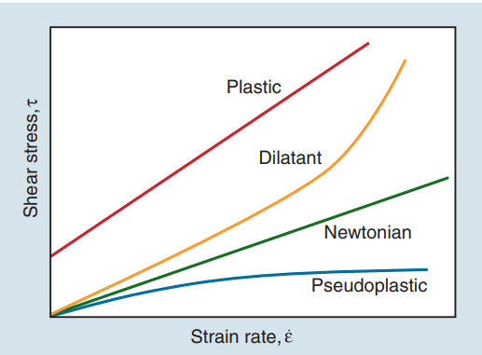

The viscosity of many dental materials decreases with increasing strain rate until it reaches a nearly constant value. That is, the faster they are stirred, forced through a syringe, or squeezed, the less viscous and more fluid they become. Liquids that show the opposite behaviour are dilatant and become more rigid as the rate of deformation (shear strain rate) increases. That is, the faster they are stirred, etc., the more viscous and resistant to flow they become.

The viscosity of most fluids decreases rapidly with increasing temperature. Viscosity may also depend on previous deformation of the liquid. Such fluids become less viscous and more flowable upon repeated applications of pressure and are termed thixotropic. Dental prophylaxis pastes, plaster of Paris, resin cements, and some impression materials are thixotropic. The thixotropic nature of impression materials is beneficial because the material does not flow out of a mandibular impression tray until it is placed over dental tissues, and a prophylaxis paste does not flow out of a rubber cup until it is rotated against the teeth to be cleaned. If these materials are stirred rapidly and the viscosity is measured, a value is obtained that is lower than the value for a sample that has been left undisturbed.

**STRESS RELAXATION**

After a substance has been permanently deformed, there are trapped internal stresses. For example, in a crystalline substance such as a metal, the atoms in the crystal structure are displaced and the system is not in equilibrium. Similarly, in amorphous structures, some molecules are too close together and others too far apart when the substance is permanently deformed.

The displaced atoms are not in equilibrium positions and are therefore unstable. Through a solid-state diffusion process driven by thermal energy, the atoms can slowly return to their equilibrium positions. The result is a change in the shape or contour of the solid as the atoms or molecules change positions. The material warps or distorts. Such stress relaxation is a problem with elastomeric impression materials and can lead to distortions in the impression and subsequent lack of fit.

The rate of relaxation increases with an increase in temperature. For example, if a wire is bent, it may tend to straighten out if it is heated to a high temperature. At room temperature, any such relaxation caused by rearrangement of metal atoms may be negligible. On the other hand, there are many non-crystalline dental materials (such as waxes, resins, and gels) that, when manipulated and cooled, can then undergo relaxation (with consequent distortion) at an elevated temperature. Considerable attention is given to this phenomenon in succeeding chapters because such dimensional changes by relaxation may result in an inaccurate fit of dental appliances.

**CREEP AND FLOW**

The time-dependent viscoelastic behaviour of dentine and resin based dental materials by bulk compressive creep test were evaluated and compared. The test’s methodology used was modified according to the ISO 8013:2012.

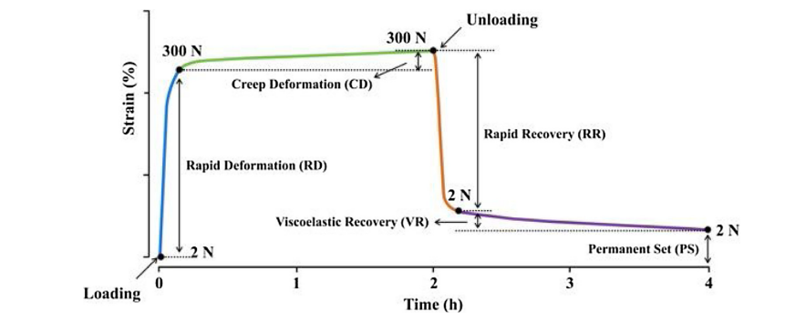

Instantaneous elastic strain (constant), viscous strain as well as delayed elastic strain in each group. The sum of the three types of strain equals to the total strain at each time point.

A schematic representation of a typical creep and recovery curve (strain-time curve) is illustrated in Figure, which consisted of four parts: rapid deformation (RD), creep deformation (CD), rapid recovery (RR), and a further time-dependent viscoelastic recovery (VR). If the recovery was not complete within the given time of the test, a permanent set (PS) is recorded.

Sound dentine presented the lowest maximum strain, creep strain, while the resin cement presented the highest strain and permanent set. The differences in deformation could possibly lead to a stress concentration at the adhesive layer or dentin – cement interface, and thus cause a potential risk of microleakage. Singh et al. evaluated the creep and fatigue properties of an adhesive composites dentine model, in their calculation of fatigue life, samples can be considered as resulting from creep failure when the strain of the adhesive layer is larger than 2.1%.

**FLUORESCENCE**

Natural tooth structure absorbs light at wavelengths too short to be visible to the human eye. These wavelengths between 300 and 400 nm are referred to as near-ultraviolet radiation. Natural sunlight, photoflash lamps, certain types of vapor lamps, and ultraviolet lights used in decorative lighting (“black lights”) are sources containing substantial amounts of near-ultraviolet radiation. The energy that the tooth absorbs is converted into light with longer wavelengths, in which case the tooth actually becomes a light source. This phenomenon is called fluorescence. The emitted light, a blue-white color, is primarily in the 400 to 450 nm range. Fluorescence makes a definite contribution to the brightness and vital appearance of a human tooth. As an example, ceramic crowns or composite restorations that lack a fluorescing agent appear as missing teeth when viewed under a black light.

**RADIOPACITY**

There are numerous circumstances where it is necessary to be able to distinguish a dental material radiographically from the surrounding tissue. For example, sufficient radiographic contrast is required in an x-ray image in order to assess restorations for marginal defects or breakdown, help differentiate composite restorations from dental caries, and detect microleakage. In case of accidental ingestion or traumatic impaction of dentures or other appliances, a delay in the detection, location, removal of the appliance and its fragments may be life-threatening.

The amount of x-ray energy absorbed by an object depends on the density and thickness of the material and the energy of the radiation. Generally, the higher the atomic number of the component atoms, the greater the x-ray absorbance and the larger the contrast produced. Polymers and resins are inherently radiolucent, whereas metals with atomic numbers above 19 (potassium) are inherently radiopaque. To impart radiopacity, restorative resins often utilize strontium or barium containing glass reinforcing particles; denture polymers may (but rarely) contain barium sulfate or other heavy-metal compound additives to render them radiopaque.

Radiopacity similar to that of hard tissue provides the optimal contrast for dental restorations. When radiopacity is too low, the resin will not be visible on an x-ray image; when it is too high, it may block out and obscure details of adjacent anatomy. Dentin has approximately the same radiodensity as that of aluminum, while enamel has approximately twice the radiodensity of dentin and aluminum. To claim that a composite is radiopaque, the American Dental Association requires commercial dental restorative resins to have a radiopacity of at least an amount equal to that of aluminium. To be adequately detectable on medical chest x-ray images, it has been found that a denture resin fragment of 2 mm should have a radiopacity equal or greater than that of 0.2 mm of copper.

**2. CHEMICAL PROPERTIES**

**SOLUBILITY**

The maximum amount of solute that can be dissolved in a solvent at a given temperature is known as solubility. It can also be described as the extent to which a dental material dissolves in saliva or oral fluids. Materials used in the oral cavity are subjected to frequent variations in temperatures. The more the temperature and lesser the pH, the higher is the solubility.

Solubility is measured as mg/mL or g/L.

The clinical solubility is described in terms of microleakage, secondary caries, marginal discoloration and deterioration. Calcium hydrochloride is the most soluble of all cements.

**CHEMICAL EROSION**

Erosion more specifically describes solubility in acids. Clinical application of erosion is in acid etching, where tooth is etched to achieve adhesion to composite resin. Erosion of restorative materials in oral cavity may occur due to intrinsic and extrinsic factors.

The lower the solubility and greater the acid resistance of a material, the greater the longevity of the restoration.

**LEACHING**

It is the process of releasing substances from a solid material into the surrounding soluble medium. In dentistry, the process of leaching has advantages as well as disadvantages.

Advantages:

During the setting reaction of glass ionomer cement, the acid attacks the surface of the powder particles that results in the leaching out of calcium and aluminium ions into the aqueous medium. These ions cross link with carboxyl group of polyacrylic acid resulting in a set matrix.

Anticariogenic property of GIC is due to the leaching of fluoride from set GIC restoration.

Leaching of hydroxyl ions from calcium hydroxide sub-base helps in maintaining an alkaline environment that is favourable for secondary dentin formation and antibacterial effect.

Disadvantages:

When there is moisture contamination before final setting reaction of GIC, it results in loss of ions, leading to decreased strength.

Leaching of monomers from incompletely polymerized resin will have deleterious effect on the underlying tissues.

**TARNISH AND CORROSION**

Tarnish is a surface discoloration on a metal or a slight loss or alteration of the surface finish or lustre. In the oral environment, tarnish often occurs from the formation of deposits on the surface of a restoration. Tarnish also arises from the formation of thin films, such as oxides, sulfides, or chlorides. The latter phenomenon may be only a simple surface deposit, and such a film may even be protective, as discussed subsequently. However, it is often an early indication and precursor of corrosion. Corrosion is a process whereby deterioration of a metal is caused by reaction with its environment. In due course, corrosion can cause severe and catastrophic disintegration of metals. Even if highly localized, corrosion may cause mechanical failure of a structure even though the actual volume of material lost is quite small. Corrosive disintegration can take place through the action of moisture, atmosphere, acid or alkaline solutions, and certain chemicals. Tarnish is often the forerunner of corrosion because the tarnish film accumulates components that chemically attack the metallic surface.

Chemical corrosion is the direct combination of metallic and non-metallic elements to yield a chemical compound through oxidation reactions. This mode of corrosion is also referred to as dry corrosion, since it occurs in the absence of water or another fluid electrolyte. This is why it is prudent to store the alloy in a cool, dry location to ensure an adequate shelf life.

Electrochemical corrosion, also known as galvanic corrosion, requires the presence of water or some other fluid electrolyte and a pathway for the transport of electrons (i.e., an electrical current). It is also referred to as wet corrosion, since it requires a fluid electrolyte. Electrochemical corrosion is seldom isolated and almost invariably is accompanied by chemical corrosion.

When a metal is in contact with a fluid electrolyte, the chemical potential causes enough ions to dissolve to form a saturated solution and produce an equal number of free electrons. The loss of electrons by a metal is known as oxidation and is the initial electrochemical event in the corrosion process. The ease with which a metal gives up electrons in solution and oxidizes can be expressed in terms of the oxidation potential.

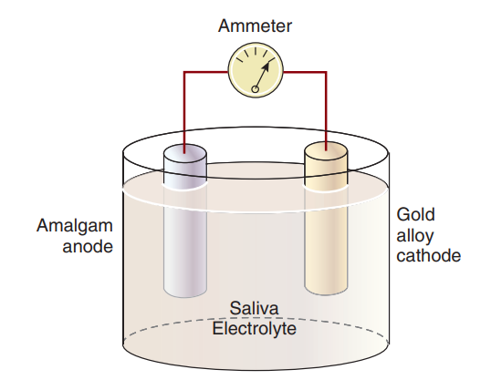

**DISSIMILAR METALS**

An important type of electrochemical reaction occurs when combinations of dissimilar metals are in direct physical contact. Here two adjacent metal restorations have different compositions. The alloy combinations that may produce galvanic corrosion or electro galvanism through the flow of galvanic currents may be in either continuous or intermittent contact. An example would be a dental amalgam restoration placed on the occlusal surface of a tooth directly opposing a gold inlay. Because both restorations are wet with saliva, an electrical circuit exists with a difference in potential between the dissimilar restorations.

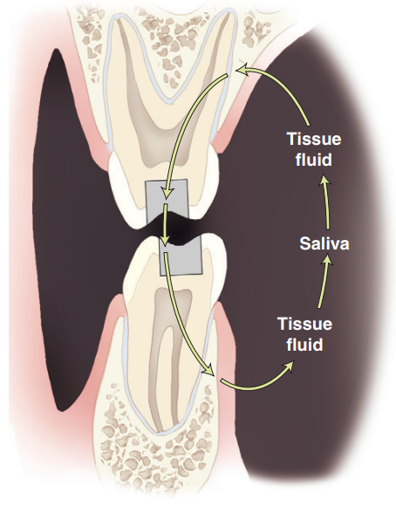

**HETEROGENEOUS SURFACE COMPOSITION**

Another type of galvanic corrosion is associated with the heterogeneous composition of the surfaces of dental alloys, whose microstructures have been described in the preceding two chapters. Examples include the eutectic alloys and peritectic alloys. Commercial dental alloys generally contain more than three elements, and they can have complex microstructures that result in even more heterogeneous surface compositions. For example, when an alloy containing a two-phase eutectic microstructural constituent is immersed in an electrolyte, the lamellae of the phase with the more negative electrode potential are attacked, and corrosion results.

**STRESS CORROSION**

Since the imposition of stress increases the internal energy of an alloy, either through the elastic displacements of atoms or the creation of micro strain fields associated with dislocations when permanent deformation occurs, the tendency to undergo corrosion will be increased. For most metallic dental appliances, the deleterious effects of stress and corrosion, called stress corrosion, are most likely to occur during fatigue or cyclic loading in the oral environment. Small surface irregularities, such as notches or pits, act as sites of stress concentration so that ordinary fatigue failure (in the absence of corrosion) occurs at nominal stresses below the normal elastic limit of the alloy. Thus, any cold working of an alloy by bending, burnishing, or malleting causes localized permanent deformation in some parts of the appliance. Electrochemical cells consisting of the more deformed metal regions (anodic), saliva, and undeformed or less deformed metal regions (cathodic) are created, and the deformed regions will experience corrosion attack. This is one reason why excessive burnishing of the margins of metallic restorations is contraindicated.

**CONCENTRATION CELL CORROSION**

An important type of electrochemical corrosion is called concentration cell corrosion, which occurs whenever there are variations in the electrolytes or in the composition of the given electrolyte within the system. For example, there are often accumulations of food debris in the interproximal areas between the teeth, particularly if oral hygiene is poor. This debris then produces an electrolyte in that area, which is different from the electrolyte that is produced by normal saliva at the occlusal surface. Electrochemical corrosion of the alloy surface underneath the layer of food debris will take place in this situation. Irregularities—such as pits, scratches, and cracks—in restoration surfaces are important examples of this phenomenon.

**3. MECHANICAL PROPERTIES**

Elastic solids may be stiff or flexible, hard or soft, brittle or ductile, and fragile or tough. However, these are qualitative mechanical properties that do not describe how similar or dissimilar dental materials of the same type may be. Mechanical properties are defined by the laws of mechanics—that is, the physical science dealing with forces that act on bodies and the resultant motion, deformation, or stresses that those bodies experience. In the oral environment, restorations are subjected to stresses from mastication action. These forces act on teeth and/ or material producing different reactions that lead to deformation, which can ultimately compromise their durability over time.14

All mechanical properties are measures of the resistance of a material to deformation, crack growth, or fracture under an applied force or pressure and the induced stress. An important factor in the design of a dental prosthesis is strength, a mechanical property of a material, which ensures that the material serves its intended functions effectively and safely over extended periods of time. In a general sense, strength is the ability of the material to resist induced stress without fracture or permanent deformation (plastic strain). Plastic deformation occurs when the elastic stress limit (proportional limit) of the prosthesis material is exceeded. Although strength is an important factor, it is not a reliable property for estimating the survival probabilities over time of prostheses made of brittle material because strength increases with specimen size and stressing rate, decreases with the number of stress cycles, and is strongly affected by surface processing damage. Thus, strength is not a true property of a material compared with fracture toughness, which more accurately describes the resistance to crack propagation of brittle materials.15

Why do dental restorations or prostheses fracture after a few years or many years of service? The simplest answer is that the mastication force exerted by the patient during the final mastication cycle (loading and unloading) has induced a failure level of stress in the restoration. But why did the fracture not occur during the first month or year of clinical service? One can assume that the stress required to fracture a restoration must decrease somehow over time, possibly because of the very slow propagation of minute flaws to become microcracks through a cyclic fatigue process. The failure potential of a prosthesis under applied forces is related to the mechanical properties and the microstructure of the prosthetic material.14

**STRESSES AND STRAINS**

When a force or pressure is exerted on an elastic solid, the atoms or molecules respond in some way at and below the area of loading, but the applied force has an equal and opposite reaction at the area at some other point in the structure (e.g., an area that supports the solid and resists its movement). Although we assume for simplicity that the stress induced in the material structure is uniform between the loaded surface and the resisting surface, this is clearly not the case. In fact, the stress induced near the surface decreases with distance from the loading point and increases as the supporting surface is approached. This pattern is called a stress distribution or stress gradient.

For the elastic solid in question, the atoms may be compressed in such a way that their interatomic equilibrium distances are decreased temporarily until the force is decreased or eliminated. However, if the force is increased further, it is possible that the atoms will be displaced permanently or their bonds ruptured. Dental restorations should be designed such that permanent displacement of atoms or rupture of interatomic bonds does not occur except possibly at surface areas where normal wear may occur.

Stress is the force per unit area acting on millions of atoms or molecules in a given plane of a material. Except for certain flexural situations, such as four-point flexure, and certain non-uniform object shapes, stress typically decreases as a function of distance from the area of the applied force or applied pressure. Thus, stress distributions in an elastic solid are rarely uniform or constant. However, for purposes of determining mechanical properties, we assume that the stresses are uniformly distributed.

For dental applications, there are several types of stresses that develop according to the nature of the applied forces and the object’s shape. These include tensile stress, shear stress, and compressive stress. The strength of a material is defined as the average level of stress at which it exhibits a certain degree of initial plastic deformation (yield strength) or at which fracture occurs (ultimate strength) in test specimens of the same shape and size. The clinical strength of brittle materials (such as ceramics, amalgams, composites, and cements) is reduced when large flaws are present or if stress concentration areas exist because of improper design of a prosthetic component (such as a notch along a section of a clasp arm on a partial denture). Under these conditions a clinical prosthesis may fracture at a much lower applied force because the localized stress exceeds the strength of the material at the critical location of the flaw (stress concentration).

When one chews a hard food particle against a ceramic crown, the atomic structure of the crown is slightly deformed elastically by the force of mastication. If only elastic deformation occurs, the surface of the crown will recover completely when the force is eliminated. Elastic stresses in materials do not cause permanent (irreversible) deformation. On the other hand, stresses greater than the proportional limit cause permanent deformation and, if high enough, may cause fracture. For brittle materials that exhibit only elastic deformation and do not plastically deform, stresses at or slightly above the maximal elastic stress (proportional limit) result in fracture. These mechanical properties of brittle dental materials are important for the dentist to understand how to design a restoration or make adjustments to a prosthesis.

Based on Newton’s third law of motion, when an external force acts on a solid, a reaction occurs to oppose this force which is equal in magnitude but opposite in direction to the external force. The stress produced within the solid material is equal to the applied force divided by the area over which it acts.

When stress is induced by an external force or pressure, deformation or strain occurs. As an illustration, assume that a stretching or tensile force of 200 Newtons (N) is applied to a wire 0.000002 m2 in cross-sectional area. The tensile stress (σ), by definition, is the tensile force per unit area perpendicular to the force direction:

image**(1)**

The SI unit of stress or pressure is the Pascal, which has the symbol Pa, that is equal to 1 N/m2, 0.00014504 lbs/in2 in Imperial units, or 9.9 × 10−6 atmospheres. Because the wire has fractured at a stress of 100 Megapascals (MPa), its tensile strength is 100 MPa, where 1 MPa = 1 N/mm2 = 145.04 psi.

In the English or Imperial system of measurement, the stress is expressed in pounds per square inch. However, the megapascal unit is preferred because it is consistent with the SI system of units. SI stands for Systéme Internationale d’ Unités (International System of Units) for length, time, electrical current, thermodynamic temperature, luminous intensity, mass, and amount of substance.

The pound-force (lbf) is not an SI unit of force or weight. It is equal to a mass of 1 pound multiplied by the standard acceleration of gravity on earth (9.80665 m/s2). The newton (N) is the SI unit of force, named after Sir Isaac Newton. To illustrate the magnitude of 1 MPa, consider a McDonald’s quarter-pound hamburger (0.25 lbf or 113 g before cooking) suspended from a 1.19-mm-diameter monofilament fishing line. The stress per unit area within the line is 1 N/mm2, or 1 MPa. If the line is 1.0 m long and if it stretches 0.001 m under the load, the strain (ε) is the change in length, Δl, per unit original length, lo, or

image**(2)**

We can conclude that the line reaches a stress of 1 MPa at a tensile strain of 0.1%. Note that although strain is a dimensionless quantity, units such as meter per meter or centimetre per centimetre are often used to remind one of the system of units employed in the actual measurement. The accepted equivalent in the English system is inch per inch, foot per foot, and so forth.

Strain, or the change in length per unit length, is the relative deformation of an object subjected to stress. Strain may be either elastic, plastic, elastic and plastic, or viscoelastic. Elastic strain is reversible. The object fully recovers its original shape when the force is removed. Plastic strain represents a permanent deformation of the material; it does not decrease when the force is removed.

Viscoelastic materials deform by exhibiting both viscous and elastic characteristics. These materials exhibit both properties and a time-dependent strain behaviour. Elastic strain (deformation) typically results from stretching but not rupturing of atomic or molecular bonds in an ordered solid, whereas the viscous component of viscoelastic strain results from the rearrangement of atoms or molecules within amorphous materials.

Stress is described by its magnitude and the type of deformation it produces. Three types of “simple” stresses can be classified: tensile, compressive, and shear. Complex stresses, such as those produced by applied forces that cause flexural or torsional deformation, are discussed in the section on flexural stress.15

**TENSILE STRESS**

When a body is subjected to axial forces in a straight line and in opposite directions, it results in tension. The resistance of the material to this load is called tensile strength.16 The length alteration that results from the application of a tensile force on a body before its rupture is defined as elongation. Nominal value of tensile strength is determined by the equation of load and cross-sectional area (kgf/cm2). Values of stress-strain determine a curve, characterizing the performance of the material under tensile test. From this curve, elastic modulus, ultimate tensile strength, resilience and toughness of such product can be registered. In this test, it is common to measure the ductility of a material. It is an important feature of metallic materials because it is the ability of the material to deform under tensile forces until the fracture moment and indicates the workability of an alloy.

**COMPRESSIVE STRESS**

Since most of mastication forces are compressive in nature, it is important to investigate materials under this condition.17 This test is more suitable to compare brittle materials, which show relatively low result when subjected to tension. Therefore, this test is applied to compare dental amalgam, impression materials, investments and cements. Materials that are more resistant under compressive forces than under tensile forces, are called malleable. To test compressive strength of a material, two axial sets of forces are applied to a sample in an opposite direction, in order to approximate the molecular structure of the material. According to ISO 9917,18 cylindrical shaped specimens are tested. The dimensions of the samples should have a relation of length to diameter of 2:1. When this proportion is exceeded, it can result in undesirable bending of the specimen.17

In the same manner of tensile strength, nominal value of compressive strength also is determined by the reason of load by cross-sectional area (kgf/cm2). Stress-strain curve of investigated material is determined as the same manner as established to tensile tests. Thus, the elastic modulus can also be determined by the ratio stress-strain, in the elastic region.

**SHEAR STRESS**

This type of stress tends to resist the sliding or twisting of one portion of a body over another. Shear stress can also be produced by the twisting or torsional action on a material. For example, if a force is applied along the surface of tooth enamel by a sharp-edged instrument parallel to the interface between the enamel and an orthodontic bracket, the bracket may debond by shear stress failure of the resin luting agent. Shear stress is calculated by dividing the force by the area parallel to the force direction.

In the mouth, shear failure is unlikely to occur for at least four reasons:

(1) Many of the brittle materials in restored tooth surfaces generally have rough, curved surfaces.

(2) The presence of chamfers, bevels, or changes in curvature of a bonded tooth surface would also make shear failure of a bonded material highly unlikely.

(3) To produce shear failure, the applied force must be located immediately adjacent to the interface, as shown in figure. This is quite difficult to accomplish even under experimental conditions, where polished, flat interfaces are used. The further away from the interface the load is applied, the more likely it is that tensile failure rather than shear failure will occur because the potential for bending stresses would increase.

(4) As the tensile strength of brittle materials is usually well below their shear strength values, tensile failure is more likely to occur.

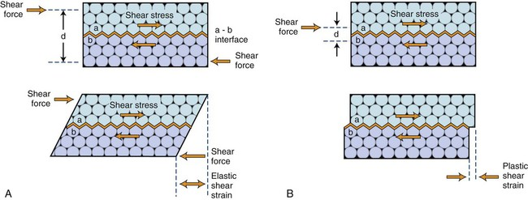

Atomic model illustrating elastic shear deformation (**A**) and plastic shear deformation (**B**) for the unit length of a material structure.

**DIAMETRAL COMPRESSION TEST**

Rupture under low tension characterizes fragile materials, susceptible to break. In these cases, tensile strength is not indicated to evaluate material reaction, because of the low cohesive condition. An alternative method of tensile strength is calculated by compressive testing. It is a relatively simple and reproducible test. It is defined as diametral compression test for tension or indirect tension.17 Disk sample is necessary to conduct this test, where it is compressed diametrically introducing tensile stress in the material in the plane of the force applied during the test (Figure 4). This is calculated by the formula: 2 P/ π x D x T,

where: P= load applied, D= diameter of the disk, T= thickness of the disk, π= constant

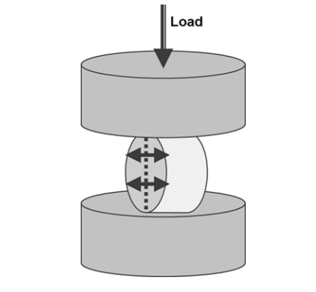

Schematic illustration of diametral compression test

**FLEXURAL STRENGTH**

The flexural strength of a material is its ability to bend before it breaks.19 It is obtained when the ultimate flexibility of one material is achieved before its proportional limit.20 Flexural forces are the result of forces generated in clinical situations and the dental material needs to withstand repeated flexing, bending, and twisting. A high flexural strength is desired once these materials are under the action of chewing stress that might induce permanent deformation.

To evaluate flexural strength of a dental material, a bar-shaped specimen with a dimension of 25 mm in length X 2 mm in width X 2 mm in height (ISO 9917 – 212). Specimens are placed on two supports and a load is applied at the centre. This test is known as the three-point bending test. The load at yield is the sample material’s flexural strength that is calculated by the following formula: 3Pl (2) 2bd2

where:

P= the ultimate load at fracture,

l= the distance of the supports,

b= the width of the specimen,

d= the thickness of the specimen.

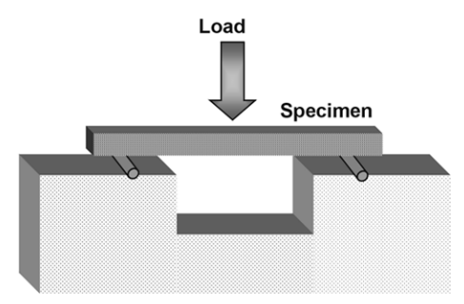

Schematic illustration of flexural strength test of a material

**POISSON RATIO**

When a material is under axial loading as tensile or compression tests, it is stated that the stress provokes strain in an axial direction. However, lateral strain also occurs.16 Then, tensile force results in material elongation in the axial direction and a reduction of the cross-section. On the other hand, compressive force leads materials to increase in the cross-section and reduction of original length. If these reactions occur in the elastic limit, the ratio between lateral and axial strain is denominated as Poisson’s ratio. Poisson’s ratio indicates that the alteration in cross-section is proportional to the deformation during the elastic range. Brittle materials show little permanent reduction in cross-section during tensile test situations than more ductile materials.

**RESISTANCE TO FATIGUE**

The complexity of the oral environment and geometric diversity of cavities filled with restorations make it difficult to precisely define clinical failure processes and to associate routinely measured mechanical properties with dental materials performance. The behaviour of these materials under the action of stresses, which are relatively low but intermittent, shows the resistance to fatigue.17 This method permits measurement of a fatigue limit, with no fracture, at a given number of stress cycles. Compressive fatigue curves are generated when different materials are submitted to cyclic compressive stress. Tests are made with the test machine in a given loading frequency. The presence of defects in the microstructure of the restoration or specimen submitted to high or low stresses leads to the development of cracks. As clinical environment influences are critical factors due to the relatively low stress, these cracks will turn into fracture of the material.

**HARDNESS TEST**

Major laboratory tests are performed to investigate products based on their bulk features. However, surface characteristics are also a determinant factor when the material is in service in oral environment. Surfaces characteristics can influence polishing ability, on the scratching occurrence and on the resistance to load application. Surface hardness is a parameter frequently used to evaluate material surface resistance to plastic deformation by penetration.21 Hardness is not an intrinsic material property dictated by precise definitions in terms of fundamental units of mass, length and time. A hardness property value is the result of a defined measurement procedure. The usual method to achieve hardness value is to measure the depth or area of an indentation left by an indenter of a specific shape with a specific force applied for a specific time. There are four common standard test methods for expressing the hardness of a material: Brinell, Rockwell, Vickers, and Knoop. Each of these methods is divided into a range of scales, defined by a combination of applied load and indenter geometry. The Brinell hardness test method consists of indenting the material with a 10 mm diameter hardened steel or carbide ball subjected to a load. It is the oldest method to measure surface hardness and is applicable to test metal and alloys. The Rockwell hardness test method consists of indenting the test material with a diamond cone or hardened steel ball indenter. This method is useful to evaluate surface hardness of plastic materials used in Dentistry. The Vickers hardness test method consists of indenting the test material with a diamond indenter, in the form of a right pyramid with a square base and an angle of 136 degrees between opposite faces subjected to a load of 1 to 100 Kgf. The load is normally applied for 10 to 15 seconds. The two diagonals of the indentation left in the surface of the material after removal of the load are measured using a microscope and their average calculated. The area of the sloping surface of the indentation is calculated. It is suitable to be applied to determine the hardness of small areas and for very hard materials. Knoop hardness is more sensitive to surface characteristics of the material. The Knoop indenter is a diamond ground to pyramidal form that produces a diamond shaped indentation having approximate ratio between long and short diagonals of 7:1. The depth of indentation is about 1/30 of its length. When measuring the Knoop hardness, only the longest diagonal of the indentation is measured and this is used in the following formula with the load used to calculate KHN:

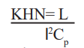

where,

L= load applied,

l= the length of the long diagonal of the indentation,

Cp = constant relating l to projected area of the indentation.

Knoop hardness test is applied to evaluate enamel and dentine structures. One of the major difficulties is the requirement of a high polished flat surface that is more time-consuming and more care taking compared to other tests. Comparing the indentations made with Knoop and Vickers Diamond Pyramid indenters for a given load and test material, there are some technical differences as follow:22

* Vickers indenter penetrates about twice as deep as Knoop’s indenter
* Vickers indentation diagonal about 1/3 of the length of Knoop’s major diagonal
* Vickers test is less sensitive to surface conditions than Knoop’s test
* Vickers test is more sensitive to measurement errors than Knoop’s test
* Vickers test is best for small rounded areas. Knoop’s test is best for small elongated areas
* Knoop’s test is good for very hard brittle materials and very thin sections.

Hardness tests are extremely used and have important applicability on Dentistry. Hardness test can evaluate the degree of mineralization of a dental substrate23 for example. A specific force applied for a specific time and distance provides important data in studies assessing the ability of enamel and dentin remineralization after different treatments as happens in unbalanced situations of demineralization. Another important use of this test is to evaluate the degree of polymerization of resin composite and resin cements. Hardening and depth of cure of these materials can be obtained using Vickers and Knoop’s micro-hardness test.24

**ELASTIC MODULUS / YOUNG’S MODULUS**

Elastic modulus describes the relative stiffness or rigidity of a material, which is measured by the slope of the elastic region of the stress-strain graph. The straight-line region represents reversible elastic deformation, because the stress remains below the proportional limit of 1020 MPa, and the curved region represents irreversible plastic deformation, which is not recovered when the wire fractures at a stress of 1625 MPa. However, the elastic strain (approximately 0.52%) is fully recovered when the force is released.

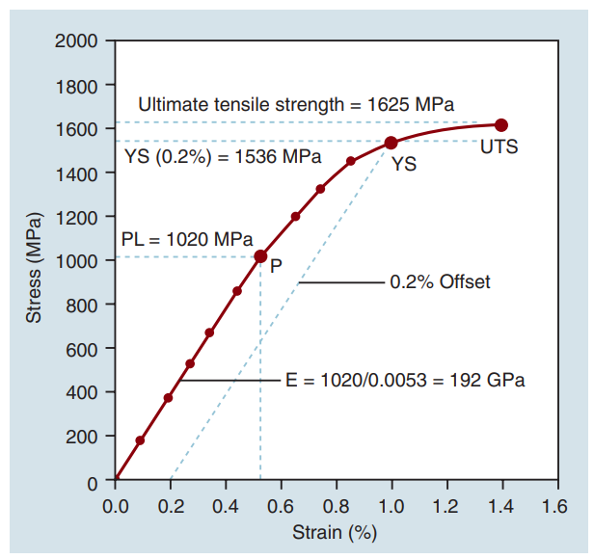

Stress-strain plot for a stainless-steel orthodontic wire that has been subjected to tension. The proportional limit (PL) is 1020 MPa. Although not shown, the elastic limit is approximately equal to this value. The yield strength (YS) at a 0.2% strain offset from the origin (O) is 1536 MPa and the ultimate tensile strength (UTS) is 1625 MPa. An elastic modulus value (E) of 192,000 MPa (192 GPa) was calculated from the slope of the elastic region.

The elastic modulus has a constant value that describes a material’s relative stiffness as determined from a stress-strain graph, which compensates for differences in cross-sectional area and length by plotting force per unit area by the relative change in dimension, usually length, relative to its initial value. Variations in values of proportional limit, elastic modulus, and ultimate compressive strength have been reported for enamel and dentin relative to the area of the tooth from which the test specimens were obtained. Because the elastic modulus of a material is a constant, it is unaffected by the amount of elastic or plastic stress induced in the material. It is independent of the ductility of a material, since it is measured in the linear region of the stress-strain plot. Thus, elastic modulus is not a measure of its plasticity or strength. Materials with a high elastic modulus can have either high or low strength values. Although a compressive test was selected to measure the properties of tooth structures, the elastic modulus can also be measured by means of a tensile test.

The elastic modulus (E) of a tensile test specimen can be calculated as follows:

Stress P A = = / σ

Strain l l = =∆ o / ε

where

P = the applied force or load

A = the cross-sectional area of the material under stress

Δl = the increase in length

lo = the original length

Thus,

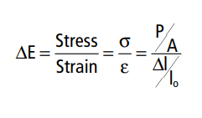

**DYNAMIC YOUNG’S MODULUS**

The velocity of sound wave and the density of the material can be used to calculate the elastic modulus and Poisson’s ratio. This method of determining dynamic elastic moduli is less complicated than conventional tests of tensile or compressive strength, but the values are often found to be higher than those obtained by static measurements.

The shear modulus (G) can be calculated from the elastic modulus (E) and Poisson’s ratio (ν) using

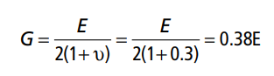

A value of 0.25 to 0.30 for Poisson’s ratio is typical. Thus, the shear modulus is usually about 38% of the elastic modulus value.

**BRITTLENESS**

Materials that are very brittle have a tensile strength markedly lower than their corresponding compressive strength because of their inability to plastically deform and reduce the tensile stress at flaw tips. This is true of all brittle dental materials, such as amalgams, composites, cements, ceramics, and some base metal alloys. The failure of these materials in clinical usage is most often associated with their low tensile strengths and the presence of flaws within the tensile stress region. Shown in Figure are three stress-strain curves of materials with variable strength, elastic modulus, and percent elongation. Material A is stronger, stiffer, and more ductile than materials B and C. Material B has less ductility than material A and thus, is more brittle. Material C has no ductility and is perfectly brittle; it is also the weakest of the three materials. Brittleness is the relative inability of a material to sustain plastic deformation before fracture of a material occurs. For example, amalgams, ceramics, and composites are brittle at oral temperatures (5 to 55°C). They sustain little or no plastic strain before they fracture. In other words, a brittle material fractures at or near its proportional limit. This behaviour is shown by material C in Figure.

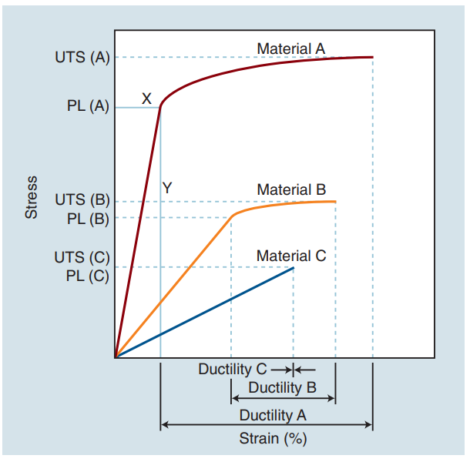

Stress-strain plots of materials that exhibit different mechanical properties. UTS, ultimate tensile stress; PL, proportional limit.

If a glass is drawn into a fiber with very smooth surfaces and insignificant internal flaws, its tensile strength may be as high as 2800 MPa (400,000 psi), but it will have no ductility (0% elongation). Thus, dental materials with low or zero percent elongation—including amalgam, composite, ceramics, and non-resin luting agents—will have little or no burnishability because they have no plastic deformation potential.

**DUCTILITY AND MALLEABILITY**

When a cast dental alloy is stressed beyond its proportional limit, it becomes permanently deformed. If it sustains tensile stress and considerable permanent deformation without rupture, it is classified as a ductile alloy. Ductility represents the ability of a material to sustain a large permanent deformation under a tensile load up to the point of fracture. Malleability is the ability of a material to sustain considerable permanent deformation without rupture under compression, as in hammering or rolling into a sheet. Gold is the most ductile and malleable pure metal, and silver is second. Of the metals of interest to the dentist, platinum ranks third in ductility, and copper ranks third in malleability. Ductility is the relative ability of a material to be stretched at room temperature without fracturing. Its magnitude can be assessed by the amount of permanent deformation indicated by the stress-strain curve. For example, the plastic strain indicated in the Figure above is a relative measure of the ductility of the solid material. After fracture, the mechanical stress decreases instantly to zero, and the residual strain represents the amount of permanent deformation that has been produced in the object.

**4. OPTICAL PROPERTIES**

Another important goal of dentistry is to restore or improve esthetics—the colour and appearance of natural dentition. Esthetic considerations in restorative and prosthetic dentistry have received increasingly greater emphasis in recent decades, and the challenges have grown even greater in the past few years. Thus, the development of a general-purpose, technique insensitive, direct-filling, tooth-coloured, colour-stable restorative material remains one of the more serious challenges of current dental materials research. Since esthetic dentistry imposes severe demands on the artistic abilities of the dentist and technician, knowledge of the underlying scientific principles of colour and other optical effects is essential. This is especially true for the increasingly popular restorations that involve ceramic materials.

**THREE DIMENSIONS OF COLOUR**

To overcome this problem, colour perception is described by three objective variables: hue, value, and chroma. These three parameters constitute the three dimensions of “colour space,”

**Hue**: The dominant colour of an object, for example red, green, or blue. This refers to the dominant wavelengths present in the spectral distribution. The continuum of these hues creates the 3-D colour.

**Value**: Value is also known as the grey scale. It is represented as the vertical, or the Z-axis. Value increases toward the high end (lighter) and decreases toward the low end (darker). Value is also expressed by the “lightness” factor, with varying levels of grey between the extremes of white and black. Teeth and other objects can be separated into lighter shades (higher value) and darker shades (lower value). For example, the yellow of a lemon is lighter than the red of a cherry. For a light-diffusing and light-reflecting object such as a tooth or dental crown, value identifies the lightness or darkness of a colour, which can be measured independently of the hue.

**Chroma**: Chroma is the degree of saturation of a particular hue. For example, red can vary from “scarlet” to light pink, where scarlet has a high saturation and pink has a low saturation. The yellow colour of a lemon is a more saturated, “vivid,” colour than that of a banana, which is a less saturated, “dull” yellow. Chroma varies radially, perpendicular to the value/L* axis, near the bottom right. Colours in the centre are dull (grey). In other words, the higher the chroma, the more intense the colour. Chroma is not considered separately in dentistry. It is always associated with the hue and value of dental tissues, restorations, and prostheses. One can see the relationship among these dimensions of colour in the adjustments on a colour television set, which use the same principles of hue, value, and chroma.

**THE EFFECT OF THE LIGHT SOURCE**

As the spectral distribution of the light reflected from or transmitted through an object is dependent on the spectral content of the incident light, the appearance of an object is dependent on the nature of the light in which the object is viewed. Daylight, incandescent, and fluorescent lamps are common sources of light in the dental operatory or laboratory, and each of these has a different spectral distribution. Objects that appear to be colour-matched under one type of light may appear different under another type. This phenomenon is called metamerism. Thus, if possible, colour matching should be done under two or more different light sources, one of which should be daylight, and the laboratory shade matching procedures should be performed under the same lighting conditions

**FLUORESCENCE**

In addition to the processes already discussed, natural tooth structure absorbs light at wavelengths too short to be visible to the human eye. These wavelengths between 300 and 400 nm are referred to as near-ultraviolet radiation. Natural sunlight, photoflash lamps, certain types of lamps, and ultraviolet lights used in decorative lighting (“black lights”) are sources containing substantial amounts of near-ultraviolet radiation. The energy that the tooth absorbs is converted into light with longer wavelengths, in which case the tooth actually becomes a light source. This phenomenon is called fluorescence. The emitted light, a blue-white colour, is primarily in the 400 to 450 nm range. Fluorescence makes a definite contribution to the brightness and vital appearance of a human tooth. As an example, ceramic crowns or composite restorations that lack a fluorescing agent appear as missing teeth when viewed under a black light.

**OPACITY**

Base and liner materials must have an optimal radio-opacity to contrast with recurrent caries, enabling the correct diagnosis. The base material or liner should be sufficiently radio-opaque to be identifiable and to delimit the tooth–restoration interface from the tooth structure.25

All flowable composites studied were more radio-opaque than dentine (*p* < 0.05) and had a radio-opacity similar to or greater than enamel.  There was a variation among the radio-opacities for samples of the same thickness, which was not so clear among the GICs. It can also be observed that an increased thickness corresponded to an increase in radio-opacity.

All the CHCs had radio-opacity greater than dentine (*p* < 0.05) but only Dycal showed a radio-opacity lower than enamel. Hydro C, Hydcal and Liner presented similar or greater radio-opacities than enamel.

The level of radio-opacity of the tested flowable composites was variable; those with low radiodensity should be avoided in Class II restorations, where a clear determination of recurrent caries by the examining clinician could be compromised.25

The higher the atomic number of the element added to the radio-opaque filler of the material composition, the higher the radio-opacity of the materials, because the absorption capacity of X-rays is increased. Therefore, ytterbium, which has the atomic number 70, is the element that provides the highest radio-opacity, followed by barium (*Z* = 56), yttrium (*Z* = 39), strontium (*Z* = 38), zinc (*Z* = 30), silicon (*Z* = 14) and aluminium (*Z* = 13). This importance can be demonstrated in this study by analysing the differences between the GIC Maxxion and its radio-opaque version Maxxion R. While the first one had a radio-opacity lower than dentine, for all thicknesses, the second one had a radio-opacity greater than this structure, meeting the ISO recommendation. This difference in radio-opacity is because the manufacturer has added strontium to Maxxion R; this has better radio-opacity than the silicon found in the composition of Maxxion. It has been demonstrated that the compound fluoraluminium silicate, which is present in the GICs' radio-opaque filler, does not provide sufficient radiopacity.26

The FRCs with the highest radio-opacities were Tetric, Tetric N and Surefil. Tetric showed radio-opacity greater than enamel, confirming results found by several authors.27-29

The radio-opacity of the calcium hydroxide cements studied was provided by zinc (Hydro C and Dycal) or barium and zinc (Liner and Hydcal). The radio-opacities of Dycal and Hydro C were lower than those of Liner and Hydcal, suggesting that the addition of barium improves the radio-opacity. All these materials showed radio-opacities greater than those of dentine, which confirms the results obtained by Devito et al and Pires de Souza et al.30 The clinician expects that a material such as CHC, when applied next to the pulp, is easily identified radiographically. Radio-opacity lower than enamel, as shown by Dycal, can lead the clinician to an incorrect diagnosis, mistaking this cement for dentine, caries, pulp or voids. 31

**REFRACTIVE INDEX**

Refractive index or index of refraction is a measure of bending of a ray of light when passing from one medium into another.17 Optical properties of some biological tissues and dental materials were investigated on some researches and the refractive indices were determined to be n = 1.652 and 1.546 for enamel and dentin, respectively.32

RMGIC represented higher colour change compared with GIC and resin cement, but there was no statically significant difference between their mean colour change value (p > 0.05). It was an expected result that the refractive index solutions would affect the colour co-ordinate of the luting cements, because it affected the transmittance of light passing through cement. However, sorption and solubility of luting cements in refractive index solutions might be the major factor for the color change.

(1) Refractive index solutions affected the colour of luting cements.

(2) Type of the luting cement, matrix and the filler characters, polymerization degree, mixing method and many other factors may be decisive factors on the discoloration of luting cements.

(3) When the refractive index solutions are used in dental research, especially for discolouring materials, researchers must pay attention and keep the contact time as short as possible.33

**TRANSLUCENCY**

Translucency is the intermediary between complete opacity and complete transparency, making its analysis highly subjective. In nature, the translucency of dental enamel varies from tooth to tooth, and from individual to individual. Therefore, four important factors must be considered when appraising translucency. Presence or absence of color, thickness of the enamel, degree of translucency, and surface texture are essential components when determining translucency. State-of-the-art resin composites provide varying shades and opacities that deliver a more faithful reproduction of the chromaticity and translucency/opacity of enamel and dentin. This enables the attainment of individualized and customized composite restorations.

When dealing with these types of translucent substances, the variation in the refractive index is also an important consideration, as it is directly related to the thickness of the material. When light is diffused in the interior, the material becomes translucent. The translucency of the substance may also vary because of the thickness of the material. For example, if there are three bodies of the same material with three different thicknesses (i.e., 0.5, 1, 2 mm), the one with the greatest thickness will be the least translucent.

In natural teeth, the thickness of the enamel varies greatly and is greater at the incisal one-third, decreasing gradually toward the cervical one-third. Therefore, translucency in the cervical region is greater when compared with the incisal region, allowing for a clearer perception of the dentin. The same principle applies to tooth age, whereby younger teeth present more enamel than in older teeth.34

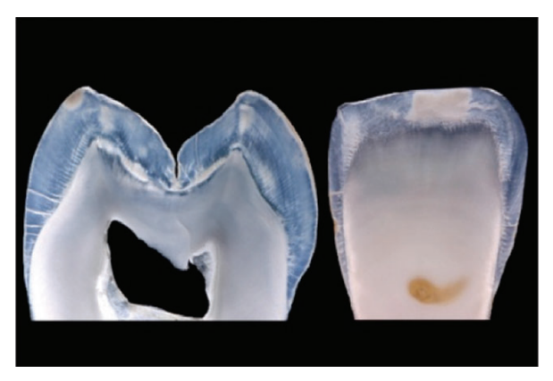

A side-by-side comparison was made to colorless young enamel and older enamel, which is achromatically translucent.

Modern composite resins have different hues and opacities that imitate the chromaticity and translucency of enamel, as well as dentin, in the best possible manner.35

The following describes a classification of composite resin for reproduction of effective translucency:

Artificial body enamel resins: keyed to the Vita shade guide, provide a chromatic basis to the restoration, responsible for generating colour hue.

Artificial translucent effect enamel: provides translucency especially to deep areas throughout incisal and proximal edges.

Artificial milky-white semi translucent enamel: used for creating halos, which are high-value areas with white effects.

Artificial value-modifying enamel: used as final layers in specific areas of the labial aspect, in order to enhance, to decrease, or to corroborate the pre-existing natural enamel colour value.3

**5. THERMAL PROPERTIES**

When a tooth is restored with a metallic restoration, any change in temperature is transmitted through the metal. If it is conveyed to the pulp in a gradual manner, the functions of the pulp are unaffected. To prevent any injury to the pulp, a non-conducting material is placed between the metal and sensitive dentine. Heat only accumulates upon its surface, and is transmitted so slowly, that it can be used up in the work of quickening the vital energy of the pulp.

**THERMAL CONDUCTIVITY**

Thermal conductivity is the rate at which thermal changes are conducted through a material. Materials with high thermal conductivity are good conductors of heat and cold, and could contribute as a factor in post operative sensitivity. This is the rationale for placing bases and or liners in cavity preparations that are close to the pulp. Bases and liners have low thermal conductivity and thus are efficient insulators.

There is a speculation by some that these bases and liners are not needed because dentin itself is a good insulator. However, often the thickness of dentin over the pulp may be minimal, so it is usually recommended that the thickness of remaining dentin and the thickness of the base or liner should be at least 0.5 to 1 mm.

It is interesting to note that amalgam is an excellent thermal conductor, whereas composite resin is an effective insulator; however, the incidence of postoperative sensitivity is significantly higher with composite resin restorations than with amalgam restorations. This demonstrates that the phenomenon of postoperative sensitivity is multifactorial and complex, and not due to thermal conductivity alone.

Layered zirconia restorations experience a rate of veneer chipping about 8 times that of metal-ceramic restorations. The etiology of this chipping is multifactorial, but one of the potential causes is the thermal conductivity of the zirconia core. The thermal conductivity is extremely low, and zirconia can be considered as an insulator. The consequence of this is that when a layered zirconia restoration is removed from the sintering oven, the core cools very slowly and the veneering ceramic cools past its glass transition temperature, while the core continues to cool and shrink. The net result of this interaction is that stress builds up in the veneering ceramic, which is later released via clinical chipping of the veneering material. New firing cycles involving slower cooling rates seem to have reduced the incidence of chipping in recent years.

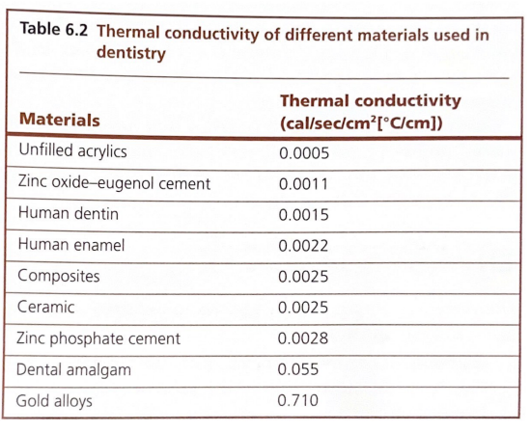

Enamel and dentin are composed of finely packed hydroxyapatite crystals that make these structures act as thermal insulators. When tooth structure is replaced with metallic restoration which are good thermal conductors, it is important to provide thermal insulation to protect the dental pulp from rapid change of temperatures within the oral cavity. Generally, dental cements that are used as base under metallic restorations, act as insulators. An advantage of a composite is that it has low thermal conductivity. Composites do not need liners and bases to provide thermal insulation. Heat flow through a material is measured in terms of thermal conductivity.

The thermal conductivity of human dentin has been reported by Lisanti and Zander37, Simeral38, Reinking, and Phillips39, and Soyenkoff and Okun to be 2.29 x10-3, 2.35 x10-3, 0.257 x10-3, and 0.96-1.07 x10-3 cal/sec/cm2/0C/cm, respectively. The thermal conductivity of human enamel has been reported by Soyenkoff and Okun to be 1.55 x 10-3.

Simeral38 reported values of 2.81 x10-3 for zinc phosphate and 2.00 x10-3 for silicate cements. Phillips and co-workers39 at different times listed the thermal conductivity of zinc phosphate cement to be 3.91-5.37 x10-3. Silicate cement was found to have a thermal conductivity of 0.458 x10-3 c.g.s. units. Dental amalgam was found to have an average thermal conductivity of 5.4 x10-2 cal/sec/cm2/0C/cm.40

All literature values indicate that dentin, enamel, zinc phosphate cements, and silicate cements are good thermal insulators.

**THERMAL COEFFICIENT OF EXPANSION (COE)**

The coefficient of expansion (COE) is defined as the amount a material expands per unit length if heated 1 degree higher. Waxes have the highest COE of dental materials.   
When the lost wax process is used, wax patterns should be invested as soon as possible. This property can be very important when dealing with materials that have cores with veneering materials. An example is metal-ceramic crowns. The feldspathic porcelain veneer, which provides excellent esthetic result with such restorations, is very brittle and must be supported with a rigid material (metal alloy). When fabricating metal-ceramic restorations, the crowns must be heated to a high temperature several times to sinter the veneering ceramic. Then the units must be cooled to bench temperature. If the COEs of the metal alloy and veneering porcelains are not closely matched, stresses can build up in the veneering porcelain that result in the cracking or fracture of the ceramic. This can occur at the time of fabrication or later in clinical service. Generally, the COE of the metal alloy is reduced with the addition of platinum, and the COE of the porcelain is increased with the addition of sodium.

Whatever the mechanism used, it is clear that the COEs of both the core and veneering material must be closely matched. It is often thought that the COEs of restorative materials must be matched with the COE of tooth structure. If they are not matched, the ingestion of hot beverages (e.g. coffee) and cold food and beverages (e.g. ice cream) could result in uneven expansion and contraction of the restoration and tooth, resulting in microleakage. The reality is that food and beverages do not surround the tooth/restoration complex for a long enough time frame to produce any significant change in the temperature of the tooth restoration.

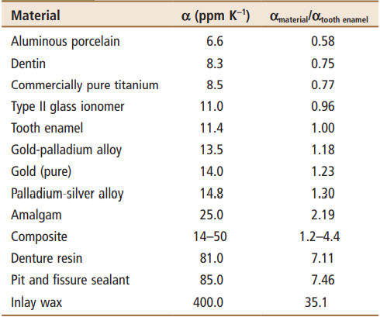

Coefficients of Thermal Expansion (α) of Dental Materials Compared with Those of Tooth Enamel and Dentin

**THERMAL DIFFUSIVITY**

Thermal diffusivity is defined as the thermal conductivity divided by the product of the density and the heat capacity (Braden, 1964). It is the parameter which characterizes the transient temperature change within a material when the material is exposed to an environmental temperature stimulus. It is thus of importance in the protection of the dental pulp from thermal shock.

The thermal diffusivity values for dentin and enamel of human teeth are 0.18– 0.26 x10-6 Wm-1K-1 and 0.47x10-6 Wm-1K-1 respectively.41

In general, diffusivity values for both polymeric and ceramic materials decrease with increasing temperature. For example, the diffusivity of polymethylmethacrylate decreases in a near-linear manner from a value of 0.136 mm2/sec at 00C to a value of 0.080 mm2/sec at 100°C (Touloukian, 1973).

The highest diffusivities were observed for materials containing filler particles of either quartz or silicon nitride and silica. Crystalline quartz has a diffusivity of about 4.0 mm2/sec at 300K. By contrast, materials incorporating either barium or strontium glasses, which are radiopaque (Omer et al., 1986), or microfine silica exhibited lower thermal diffusion rates closer to that of dentin, (Brown et al., 1970).

**SPECIFIC HEAT CAPACITY**

Specific heat is a parameter that is used to assess the thermal properties of dental materials, it is the measure of the heat required to increase the temperature of a unit mass by one degree.

Specific heat measurements were performed on a Perkin-Elmer differential scanning calorimeter (DSC). This is a power-compensated apparatus which enables direct measurements of the specific heat. A sapphire reference specimen of 60.50 mg is utilised for the measurement. According to Mraw (1988), comparative measurements ensure a higher accuracy. Moreover, in such a case continuous measurements are easier to perform. The investigated specimens are encapsulated in aluminium sample pans of mass of 26.3 mg. Every single experiment consisted of three dynamic steps: cooling from 35.80C to 10.80C, heating from 10.80C to 49.80C, and cooling from 49.80C to 35.80C. The heating or cooling rate was 2 K/min. Despite the fact that calculations of the specific heat are performed both for heating and cooling processes, the results of only the first, i.e heating characteristics, are accepted. This is because the calibration of the instrument is made for the heating mode. According to Richardson (1984) and Mraw (1988), the specific heat on cooling has rarely been investigated. The specific heat capacity can be expressed in the equation:

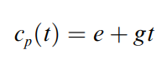

1. Calibration on cooling generates additional problems due to supercooling of calibrants.
2. Fragments of data corresponding to the initial transient heat exchange were neglected;

where e and g are constants.

According to the published data (Richardson 1984; Mraw 1988), when the instrument is correctly set up, overall accuracy of about 100% can be reached. Test runs with the use of pure copper, nickel, and iron specimens confirm that. During investigations of the Tetric specimen, discrepancies were obtained between results in different temperatures. A possible explanation of that paradox is that despite the initial curing, the specimens could not be considered as thermally stabilised. That is the main reason why it is difficult to comment on the reproducibility and the overall accuracy when composite-resin-type materials are taken into account. In dilatometric investigations, Compo glass exhibited the highest linear expansivity, followed by Tetric, and the lowest values were obtained for Valux Plus. According to the most popular models of thermophysical properties (eg Grimvall 1986) the higher the specific heat, the higher the values of thermal expansivity was observed.42

**6. BIOCOMPATIBILITY**

Biocompatibility is the ability of a material to elicit a biological response, when applied to the body, without causing a chronic inflammatory reaction, foreign body reaction or toxicity. It is related to the interaction of the cell or any biomaterial. There are several biological responses that can occur when a material is placed in contact with living tissue. This response may be inflammatory in nature, allergic, toxic and mutagenic, and this classification is based on pathological and histological analyses.43 The toxicity is dose related material which can cause cell death or tissue. The use of a non biocompatible material of the dental element can cause an increase in the inflammatory response, leading to cell death and tissue necrosis.44

The interaction that occurs at the interface material is dynamic and depends on a number of factors such as: the place to be implanted biomaterial, material properties and biological response of the host.45 No material in dentistry is completely safe, so the decision about the use of these materials must be balanced in the potential risks and benefits determined by the professional, overlapping the benefits against the possible risks. A material considered to be biologically compatible should not: Damage pulp and soft tissues, contain toxic substances that cause problems that are systemic in nature, have agents that induce allergic responses and submit carcinogenic potential. Significant advances in the use of biomaterials in dentistry, in order to repair bone tissue and teeth lost by some kind of disease or accident, has enabled professionals using innovative therapeutic rehabilitation in re-establishing the physical, psychological and social functions of the patients. Although a wide range of dental restorative biomaterial on the market, very few materials meet all the necessary requirements for the use of a biomaterial, being the most relevant biocompatibility.46

**1) AMALGAM**

The amalgam is a widely used restorative material for metallic restorations in posterior teeth. Its composition consists of alloy powder containing silver, tin, copper, zinc among other elements and liquid mercury.47 Its major disadvantages are, unfavourable aesthetic properties, lack of adhesiveness to tooth structure and has mercury in its composition. The biocompatibility of amalgam has been a point of controversy for many years, being related to mercury toxicity and the debate over whether mercury from amalgam has toxic effects.48 Mercury occurs in three forms: As metal (HgO) as inorganic ions (Hg2+) or as one of many organic forms of mercury methyl or ethyl. Metallic mercury gains access to the body via the skin or as vapor through the lungs, and inhalation of mercury vapor into the body reaches the bloodstream via alveoli, where it is distributed in the body, especially into tissues adipose and nervous. Studies have shown that the vapor release from amalgams is sufficient to cause absorption of 1-3 µg of mercury per day, depending upon the amount of alloy present. Mercury is also ingested during the wear of amalgam restorations, about 45 µg per day can reach the gut in the form of amalgam particulate or be dissolved and released as Hg2+ ions. Symptoms of the toxicity of mercury are related to the form of the mercury. The lowest level of mercury to any known toxic effect is 3 µg / kg. Acute symptoms are neurological or renal paraesthesia, at levels ≥ 500 µg / kg to ataxia at the level of ≥ 1000 µg / kg, joint pain at the level of ≥ 2,000 µg / kg and death at the level of ≥ 4000 µg / kg. Symptoms of chronic exposure include weakness, fatigue, anorexia, weight loss, insomnia, irritability, dizziness and tremors in the extremities or eyelids. However, studies conducted in populations exposed to mercury professionally stated no evidence that dental amalgam mercury released is harmful.49

**2) GLASS IONOMER CEMENT**

The conventional glass ionomer cements (GICs) are presented commercially in the form of powder and liquid. The powder is composed of silica (SiO2), alumina (Al2O3), calcium fluoride (CaF2), aluminum fluoride (AlF3), aluminum phosphate (Al PO4) and sodium aluminum fluoride (Na3AlF3) the liquid comprises by an alkenoic acid, and polyacrylic acid (30%), itaconic acid (15%), tartaric acid (10%) and water (45%). These materials exhibit unique properties that include: ability to ion exchange with the tooth surface, release fluoride for a lifetime from the restoration and maintenance of tooth structure with marginal sealing for long periods (Dahl, 1978). Limitations in clinical use are related to their mechanical properties, i.e., mechanical strength of this material is inferior when compared with amalgam and composite resin, also presents a slow polymerization reaction.50 To improve the physical and mechanical properties, these materials have undergone some changes in its composition. One was the inclusion of hydrophilic monomers such as 2-hydroxyethyl-methacrylate (HEMA) and polymerization initiators, thus resulting in resin-modified (RMGICs). The biocompatibility of ionomer cements is attributed to some reasons such as the ability to adhere to tooth structure, high molecular weight polyacrylic acid present in the composition, minimally exothermic curing reaction and rapid pH neutralization. The cytotoxicity of these materials is a property that is a point of discussion in the literature because there is no unanimity of opinion.51 The canals or dentinal tubules are responsible for the diffusion of fluids through the dentin and are directly related to the protective function. The material crosses the dentin throughout its thickness, containing the cytoplasmic processes of odontoblasts present in dental pulp. Residues of methacrylate monomers can be incorporated into the lipid bilayer of the cell membrane which leads to the solubilization of odontoblasts and the consequent irreversible cell damage. Thus, the RMGICs should not be placed in direct contact with the pulp tissue. However, studies show that they are compatible when used in contact with the gingiva and oral mucosa.52

**3) COMPOSITE RESIN**

Dental composites are complex mixed materials which generally consist of an organic polymerizable matrix, reinforcing fillers, which are mainly inorganic and a silane-coupling agent. The polymerizable matrix contains one or more monomers: e.g., Bis GMA and/or UDMA, comonomers (EGDMA, DEGDMA, TEG-DMA) and various additives, like an initiator (camphorquinone), co initiator (e.g., dimethyl–aminobenzoic acid ester), an inhibitor of polymerization (e.g., BHT), a photo stabilizer (e.g., benzophenone) and various inorganic materials used as fillers: quartz, borosilicate, lithium aluminum silicate glasses, and amorphous silica. In order to achieve radiopacity, oxide glasses with barium, strontium, zinc or other metals are added to fillers of modern resin composites.53 Organic substances from unpolymerized material and also unbound resin components may leach into saliva during the initial phase after polymerization is said to predispose both patients and dental personnel to allergic reactions. Systemic reactions are expressed generally as allergic skin reactions. Some brands of dental restorative materials possess the ability to release histamine from human blood basophils in sensitive patients.54

Restorative resins are said to be cytotoxic before polymerization and immediately after placement. When glass–ionomer cements (GICs) were first introduced, with just one acid (polyacrylic), pulpal responses were classified as bland. With the addition of many more acids to enhance certain characteristics and reduce the setting time, GICs have become more irritating. A co-polymerized new resin composite, in which the filler particle is trimethylolpropane-trimethacrylate is chemically bonded to the resin matrix, demonstrated no pulpal irritation or inflammation when was placed on vital dentin of teeth with complete enamel removal. Unpolymerized resin monomers in RMGIC and Cu2+ and Ag+ in metal-reinforced glass ionomer are responsible for cytotoxicity of the materials.55 The biocompatibility of a fast-setting glass–ionomer cement based on a comparative biological study, which concluded that Ketac-bond is an acceptable restorative material. Fluoride-releasing resin biocompatibility is comparable to that of non-fluoride dental resin. Therefore, it can be considered as a biologically safe material as an adhesive or a dental restorative resin.56

**4) ZINC PHOSPHATE**

Zinc phosphate dental cement is one of the oldest and widely used cements, and is commonly used for luting permanent metal and zirconium dioxide restorations and as a base for dental restorations. Zinc phosphate cement is used for cementation of inlays, crowns, bridges, and orthodontic appliances and occasionally as a temporary restoration. It is prepared by mixing zinc oxide and magnesium oxide powders with a liquid consisting principally of phosphoric acid, water, and buffers. It is the standard cement to measure against. It has the longest track record of use in dentistry. It is still commonly used; however, resin modified glass ionomer cements are more convenient and stronger when used in a dental setting.57

**5) ZINC POLYCARBOXYLATE CEMENT**

Polycarboxylate cement also sets according to an acid–base reaction and was introduced by Smith in the 1960s (Smith, 1971). The powder is composed of mainly zinc oxide, magnesium oxide, bismuth, and aluminum oxide. It may also contain stannous fluoride, which increases its strength compared to the original non fluoride formulation. The liquid is composed of an aqueous solution of polyacrylic acid or a copolymer of acrylic acid and other unsaturated carboxylic acids. Fluoride release by the cement is a small fraction (15–20%) of that released from materials such as silicophosphate and glass ionomer cements (GICs).

When mixed at the recommended powder:liquid ratio, the final mix appears more viscous than zinc phosphate cement. However, the low viscosity can be offset by vibratory action during seating, yielding a film thickness of ±25μm. At no time should the cement be under-mixed by incorporating less powder to make the viscosity resemble that of zinc phosphate cement, as this will adversely affect the compressive strength, which at 55MPa is already lower than that of zinc phosphate cement (>~100MPa). Biocompatibility testing of polycarboxylate cement in subhuman primates demonstrated by means of histology that the cement reacted very favourably and caused no pulpal inflammation of significance, even at an RDT of 0.2mm. It has been speculated that the long molecular chains of the polyacrylic acid prevent penetration into the dentinal tubules; however, it should be noted that both zinc phosphate and polycarboxylate cements have a low pH immediately after mixing. Polycarboxylate cement (and glass ionomers) exhibits a property called chelation, which is the ability to bond to the Ca ions of the tooth. It is possible that this bond reduces microorganisms from microleakage that can cause irritation to the pulp, thus contributing to the cement’s biocompatibility. In summary, the biocompatibility of polycarboxylate cement appears very good; however, as a permanent cement, early washout has caused decementation resulting in failed restorations, either due to improperly mixed cement or the inherent physical properties. Currently, polycarboxylate cements are mostly used for long-term temporary cementation.58

**6) ADHESIVE RESIN CEMENTS**

Compositional changes in monomers, filler, and initiator technology were introduced, leading to adhesive cements that do not require pretreatment or bonding agents to maximize their performance. Examples include: MaxCem (Kerr), RelyX Unicem (3M/ESPE), Breeze (Pentron), Embrace Wet Bond (Pulpdent Corporation) that are popular due to a wide range of applications. Yet in a similar manner to resin and RMGI cements, polymer degradation over time remains an issue. Furthermore, MMPs that are fossilized within mineralized dentin can be released and activated during bonding. These endogenous collagenolytic enzymes are on the collagen fibers that are needed for bonding and their slow degrading enzymatic action is beyond the control of even the most meticulous clinician. Reports have appeared that recommend pretreatment of the dentin with 2.0% chlorhexidine gluconate with a pH of 6.0, which prevents the action of the endogenous enzymes (Ricci et al., 2010). One report on biocompatibility appeared in the literature in contrast to the numerous publications on bond strength to various substrates and marginal leakage. This clinical investigation compared a self-adhesive cement (iCem, Heraeus Kulzer) with an RMGI (Fuji Plus, GC-America) and reported that crowns cemented with the self-adhesive cement produced less sensitivity than the control teeth with RMGI. No difference in sensitivity was noted after 24 hours; however, after 3 weeks the self-adhesive cement scored lower sensitivity values. 59 As mentioned previously for resin cements and RMGIs, water sorption resulting in bond degradation is an inherent problem for all resin-based cements.

**7) BIOACTIVE HYBRID-ACID-BASED GLASS IONOMER**

A recently developed dental luting agent intended for permanent cementation of crowns and bridges, gold inlays and onlays, prefabricated metal crowns, cast post and cores, and all-zirconia or all-alumina crowns has been introduced. Ceramir C&B (Doxa Dental AB, Uppsala, Sweden) is a water-based hybrid composition comprising of calcium aluminate and glass ionomer components that is mixed with distilled water. The setting mechanism of Ceramir C&B is a combination of a glass ionomer reaction and an acid–base reaction of the type occurring in hydraulic cements. The incorporation of the calcium aluminate component provides several unique properties compared with conventional GICs. It has been demonstrated that the material has bioactive properties according to the following tests. After storage at 37°C in phosphate-buffered saline for 1 hour, 1 day, 7 days, and 4 weeks, samples were analysed in order to investigate if a surface layer of hydroxyapatite had formed. Technical analysis included grazing incidence. There are several features that strongly contribute to the biocompatibility profile of the material. These include the fact that immediately after setting the material is slightly acidic, pH 4. This basic pH property reached in a matter of hours is the most important feature of the material contributing to its biocompatibility and to the bioactivity, while in addition apatite is created on its surface when in contact with phosphate-containing solutions.60The apatite forms during hardening but its formation continues when the hardened material is in contact with phosphate solutions through the interaction with calcium aluminate. Additionally, the material produces an excess of Ca2+ ions, which also contributes to its bioactivity and ability to remineralize tooth structure. The incorporation of calcium aluminate locks in the GIC structure and hinders the ionomer glass from continuously leaching over time. Therefore, the clinical behaviour of this material is very different from conventional glass ionomers that leach ions after setting. Ceramir C&B has an initial fluoride release comparable with a glass ionomer, although the release decreases with time. Unique properties such as apatite formation and remineralization develop quickly and continue to be active thus contributing to sealing of the marginal interface and increasing resistance against acid attack from bacteria of the enamel margins.

To summarize, the biocompatibility of the material appears very good and the literature has reported no postoperative hypersensitivity.61

Polycarboxylate cements and Ceramir C&B both demonstrate biocompatibility and are the least irritating cements available today.

**BIOCOMPATIBILITY TESTS**

In 1970, Autian proposed a sequence of studies to determine the safety of the clinical use of new materials. The purpose of conducting in vitro researches, followed by investigations in animals, and finally, clinical studies, is to evaluate the biocompatibility of new materials in an ethical and financially feasible manner, and at every level, eliminate materials that present greater cytotoxic potential.62

**1) IN VITRO STUDIES**

Analysis of the biocompatibility of materials in vitro occurs outside of live organisms, using cell cultures or constituents. These tests allow the incorporation of strategies to increase the proximity to clinical practice, such as for example, the use of physical barriers, such as enamel and/or dentin discs. The evolution of these methodologies allows for evaluation of cell function and viability, gene expression, the expression of proteins and inflammatory mediators, reactive oxygen species, type of cell death, cell morphology, among others.63

Furthermore, in vitro studies enable greater reproducibility, speed, low cost, ease in determining control groups and avoid legal and ethical conflicts, such as submitting animals or humans to pain, suffering and possible risks in general.64

The insertion of models that use a dentin barrier has been recognized as an important evolution of in vitro tests of dental materials biocompatibility, providing greater similarity of the experimental conditions to those observed in vivo. Thus, the use of the artificial pulp chamber (APC) is an effective experimental model for performing different laboratory protocols for the purpose of evaluating new materials and their application techniques. For this in vitro model, dentin and/or enamel discs, which may be selected and standardized according to the object understudy, are inserted into APCs. In this protocol, the pulpal surface of the disk is kept in contact with the culture medium, and the occlusal surface remains exposed, so that the materials and/or technique can be applied and evaluated.

Another important parameter that should be taken into consideration for the development of in vitro studies, which must as far as possible, approximate and mimic the clinical conditions, is the selection of cell lineages that must be relevant to the analysis of the dental materials. For the evaluation of dental materials and techniques for the application of new products indicated for use on different dental tissues, it is important to select cells that present an odontoblastic phenotype, because in the teeth of mammals this type of cell is organized in layers to line the coronal and root dentin internally.65

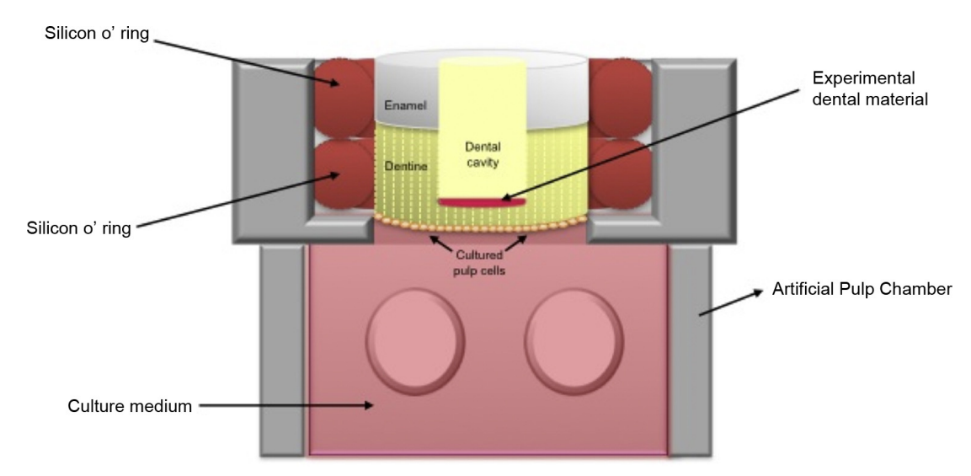

Schematic representation of an artificial pulp chamber.

For these tests, undifferentiated pulp cells, primary cultures of human pulp cells or undifferentiated cells from human pulp have also been used, which may more safely indicate the possible effects of the tested materials.

It should also be pointed out that a large portion of the in vitro cytotoxicity/biocompatibility studies have been developed with the use of monolayer cell culture models. However, the 3D culture models, in which cells are cultivated in specific types of collagen matrix (scaffolds), appear to provide more favourable conditions for the morphological and phenotypical expression of the cells, and this experimental model may also be used for the direct and indirect evaluation of the biologic effects of new dental materials and techniques.66

When considering cytotoxicity tests, the most widely used methods are those that determine cell viability, particularly by means of analysing the mitochondrial activity of the cells exposed to the materials and/or their isolated components. Another parameter that may also be evaluated is the production of reactive oxygen species, which is directly related to the induction of cell lesion, and may be detected by means of fluorescent probes.67

In addition to quantitative tests, the effects of dental material on cell cultures may also be evaluated in a qualitative manner, such as in complementary analyses of cells by scanning electron microscopy.68

**2) IN VIVO STUDIES (IN ANIMALS)**

The use of animals for research is a controversial subject and has been the target of broad discussions, mainly of an ethical nature. Nevertheless, these studies may provide more relevant scientific data than those observed in vitro and enable the evaluation of important parameters, such as the interaction of the material with blood, chronic inflammatory responses and bone regeneration.69

The tests attempt to reproduce, in the best possible manner, the conditions found in clinical reality, such as size, dosage, method of application, presence of physical barriers, such as dentin and/or dentin/enamel, as well as the composition and manipulation of the materials.

Another difficulty found with regard to the use of animals for research is in determining adequate control groups that favour interpretation of the results, with the lowest possible number of biases. In addition, statistical analysis of the responses characterizes a great challenge, since there may be problems with respect to the correct definition of independent variables.

**3) CLINICAL STUDIES**

Clinical studies are characterized by the application of the experimental materials in human volunteers and are considered the “gold standard” for the evaluation of properties and performance of dental materials. These types of studies may present various experimental protocols that vary as regards cost and the difficulty of conducting them.70

The large majority of clinical studies have sought to evaluate the mechanical properties of materials, so that biocompatibility would not be their main focus. In general, clinical studies are more expensive, take longer, are more difficult to control and interpret the results, particularly when compared with researches developed in animals and in vitro tests. In addition, these studies using human beings face strong ethical barriers.71

Among the different types of clinical studies, there are retrospective, cross-sectional and prospective studies. Longitudinal or prospective studies are more representative with regard to determination of the biological performance of a material, and there are strategies that can be used to increase their reliability, such as blinding, randomization, placebo groups and strategies to minimize biases.72 After treatment, the patients are followed-up over the course of time, which allows data collection. Nevertheless, in general, these types of studies are expensive, require a long period for their finalization and may be influenced by the operator’s skill, which may be far above or below the clinical average.

**STANDARDIZATION**

In an effort to make the testing of dental materials for biocompatibility more uniform within individual countries and around the world, Standard Development Groups within several organizations have issued documents specifying or recommending the testing that should be performed to determine the suitability of new and existing materials in the oral and maxillofacial environment.73 In addition to the standard documents specific to dental materials, an additional ISO standard 74 and its related standards are referenced in the standard for dental materials; another similar document that has applicability to all types of medical materials, including dental materials, is available.75 Many issues are related to the selection of appropriate test methodology, among them the anticipated site of implantation or use, the types of tissues with which the material is in contact with, and the duration of tissue exposure to the material or its associated by-products. Each of the referenced testing standards categorizes materials according to the type of tissue contact and site of contact. All standards but the American Dental Association document also separate testing requirements by duration of contact. In case of American Dental Association practice, the types of dental materials are specifically called out and the duration of exposure is inherent in the description.

**RESTORATIVE MATERIALS**

**DENTAL AMALGAM**

**HISTORY**

Mercury, one of the key ingredients of dental amalgam, was first described by Aristotle in the 4th century B.C. as “liquid silver.” Five centuries later, Dioscorides, a Greek physician, used it as an eye medicine, but warned it was dangerous if swallowed. Amalgam had appeared in Chinese medicine of Su Kung back in 659 AD, during the Tang Dynasty. In Europe, Johannes Stockerus, a municipal physician in Ulm, Germany, recommended amalgam as a filling material in 1528.76

In 1805, W.H. Pepys and Joseph Fox of England first introduced “fusible metals” for filling cavities; however, the heat required to melt the material was obviously objectionable. In 1818, Louis Nicolas Regnart, a Parisian physician who devoted himself to dentistry, overcame this problem by the addition of one-tenth by weight of mercury; and, in this manner, amalgam (an alloy of mercury with another metal or metals, derived from the French word amalgame, which was reportedly derived from the Latin malagma, meaning a “soft mass”) was invented.

In 1837, J.L. Murphy of London stated he had used amalgam for 12 years.77

The so-called “Amalgam War” raged from 1840 to 1855, “broke up friendships and, even threatened to disrupt the profession.” Various doctors reported that all filling materials, in which mercury was an ingredient, were hurtful both to the teeth and every part of the mouth.

In 1844, Parmly of New York stated that “gold is the only substance known, that can be permanently relied upon.” Even in 1844, some dentists advocated removing amalgam fillings and replacing them with gold.

In 1861, J. Foster Flagg presented his findings to the Pennsylvania Association of Dental Surgeons. In 1881, he published his book, Plastic and Plastic Fillings as amalgam fillings were then popularly referred to as “plastic fillings.” The inevitable result of this affair was that silver amalgam was proven to be “an excellent filling material” and expanded dentistry’s “ability to save teeth.”77

 At the Brooklyn Dental Association’s meeting in October 1864, it was recorded: “Some men’s amalgam is good universally, and some men’s gold is bad universally; the difference lies in the preparation of the tooth and in the plug (filling)”; however, the manner of preparation and use of the material was condemned in unqualified terms. Many amalgam failures were blamed on them having been “put in over the decay.”78

In the late 1870s, a new trend called the “new departure” came into popularity, which signified “total abstinence from the use of gold.” The “new departure” considered gold the “worst material” and amalgam an “excellent filling material.”

In August 1871, at the 11th annual meeting of the American Dental Association held at Niagara Falls, Dr. E.A. Bogue gave a report on operative dentistry, which discussed the expansion and contraction of amalgam.

In 1895, Dr. Greene V. Black laid the foundation for a “scientifically balanced alloy.” His formula of silver and tin would “neither shrink nor expand in setting” at ordinary room temperature, and did not discolor. He also found that copper (as much as 5 percent) was beneficial.

 In 1908, Dr. E. Bumgardner of Lawrence, Kan., in a paper before the Kansas State Dental Association, stated, “I think that amalgam is the best filling material in the world for the place in which it should be put: In a cavity that is properly selected and properly prepared, when the amalgam is properly mixed with a proper alloy, and properly inserted, you have the best filling material in the world.”79

In 1959, Dr. Wilmer Eames recommended a 1:1 ratio of mercury to alloy, thus lowering the 8:5 ratio of mercury to alloy that others had been recommending.80 In 1962, a spherical particle dental alloy was introduced.81 This was followed in 1963 by a high copper dispersion alloy system that proved to be superior to its low copper predecessors.82 Although this performance was theorized to be the result of dispersion strengthening of the alloy, researchers discovered that the additional copper combined with the tin, creating a copper–tin phase that was less susceptible to corrosion than the tin–mercury (gamma-2) phase found in low copper alloys.82,83

Introduction of new atomization process in the manufacture of dental amalgams led to a dramatic improvement in the quality and ease of manipulation with this material. This process involves spraying of the molten alloy into a chamber containing an inert gas by a patented atomization process.84 The molten metal forms droplets which solidify. These spheres are then subjected to some heat treatment. Thus, spherical particles are formed.85

**COMPOSITION OF ALLOYS**

Dental amalgam alloys are usually provided as

(1) Irregularly shaped particles produced by milling or lathe-cutting a cast ingot of the amalgam alloy

(2) Spherical particles produced by atomizing the liquid alloy in a chamber filled with inert gas

(3) As a mixture of both lathe-cut and spherical particles (Admixed)

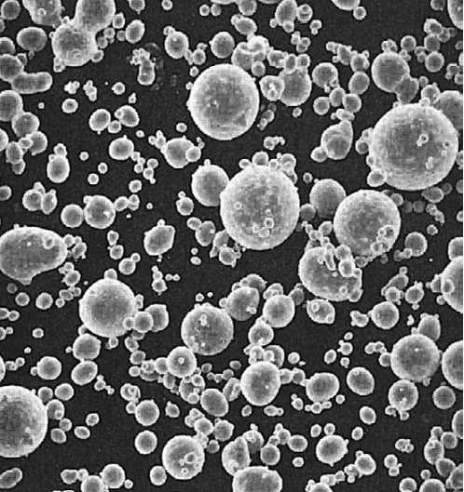 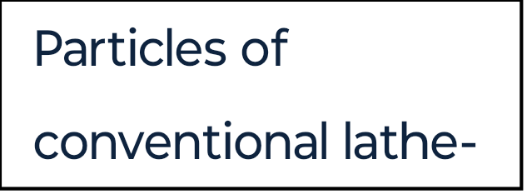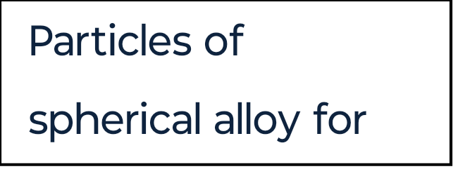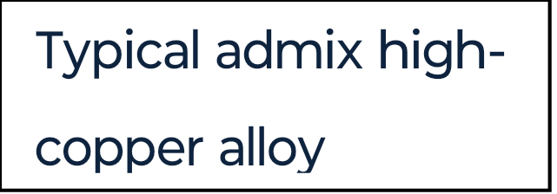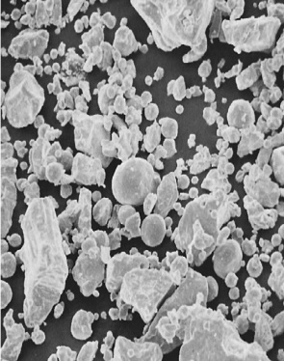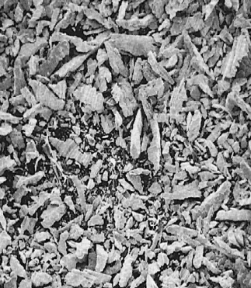

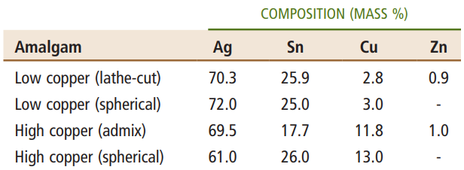

LOW-COPPER ALLOYS

Silver-tin alloys are quite brittle and difficult to blend uniformly unless a small amount of copper is substituted for silver. Within the limited range of copper solubility, an increased copper content hardens and strengthens the silver tin alloy. The chief function of zinc in an amalgam alloy is to act as a deoxidizer, which is an oxygen scavenger that minimizes the formation of oxides of other elements in the amalgam alloys during melting. Alloys without zinc are more brittle, and their amalgams tend to be less plastic during condensation and carving. The American Dental Association (ADA) Specification No. 1 for amalgam alloys allows some mercury in the alloy powder. The ranges of conventional alloy composition by weight in the early 1980s were 66.7% to 71.5% silver, 24.3% to 27.6% tin, 1.2% to 5.5% copper, 0% to 1.5% zinc, and 0% to 4.7% mercury. The structure of these conventional alloys was dominated by Ag3Sn (γ phase) with some Cu3Sn (ε phase).

HIGH-COPPER ALLOYS

The first high-copper alloy was formulated by mixing one part of silver-copper, spherical eutectic (Ag-Cu; 71.9% silver and 28.1% copper by weight) particles to two parts of Ag3Sn, provided as lathe-cut particles. This modification raises the copper content to 11.8% by weight. This is often called “dispersed-phase alloy” or “admixed high-copper alloy.” A second type of high-copper alloy was made by melting all components of the dispersed phase alloy. This process yields a single composition system. The presence of the higher copper content makes mechanical cutting of ingots into particles difficult. Thus, they are often provided in a spherical form that is produced by an atomization process. The copper content of this group of alloys can be as high as 30% by weight. Various amounts of indium or palladium have been included in some commercial systems.

THE SILVER-TIN SYSTEM

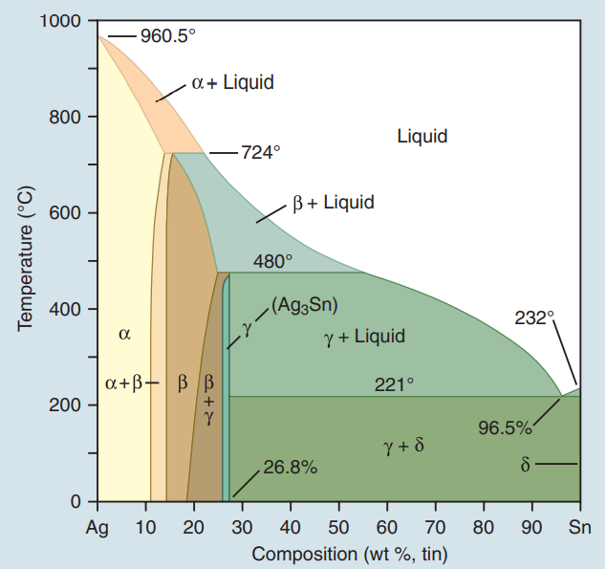

It is an equilibrium-phase diagram of the silver-tin alloy system. Conventionally, starting from the left of the phase diagram, each phase is designated with a Greek letter in alphabetical order from 0% Sn to 100% Sn. The ratio of silver to tin shows that amalgam alloys have a narrow range of compositions, falling within the β (Ag-Sn) + γ (Ag3Sn) and the γ phases.

GALLIUM-BASED ALLOYS

In an attempt to eliminate mercury from direct metallic restorative materials, gallium, which is also a liquid when alloyed with indium and tin at room temperature, has been considered as a substitute. Like mercury, this metal element can be triturated with alloys for high-copper amalgam.

POWDER CONFIGURATION

Dental amalgams are made by mixing alloy powders with mercury.

LATHE-CUT POWDER

To produce this powder, the cast ingot is first annealed to retain a uniform phase and then it is placed in a milling machine or in a lathe to be fragmented by a cutting tool or bit. The powders obtained from cutting are acid-washed to produce a more reactive surface. Since the stresses induced into the particle during cutting are not uniform and can slowly be self-relieved over time, they will cause the performance of the amalgam to be inconsistent.

ATOMIZED POWDER

The liquid metal is atomized into fine spherical droplets of metal in a chamber of inert gas. If the droplets solidify before hitting a surface, the spherical shape is preserved as spherical powders. Like the lathe-cut powders, spherical powders are given an annealing heat treatment and surface washing.

LATHE-CUT POWDER VERSUS SPHERICAL POWDER

Amalgams made from lathe-cut powders or admixed powders tend to resist condensation better than amalgams made entirely from spherical powders. Since freshly triturated amalgams from spherical powders are very plastic, one cannot rely on the pressure of condensation to establish a proximal contour for a class II restoration. Spherical alloys require less mercury than typical lathe-cut alloys because spherical alloy powder has a smaller surface area per volume ratio than does the lathe-cut powder.

**AMALGAMATION**

It is the process of mixing liquid mercury with one or more metals or alloys to form an amalgam.

**LOW-COPPER ALLOYS**

The low-copper alloy is usually mixed with mercury in a ratio of about 1 : 1. There is an insufficient amount of mercury to consume the original alloy particles completely; consequently, unconsumed particles are present in the set amalgam. Thus, a typical low-copper amalgam is a composite in which the unconsumed particles are embedded within γ1 and γ2 phases.

The main reactions of low-copper alloy produce alloy phases including the body-centered cubic Ag2Hg3 (γ1) phase and the hexagonal Sn7-8Hg (γ2) phase. There is evidence from x-ray diffraction and thermal analyses of set amalgam that a δ phase, which is richer in mercury than γ2, is present in low-copper alloy instead of γ2.

The physical properties of the hardened amalgam depend on the relative percentages of each of the microstructural phases. The greater the number of unconsumed Ag-Sn particles retained in the final structure, the stronger the amalgam will be. The γ2 phase is the weakest and least stable in a corrosive environment and may suffer corrosion attack especially in crevices of the restorations. A reaction between Cu3Sn (ε phase) and γ2 also occurs and yields Cu6Sn5 (η′ phase). Because of the low copper content, a majority of γ2 remains.



**HIGH-COPPER ALLOYS**

Two different types of high-copper alloy powders are available. The first is a two-phase admixed powder and the second is a single-composition single-phase powder. Both types contain more than 6% of copper by weight.

**ADMIXED ALLOYS**

When mercury reacts with an admixed powder, silver in Ag-Cu spheres and silver and tin from Ag-Sn particles dissolve into the mercury. Whereas both γ1 and γ2 crystals form, as in lathe-cut alloys, the tin in mercury diffuses to the surfaces of the Ag-Cu alloy particles and reacts with the copper to form a layer of η′ phase crystals on the surface. The η′ layer on the surface of Ag-Cu alloy particles also contains γ1 crystals, since γ1 and η′ phases form simultaneously. As in the low-copper amalgams, γ1 is the matrix phase (i.e., the phase that binds the unconsumed alloy particles together). In this reaction, the γ2 phase does form along with the η′ phase but later reacts with copper from Ag-Cu particles, yielding additional η′ phase. The γ2 phase can be eliminated with at least 11.8% of copper by weight in the alloy powder.

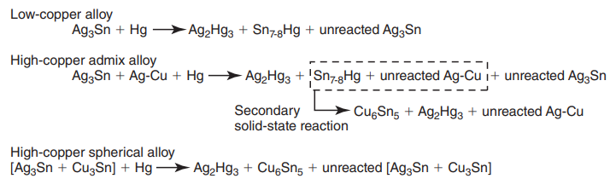

**SINGLE-COMPOSITION ALLOYS**

The major components of single-composition particles are usually silver, copper, and tin. The copper content of various single-composition alloys ranges from 13% to 30% by weight. In addition, small amounts of indium or palladium are included in some of the single-composition alloys. A number of phases are found in each single-composition alloy particle, including the β phase (Ag-Sn), γ phase (Ag3Sn), and ε phase (Cu3Sn). Some of the alloys may also contain some η′ phase.

When triturated with mercury, silver and tin from the Ag-Sn phases dissolve in mercury. Very little copper dissolves in mercury. The γ1 crystals grow, forming a matrix that binds together the partially dissolved alloy particles. The η′ crystals are found as meshes of rodlike crystals at the surfaces of alloy particles, dispersed in the matrix.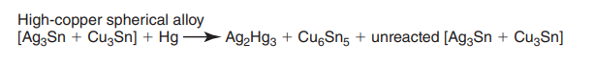

**DEVELOPMENTS IN CAVITY DESIGN**

Traditionally, Black’s original preparation design called for extravagant extension with the intention of preventing recurrent caries. Overtime, improvements in knowledge have supported the more conservative cavity preparations. Some authors advocate extending the preparations into fissures, whether carious or not. Smaller burs can be used to create preparations that involve the removal of only diseased and weakened enamel and dentin, and with the use of fissure sealants sound tooth can be preserved. A small diameter bur can be used to slightly open the fissures to be sealed to ensure access to sound enamel for etching and flow of a liquid resin to provide seal. Many studies have shown that smaller restorations last long.86,87 Osborne and Gale evaluated 196 amalgam restorations 13–14 years after insertion. They found that cavity width was the single most significant factor for clinical survival. The wider restorations showed greater marginal fracture and a higher rate of replacement than narrow restorations. Other benefits associated with the success of smaller preparations include reduced occlusal stress on the margins and preservation of tooth strength.

**MODIFICATIONS IN AMALGAM**

**1) RESIN COATED AMALGAM**

To overcome the limitation of microleakage with amalgams, a coating of unfilled resin over the restoration margins and the adjacent enamel, after etching the enamel, has been tried. Although the resin may eventually wear away, it delays microleakage until corrosion products begin to fill the tooth restoration interface. Mertz-fairhurst and others evaluated bonded and sealed composite restorations placed directly over frank cavitated lesions extending into dentin versus sealed conservative amalgam restorations and conventional unsealed amalgam restorations. The results indicate that both types of sealed restorations exhibited superior clinical performance and longevity compared with unsealed amalgam restorations over a period of 10 years.88

**2) FLUORIDATED AMALGAM**

Fluoride, being cariostatic, has been included in amalgam to deal with the problem of recurrent caries associated with amalgam restorations. The problem with this method is that the fluoride is not delivered long enough to provide maximum benefit. Several studies investigated fluoride levels released from amalgam. These studies concluded that a fluoride containing amalgam may release fluoride for several weeks after insertion of the material in mouth. As an increase of up to 10–20 fold in the fluoride content of whole saliva could be measured, the fluoride release from this amalgam seems to be considerable during the first week. An anticariogenic action of fluoride amalgam could be explained by its ability to deposit fluoride in the hard tissues around the fillings and to increase the fluoride content of plaque and saliva, subsequently affecting remineralization. In this way, fluoride from amalgam could have a favourable effect not only on caries around the filling but on any initial enamel demineralization. The fluoride amalgam thus serves as a "slow-release device".89

**3) BONDED AMALGAM**

Conventional amalgam has the provision for adequate resistance and retention form and may require removal of healthy tooth structure. Further, since amalgam does not bond to tooth structure, microleakage immediately after insertion is inevitable. So, to overcome these disadvantages of amalgam, adhesive systems that reliably bond to enamel and dentin have been introduced. Amalgam bond is based on a dentinal bonding system developed in Japan by Nakabayashi and co-workers.90 The bond strengths recorded in studies have varied, approximately 12–15 MPa, and seem to be routinely achievable. Using a spherical amalgam in one study of bonded amalgam, Summitt and colleagues reported mean bond strength of 27 MPa. The authors believed that this higher bond strength was achieved because the bonding material was refrigerated until immediately before its use. Bond strengths achieved with admixed alloys tend to be slightly lower than those with spherical alloys. One study compared post-insertion sensitivity of teeth with bonded amalgams to that of teeth with pin-retained amalgams. After 6 months, teeth with bonded amalgams were less sensitive than teeth with pin-retained amalgams. This difference in sensitivity was not present 1 year after insertion. This is possibly because of corrosion products in nonbonded amalgam restorations filling the interface, and thus, decreasing microleakage and sensitivity.91

**4) CONSOLIDATED SILVER ALLOY SYSTEM**

One amalgam substitute being tested is a consolidated silver alloy system developed at the National Institute of Standards and Technology. It uses a fluoroboric acid solution to keep the surface of the silver alloy particles clean. The alloy, in a spherical form, is condensed into a prepared cavity in a manner similar to that for placing compacted gold. One problem associated with the insertion of this material is that the alloy strain hardens, so it is difficult to compact it adequately to eliminate internal voids and to achieve good adaptation to the cavity without using excessive force.92

**5) GALLIUM – AN ALTERNATIVE TO AMALGAM**

Several times since the introduction of amalgam restorations in USA in the 19th century, the public has expressed concerns about the use of mercury in dental amalgam. However, an effective alternative to amalgam has not been identified. As early as 1956, Smith and Caul and Smith and co-workersclaimed that a gallium-based alloy could serve as a possible alternative to dental amalgam. They found that mixing gallium with either nickel or copper and tin produced a pliable mass that could be condensed into a prepared cavity, which, after setting, had physical properties suitable for a restorative material.

**FUTURE OF DENTAL AMALGAM**

The prediction that amalgam would not last until the end of the 20th century was wrong. Its unesthetic appearance, its inability to bond tooth, concerns about the mercury and versatility of other materials have not led to the elimination of this inexpensive and durable material. As other materials and techniques improve, the use of amalgam will likely continue to diminish, and it will eventually disappear from the scene. Amalgam will probably disappear eventually, but its disappearance will be brought about by a better and more esthetic material, rather than by concerns over health hazards. When it does disappear, it would have served dentistry and patients well for more than 200 years.

**AMALGAM HAZARDS**

For most of the 1970s and 1980s the major concern with amalgam was the hazard to dentists and office staff resulting from the inhalation of mercury vapor associated with the use of two to three pounds of mercury a year in the preparation and insertion of amalgam restorations. In offices placing great numbers of restorations and practicing poor mercury hygiene, the urinary mercury levels of office personnel were elevated significantly.

Despite this modest contribution to the body burden of mercury, a whole range of untoward effects have been attributed to the mercury vapor released from amalgam restorations. Major concerns have been:

* Neurotoxicity—not only the classic problems associated in the past with occupational hazards, but also an involvement in the cause of multiple sclerosis
* Kidney dysfunction
* Reduced immunocompetence resulting in varied disorders
* Increased stillbirths and birth defects

**MERCURY POISONING FROM DENTAL AMALGAM**

For various reasons the hazards of amalgam have been disregarded for at least 50 years, resulting in insufficient information about its dangers and an unsatisfactory development of alternative filling materials. The dangers of insidious mercury intoxication from amalgam are known at least since the 1920s, but after more than half a century the problem seems more to the fore than ever. Voices have often been raised, warning that silver amalgam is not harmless and describing symptoms of poisoning. In spite of this, the amalgam situation in the mouth is seldom considered in medical practice.

**SYMPTOMS OF THE AMALGAM SYNDROME**

* Irregular heartbeat, often together with anxiety
* Strong pains in the left part of the chest
* Retinal bleeding
* Dim vision, especially after exercise; slow and poor accommodation Inability to fix the gaze, uncontrollable eye movements.
* Eyes drawing to one side Geometric figures in the visual field, migrating in a few minutes from the periphery towards the centre and slowly disappearing A "film" over the eyes, dry eyes
* Arcus senilis: a grey ring around the cornea (permanent)
* Red, irritated throat; inflammation in upper airways and pleurisy a year after the dental treatment
* Difficulties in swallowing
* Severe amnesia
* Constant strain
* Anxiety
* Irritability
* Difficulty and even impossibility to control behaviour
* Indecision
* Loss of interest in life
* Tiredness
* A feeling of being old Resistance to intellectual work
* Reduced capacity for work, both intellectual and physical
* Reduced powers of comprehension, information does not come through.
* Increased need for sleep Vertigo Headache (about once a week), often migraine-like, especially induced by weather changes and by prolonged sleep in the mornings.
* Facial paralysis, right side and partly permanent.
* Damage to balance and hearing
* A painful pull at the lower jaw towards the collar bone
* Increased salivation
* Sour-metallic taste
* Bleeding gums at toothbrushing
* Joint pains
* Pains in the lower back Weakness of muscles
* Slow muscle action Pressure, pains
* "Needles" in the liver region
* Asthmatic breathing troubles, a feeling of not being able to breathe
* "Cracking" in the lower part of the pleural sac, forcing to cough Gastrointestinal irritation
* "Needles" at lymph nodes under arms and in groin Eczema

**DENTAL CEMENTS**

Cements are used in dental practice primarily for retaining or sealing restorations and prosthetic devices in a fixed position within the mouth. They are also used for a variety of special-purpose applications in dentistry e.g. cavity lining, direct restorations, and orthodontic, periodontic and surgical procedures. Traditionally, cements are formed by an acid–base reaction in which an acidic component (typically a liquid) is mixed with a basic component (typically a powder). The search for better materials has inspired many chemical developments to meet the ever-changing needs of the dental practitioner and, coupled with innovations in delivery devices, has made the cementation procedures faster, easier and more predictable. Functionally these cements must with stand masticatory stresses and maintain their integrity in the oral environment.

**GENERAL REQUIREMENTS OF DENTAL CEMENTS**

An ideal luting cement should have physicomechanical properties resembling those of dentine. However, the cements available today have a wide range of properties depending on their composition and hence are restricted in their use to specific indications (Donovan and Cho, 1999).

**ZINC PHOSPHATE CEMENTS**

Zinc phosphate cement has been a mainstay in dentistry for crown and bridge applications for well over a century and has undergone many refinements in formulation and compounding.

Roastaing’s patents and Rollins’s article93, published in the late 19th century, are the first documents that provide formulations in which zinc oxide is reacted with phosphoric acid to produce dental cements. The purpose behind much of the following research was to find ways to retard the vigorous reaction between these components so that practical cements could be developed. This was accomplished by the calcining of zinc oxide and partially neutralizing phosphoric acid with zinc and/or aluminum hydroxide. Combination of these two methods yielded good dental cements94 that allowed dentists sufficient time to mix and apply them. The resulting phases in these cements were crystalline. The major phases depended on the time of curing and the presence of water during curing. These phases were also influenced by other components, such as aluminum oxide, in the mixture. However, in simple systems of zinc oxide and phosphoric acid, investigations revealed that zinc hydrophosphates [Zn(H2PO4)2.2H2O and ZnHPO4.3H2O] are formed first and these partially soluble hydrophosphates are gradually converted to hopeite, Zn3(PO4)2.4H2O95, which is the ultimate form of the cement.

The role of aluminum in the zinc phosphate cements was considered very important. Aluminum oxide greatly moderated the reaction of zinc oxide and phosphoric acid, and this effect was attributed to the formation of an aluminum phosphate gelatinous coating on zinc oxide particles. In fact, Wilson and Nicholson96believe that the gelatinous substance may even be a zinc aluminophosphate phase, which subsequently crystallizes into hapetite and aluminophosphate amorphous gel (AlPO4.nH2O).

The final cement is an opaque solid that consists of excess zinc oxide coated and bonded possibly by aluminum phosphate and zinc phosphate gels. The cement is porous and permeable to dyes.96

Another major development in zinc phosphate cement is zinc silicophosphate97. Mixing aluminosilicate glass and zinc oxide and then reacting the mixture with phosphoric acid produced this cement. Its properties lie between those of zinc phosphate and silicate cements. For example, the compressive strength is 99–1681 MPa (14,300-24,400 psi), which is lower than that of silicate dental cement but higher than that of zinc phosphate cement. Fluorides are added to these cements, and hence their main advantage is the sustained release of fluorine, which is invaluable in dentistry98. After being absorbed by the tooth enamel, this fluorine protects the tooth from caries-producing debris and plaque.

**COMPOSITION**

The powder consists of mainly amorphous zinc oxide as the major ingredient with small amounts of oxides of magnesium and bismuth added mainly to facilitate the calcining process for manufacture of the powder. Small quantities of silica (typically fumed) are often added to aid in providing the right viscosity and yield stress. Minor amounts of barium and calcium compounds may be added by various manufacturers to provide a smooth, creamy mix, which is desirable for easy flow during cementation of the restoration. Some products also contain tannin fluoride although it is doubtful if the amount of fluoride released is of clinical significance. The liquid consists of an aqueous mixture of orthophosphoric acid with small amounts of aluminum and zinc phosphates which act as buffers in reducing the reactivity of the free acid. The amount of water used in the formulation is quite critical since it dictates the setting time – too little prolongs the setting time whereas too much shortens it.

**SOLUBILITY CHARACTERISTICS**

Like calcium oxide, zinc oxide readily forms zinc hydroxide in water. Thus the solubility of zinc hydroxide is more relevant with regard to the formation of zinc ceramics that are formed in aqueous solution.

Five different phases of zinc hydroxides have been identified99. Amorphous Zn(OH)2 is the most soluble species, while less soluble phases are denoted by Greek letters α, β, γ, δ, and ε with ε-Zn(OH)2 being the least soluble phase. The corresponding solubility equations may be derived from first principles.

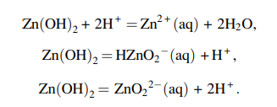

The solubility of Zn(OH)2 is in the most desirable range for the formation of ceramics. The solubility is not too high, like that of MgO and Ca(OH)2, and hence the ceramic is not too rapid setting, and at the same time it is not too low, like that of Al2O3, via which a ceramic could not be formed at room temperature. This feature may be why zinc phosphate was the first successful phosphate cement.

**FOMATION OF ZINC PHOSPHATE CERAMIC**

Zinc phosphate ceramics have been synthesized only in small sizes as dental cements, and no attempt has been made to cast large forms of these cements. In spite of this, the process of formation has been extensively studied, and properties have been optimized. The process of fabrication of zinc phosphate cements is very similar to that of magnesium phosphate ceramics. Direct reaction with phosphoric acid is vigorous and needs to be slowed down. This is done using the following methord.

**Neutralization of Phosphoric Acid**

Unlike magnesium oxide, zinc oxide is seldom used in its pure form. It is blended with MgO and often with Al2O3 to initiate some neutralization of phosphoric acid96. MgO will form its dihydrogen phosphate. Al2O3 will also form its hydrophosphate. This partial neutralization of the acid aids in reducing the strong reaction between the base ZnO and the acid. Typically, 3–10 wt% MgO and less than 1% Al2O3 are used.

**Precalcination**

As in the case of MgO, the powder is precalcined at temperatures of 1000-1350°C to reduce the surface area of the particles100. The surface area is reduced by partial elimination of the porosity of individual grains and by grain growth resulting from consolidation of the amorphous content. The presence of MgO and silica in zinc oxide promotes densification by forming a solid solution of ZnO with these oxides95.In addition to this densification, compounds of lower solubility formed by the solid solutions, such as zinc silicates, are likely to reduce the overall solubility of zinc oxide. In spite of the partial neutralization of the acid and the precalcination of the powder, the ceramic formation is extremely rapid. Accordingly, these cements gain half of their strength in the first 10 min and 80% within an hour .As a result, this product is most suitable for dental applications, where the dentist will produce slurry on a small scale within a few minutes, apply it to the patient, and expect its solidification within a reasonable waiting time. The reaction during the formation of these cements is highly exothermic. From the enthalpies of formation presented in the Appendices, the extent of energy evolution during the reaction,



is ΔH= -241.17 kJ/mol of the product formed. This energy is expended in a short time and may heat the slurry. Therefore the heat must be dissipated during ceramic formation. When a dentist prepares only a few grams of the sample the heat dissipates easily, but if one were to prepare large samples, in spite of the partial neutralization of the acid and precalcination of the powder, the heat is too much and boils the entire slurry. Thus, only small-sized zinc phosphate ceramics can be made.

**PHASE FORMATION IN ZINC PHOSPHATE CEMENTS AND THEIR MICROSTRUCTURE**

When zinc oxide is reacted with phosphoric acid, ZnO will form its hydroxide first, and then the acid-base reaction will go through several steps forming intermediate acid phosphates:



This step-by-step neutralization of ZnO is similar to other acid-base cements (and ceramics), such as MgO-containing cement. There is one difference between cement formation with MgO and ZnO. In the case of MgO, the reaction stops when monohydrogen phosphate (MgHPO4.3H2O, newberyite) is formed, while in the case of zinc phosphate cements, the ultimate phosphate product is a neutral orthophosphate, Zn3(PO4)2.4H2O (hopeite)96. The reason for this difference is the higher solubility of ZnHPO4 as compared to that of newberyite. The solubility is 9.93 g/l for ZnHPO4 and 0.0026 g/l for MgHPO4. Because of its much greater solubility, ZnHPO4 will dissolve during curing and form hoepite after its reaction with excess ZnO. On the other hand, the less soluble MgHPO4 will remain as the final phase in the ceramic.

Like the Mg-phosphate cements, all ZnO will not react and form its phosphate. The reaction with phosphoric acid and subsequently the acid phosphates (such as Zn(H2PO4)2 and ZnHPO4) occurs only on the surface of individual grains, while the core of the grains, at least for large grains, remains unreacted and acts as the nucleus for the phosphate crystallite growth. Initially, the grains are bonded by the amorphous phosphate gel, which consists of hydrophosphates of zinc and aluminum. Over a long curing time, these amorphous phases may further react with ZnO and form ultimate phases or crystallize. Thus, like other phosphate-bonded ceramics and cements, zinc phosphate cement may also be considered as a two-phase material, containing randomly distributed unreacted ZnO that is bonded by either amorphous or crystalline phosphate phases or by both.

**MECHANISM OF ACTION**

**Setting reaction**

When the alkaline zinc oxide powder is incorporated in the acidic liquid an exothermic acid–base reaction ensues. Initially, the mix becomes fluid and creamy which aids in the placement of the prosthodontic device. Within a few minutes the mass hardens to a set cement which may contain varying amounts of crystalline phosphates of zinc including the formation of hopeite, Zn3(PO4)2·4H2O, in the presence of excess moisture.

**MANIPULATION**

The proper proportioning of the powder and liquid components and the mixing technique are critical to ensuring adequate clinical success with these materials. The proper amount of powder should be slowly incorporated in incremental amounts into the liquid on a cool slab (at approximately 21 °C) since the mixing temperature has a profound influence on the setting characteristics. Aggressive mixing results in too high an exotherm for this class of technique-sensitive material. Spreading the mix over a large area on the cool glass slab helps to dissipate the heat. The liquid is rather hygroscopic, absorbing water if exposed to excessive humidity, and losing water if kept in a dry atmosphere or if the vial is not kept properly sealed.

**PROPERTIES**

Wilson and Nicholson96 have provided a thorough discussion on the properties of commercial zinc phosphate cements that contain either magnesium oxide or aluminum oxide. The compressive and tensile strengths of cements are in the range 69–127 MPa (10,000-18,500 psi) and 4.1-8.3 MPa (600–1200 psi) respectively. These strengths are several times higher compared to the strengths of ordinary Portland cement (OPC), which has corresponding strengths of 28 MPa (4000 psi) and 1 MPa (140 psi) respectively. Unlike magnesium phosphate cements that take a long time to attain full strength, these cements attain their full strength within 24 h. This rapid gain of ultimate strength is due to the higher solubility of the intermediate product, ZnHPO4.3H2O. Such a rapid gain of strength does not occur in magnesium phosphate cements because of the insolubility of the intermediate product, MgHPO4.3H2O. The ultimate compressive strength of zinc phosphate cements is higher than that of magnesium phosphate cements. This difference may not be because magnesium phosphate cements are weaker than zinc phosphate cements, but it may be a size effect. Zinc phosphate samples are cast in a very small size as dental cements, while magnesium phosphate cements are used on a bulk scale. Because large ceramics and cement casts tend to have more flaws, their strength is expected to be lower.

The clinically significant properties of zinc phosphate cements include setting time, solubility and film thickness. The mechanical properties of importance are strength, modulus of elasticity and hardness. Most commercial materials meet the American National Standards Institute/American Dental Association (ANSI/ADA) Specification 96 (ISO 9917-1: 2003). In comparison with the more recent types of cements, the modulus of elasticity is quite high, which causes them to be rather brittle materials that are prone to fracture. The solubility of the set cement is relatively high at about 0.2% in 24 h compared with some other classes of cements. Furthermore, these materials have virtually no adhesion to the dentinal core of the tooth preparation.

**CLINICAL USAGE**

Zinc phosphate cements have had a long history of clinical usage for routine luting of metal-supported crowns and bridges (Donovan and Cho, 1999). Other uses include cementation of orthodontic bands, as a basing material and as temporary restorations. Occasional post-operative sensitivity has been reported by patients with the use of this type of cement (Johnson et al., 1993). The exact cause of this is not known and has been linked to acidity of the un-neutralized orthophosphoric acid residues in the cement and/or the movement of dentinal fluid across the tubules in excessively desiccated dentine due to an improper seal. The use of resin desensitizing agents has been advocated to counter post-operative sensitivity without compromising crown retention (Swift et al., 1997; Johnson et al., 2004).

**COPPER PHOSPHATE CEMENT**

Copper-containing cements can be dated back to the literature from the early 1900s. There are basically two types of copper cements, one in which copper salts are added to the zinc phosphate powder and the other, true copper phosphate cement developed by Ames, in which zinc oxide is replaced by approximately the same proportion of red (cuprous) or black (cupric) oxide. Depending on the type of copper cement, the concentration of copper varies between 2% and 97%. Copper cement was developed in lieu of the antimicrobial property of copper. However, its disadvantages were many such as being most irritating and destructive to the pulp and causing discoloration of the teeth. Moreover, copper was considered toxic to the cells. Copper cements were used as temporary restorative material in deciduous teeth and as an indirect pulp capping material over an active caries lesion.

**SILICOPHOSPHATE CEMENTS**

Silicophosphate cements are a combination of silicate and zinc phosphate cements in which zinc oxide is combined with aluminosilicate powder. The liquid is phosphoric acid. The addition of silicate glass makes this cement more translucent than zinc phosphate and also releases fluoride.

Their clinical use is similar to that of zinc phosphate cement. They have been used historically as a substitute restoration for amalgam and for luting prosthesis. However, very less information is available about their biological properties in the literature.

Their solubility is high, comparable to silicate cements. The cytotoxicity appears to be more severe than in zinc phosphate cements. The mechanical properties are inferior as compared to other cements. The use of silicophosphates is considered inappropriate for dental practice because much better alternatives are available now.

**ZINC POLYCARBOXYLATE CEMENTS**

Zinc polycarboxylate cements, sometimes referred to simply as ‘polycarboxylate’ or ‘polyacrylate’ cements, are based on the reaction of zinc oxide with polycarboxylic (same as polyalkenoic) acid in water (Smith, 1968). Like the zinc phosphate cements these are also supplied as powder–liquid compositions.

**COMPOSITION**

The powder is quite similar to that of zinc phosphate cements and consists mainly of sintered zinc oxide ground to a fi ne particle size. The sintering process reduces the reactivity of the amorphous zinc oxide and helps in the manipulation of the cement. Small amounts of magnesium oxide (1–5%) are added to aid the sintering process while the incorporation of fumed silica helps in the mixing and flow of the cement. Fluoride salts, eg. stannous fluoride, may also be incorporated in small amounts to improve mechanical strength and to serve as a source of leachable fluoride. In some commercial embodiments the powder is coated with 5–20% of anhydrous polyacrylic acid to make it less technique-sensitive during the mixing process.

The liquid consists of an aqueous solution of a polycarboxylic acid, generally a homopolymer of polyacrylic acid or a copolymer of acrylic acid with itaconic or maleic acids. The average molecular weight (weight average) is usually in the range 20 000–50 000. The viscosity of the solution may be controlled by the addition of small amounts of tartaric acid. For products where the powder is coated with polycarboxylic acid, the liquid is either a dilute solution of the polyacid or simply water.

**MECHANISM OF ACTION**

**SETTING REACTION**

The polycarboxylic acid reacts with the basic zinc oxide in a neutralization reaction forming a zinc polycarboxylate complex salt (Smith, 1983). This results in the formation of a cross-linked polycarboxylate hydrogel reinforced by the oxide particles. The cross-linked gel is bound to the polyanion chains by electrostatic interaction. The setting reaction has been studied by infrared spectroscopy which shows that the carboxylic acid groups (COOH) are progressively converted to carboxylate (COO− ) groups as the cement hardens.

Water plays several important roles in controlling the chemistry and properties of all acid–base cements. These are outlined below.

1. As a diffusion medium. Water is needed for the acids to ionize so that the protons can be dissociated and solvated and the acidic property can be manifested. It is also needed for the diffusion of the metallic ions of the bases (e.g. zinc oxide) so that these can enter the liquid phases and thus react with the acid. In addition, it is essential for the diffusion of fl uoride ions, where present, out of the set cement.
2. As a stabilizer of the carboxylate complexes. A portion of the water coordinates with the zinc carboxylate complexes by electron donation to stabilize them. This is known as bound water and cannot be easily removed from the stabilized matrix.
3. As a plasticizer. The residual water helps to plasticize the set cement and makes it more resilient and less prone to failure by fracture.

**MANIPULATION**

The vast majority of the commercial polycarboxylate cements are supplied with a bottle of powder, a measuring scoop and a vial dispenser containing the liquid. In one product (DurelonTM, 3M ESPE) the liquid is provided in a calibrated dispenser. It is recommended to dispense the liquid on a non-absorptive surface, e.g. glass or a waxed paper mixing pad so as to avoid loss of water and thickening of the liquid. The correct proportions of powder and liquid are generally hand-spatulated with a metal mixing spatula for a specified time (usually 30–45 s). The time from the start of mix to the end of manipulation is referred to as the ‘working time’, which is dependent on the ambient temperature, decreasing at higher temperatures. Although typical working times at 23 °C are 2–4 min, a longer window may not necessarily be advantageous since it also translates to a longer set time in the mouth (hence longer chair time). As with zinc phosphate cements, using a cooled glass slab extends the working time. The mix should be creamy and should be placed while it is still glossy and before the onset of the elastomeric phase, commonly referred to as ‘cobwebbing’. If the mix loses its gloss before placement, it should be discarded since adhesion will be compromised. At least one product is supplied in a predosed capsule format, which has to be activated and triturated before to placement. The mixed cement is viscous yet thixotropic, ie. it flows better under increasing pressure. Any excess cement should be removed before it reaches a rubbery consistency.

**PROPERTIES**

**SETTING AND WORKING TIME**

Setting and working time are two important clinically relevant parameters for any cement. The working time is the time available for the manipulation of the unset cement while the setting time is the time required by the material to set or harden from a fluid or plastic state to a rigid one. While at the end of the setting time the hardening reaction may not be complete it generally progresses far enough for the dentist to proceed to successive steps in the procedure without fear of premature dislodgement of the prosthesis. There is no standard value for the working time, but it should be reasonably long so that adequate time is available for mixing and placing the cement. Since both the working time and setting time are dependent on the same chemical reaction the former should not be too long to ensure the setting of the cement within a reasonable time.

The rate of setting is affected by the following parameters: • reactivity of the zinc oxide; • particle size of the zinc oxide;

• presence of additives;

• molecular weight and concentration of the polyacrylic acid;

• powder/liquid ratio.

The first four parameters are controlled by the manufacturer. The last one is dependent on the operator. Hence, accurate dispensing of the powder and liquid are essential if consistent setting is to be obtained. For commercial cements the working times are 2–4 min and set times are between 5 and 8 min.

**STRENGTH**

In general, zinc polycarboxylate cements are lower in compressive strength than zinc phosphates but, due to the presence of a polymeric matrix, are tougher and less brittle. Plastic deformation is exhibited at higher load values, which contributes to the increased toughness of these cements. Compressive and diametral tensile strengths of the cement develop rapidly within the first hour to about 60–80% of its strength at maturity, while it takes about 24 h for maximum strength to be attained.

**SOLUBILITY AND EROSION**

The solubility of the cements when tested in water alone is low (0.1–0.5%) compared with the zinc phosphate cements, although solubility in distilled water does not always correlate to solubility in oral conditions. These cements are rather susceptible to erosion in an acidic environment, however. A quantitative measure of this property is defi ned in the ISO 9917-1 specification using the impinging lactic acid jet method devised by Beech and Bandyopadhyay (1983).

**FILM THICKNESS**

These cements appear to be more viscous than other cements but due to their marked thixotropic nature flow well under seating pressure of a prosthetic device to yield acceptable film thickness as defi ned by specifications.

**ADHESION TO TOOTH STRUCTURE**

Polycarboxylate cements can bond to enamel and dentine by ionic bond formation with the calcium ions of the hydroxyapatite mineral. In order to achieve this, it is essential to have the prepared tooth surface free of debris and contaminants. Bond strength values as measured in the laboratory are dependent on the cohesive strength of the cement, particularly its modulus. Measured values are therefore low (enamel 3–13 MPa; dentine 2–4 MPa) compared with RMGIs and resin cements. However, it is debatable whether in vitro bond strength measurements are a true reflection of clinical performance. In actual usage, the service life of prostheses cemented with polycarboxylates is quite acceptable clinically.

**CLINICAL USAGE**

Zinc polycarboxylate cements have a fairly long record of clinical success when used for specified indications. The most frequent use is for cementation of cast alloy- and metal-supported inlays, onlays and single-unit crowns. Because of the lower values of compressive modulus these materials should not be used for permanent cementation of long-span bridges. Less frequently they are also used as cavity liners and orthodontic band cementation but in such cases a higher powder/liquid ratio is recommended by manufacturers. The comparatively high long-term solubility and low hardness limit the utility of this class of materials for permanent cementation, resulting in a decline in their use in recent times.

**CALCIUM HYDROXIDE-MODIFIED ZINC POLYCARBOXYLATE**

Adding calcium hydroxide to the cement matrix has a meaningful effect on setting time, compressive strength and pH value. The obtained results indicated that adding 5 wt.% calcium hydroxide, presented reasonable setting time, and significantly higher compressive strength when compared to zinc polycarboxylate cement. By less developed setting reaction at the “setting time”, more ionic salt-bridge and covalent crosslinking predicted to form which was expected to enhance mechanical properties. The experiments provided data to support the use of the composite cements in dental applications.101

**AMINO ACID MODIFIED ZINC POLYCARBOXYLATES**

Novel amino acid modified hybrid zinc/calcium polycarboxylate cements have been developed. This system exhibited significantly higher mechanical strengths, as compared to commercial zinc polycarboxylate cement. Among the amino acid derivatives investigated, methacryloyl beta-alanine was considered to be the most promising candidate for further evaluation. Effects of polymer content, P/L ratio, tartaric acid, initiator concentration and activator concentration were significant. It was found that an appropriate ratio balance between these parameters is very important. Aging study shows that the experimental cement showed a constant increase in mechanical strength for up to 1 month and then kept constant, which is of great clinical importance.102

There were three main liquid components in its composition: resin modified polyacid, amino acid derivative and water. It is impossible if any either of them is missing. Modified polymer provides main mechanical strength; amino acid derivative is not only a comonomer but also acts to enhance compatibility to bring the resin modified polyacid into water, since the modified polyacid is not very water soluble.103

**THE EFFECT OF ULTRASOUND ON THE SETTING REACTION OF ZINC POLYCARBOXYLATE CEMENTS**

The effect of ultrasonic radiation in enhancing chemical reactions has been widely reported for the last 70 years. The enhancement is produced in liquid or solid/liquid systems. Micro cavitation occurs in the liquid and the collapse of these microscopic ‘‘bubbles’’ produces very high temperatures (2,000 to 4,600 K)104 but these are extremely localised. The effects of these are to produce actions such rupture of covalent bonds in molecules that are stable at ‘‘bulk’’ temperature of the system.

This effect of ultrasound on the setting of ZPC can allow it to be used as a root end filling material, where it will accelerate the setting and improve the adaptation and sealing. Furthermore, since ultrasound will promote ‘‘command setting’’, ZPC could be used for bonding orthodontic brackets.

Ultrasound may provide a useful adjunct to the clinical use of ZPC both as luting agent and temporary restorative. The greater sensitivity of ZPCs to ultrasound as compared to GICs appears to be related to greater particle size reduction resulting in greater surface area for reaction accompanying the application of ultrasound.105

**ZINC OXIDE EUGENOL**

Zinc oxide eugenol (ZOE) cement dates back to the year 1858, when it was introduced as a cement that was very easy to handle and manipulate even in the presence of moisture and well tolerated by the pulp. Accelerators and other agents were later added to provide the ZOE cement that is still being used today.

**COMPOSITION**

Powder

* Zinc oxide: 69%
* Rosin: 29% (to reduce brittleness)
* Zinc acetate: 0.7% (accelerator)
* Zinc stearate: 1% (plasticizer)

Liquid

Mainly eugenol with some olive oil as a

plasticizer.

Eugenol, an organic liquid, is a chemical essence

of oil of cloves. It is a weak acid. It is a phenol

derivative and is an obtundent (relieves pain).

**SETTING REACTION**

Zinc oxide reacts with eugenol to form an amorphous mix of zinc eugenolate. In this chelation reaction, two molecules of eugenol (HE) react with ZnO to form eugenolate (ZnE2). Water acts as an accelerator. T is autocatalytic reaction can be presented as follows:

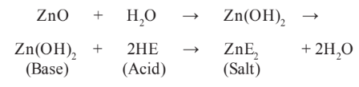

The set cement consists of a matrix of zinc eugenolate that binds the unreacted zinc oxide particles together. On hydrolysis, zinc oxide forms zinc hydroxide. T is will react with the acid eugenol to form eugenolate, with water being released. Here, water is required for initiation of the reaction and is also a byproduct of the reaction. Hence, this type of reaction is known to be autocatalytic. It can also be concluded that this reaction proceeds much faster in a humid environment and increased temperature.

### 

**CLINICAL APPLICATIONS**

1. As long-term and short-term luting agents

2. As temporary and intermediate restorations

3. As root canal sealers, e.g., Grossman’s or Ricket’s sealers

4. Surgical packs

5. Impression pastes

**AVAILABLE SYSTEMS**

Commercially available as P/L or pastes (two tubes or single container).

Some commercially available ZOE cements include Tempbond (Kerr) and TempoSIL(Coltene/Whaledent).

**TYPES**

(Modifi ed from ANSI/ADA specifi cation no. 30 for ZOE and zinc oxide noneugenol

cements)

• Type I: For temporary cementation

– Class 1: Powder–liquid

– Class 2a: Paste–paste (eugenol)

– Class 2b: Paste–paste (noneugenol)

– Class 3: Paste–paste (nonsetting)

• Type II: For long-term cementation

– Class 1: Powder–liquid, e.g., Super EBA, intermediate restorative material (IRM)

• Type III: Temporary fi lling materials and bases

– Class 1: Powder–liquid

– Class 2: Paste– paste

• Type IV: Cavity liners

– Class 1: Powder–liquid

– Class 2: Paste– paste

**MANIPULATION**

**Powder-Liquid Type**

Powder is measured and dispensed with a scoop. T e liquid is dispensed as drops. A glass slab and cement spatula are used for mixing. T e mixing process first incorporates large increments and then smaller increments until the desired consistency is obtained.

**Luting Consistency**

The consistency for luting is such that the cement pulls out into a string when the flat surface of the spatula is lifted/ raised from the mixed material. ADA specification states that the film thickness for ZOE temporary cements should be no more than 40 mm, while for permanent cementation it should be less than 25 mm.

**Temporary Restoration Consistency**

The mixing is done with a high P/L ratio until the mix attains the consistency of a dough that can be rolled into a rope. Such a proper mix can be condensed well in place. If too little powder is used, then the mix becomes sticky; if too much powder is used, the mix becomes crumbly.

**Paste Form**

The luting cements are generally available in two-paste systems. Dispense equal amounts of both pastes (accelerator and base) on the glass slab. The pastes are of different colours and mixing is done till a uniform colour is obtained.

**Manipulation for surgical pack**

A thin consistency is mixed with a few cotton fibers to increase strength and durability. Tannic acid is added to act as hemostatic agent and chlorhexidine to provide the antibacterial action. This pack is then placed on the surgical site postoperatively, which relieves pain and provides comfort to the patient. These formulations generally have a greater quantity of vegetable oil to improve plasticity and aromatic oils to improve the taste.

**PROPERTIES**

1. Solubility: Eugenol can leach out from material leading to hydrolysis and disintegration of the cement. Hence, these cements are mainly for temporary usage.
2. Coefficient Of Thermal Expansion: The coefficient of thermal expansion is close to that of the tooth, which explains its good sealing ability and minimal microleakage ZOE is a good thermal insulator.
3. Strength: The compressive strength is lesser than zinc phosphates though reinforced variations of ZOE can withstand amalgam condensation. The long-term cements used for luting are not strong as compared to other luting cements, but they have been clinically useful for luting prosthesis having a good frictional surface. The short-term luting cements are weaker which is a desirable feature for temporary crowns needing removal.
4. Biocompatibility: ZOE acts as an obtundent due to the presence of eugenol, with a sedative effect on the pulp. It has minimal microleakage. Its neutral pH accounts for the mild response on the pulp. However, in higher concentrations, the eugenol can be toxic; hence, it should not be directly used on the pulp.
5. Optical properties: ZOE cement is opaque and white in color.
6. Adhesion: Though it does not have chemical adhesion to enamel and dentin, ZOE provides an excellent seal at the tooth–restorative interface. The lower the P/L ratio, the better is the seal.

**ADVANTAGES**

1. Of all the cements, ZOE is least irritating to the pulp due to the obtundent eugenol and the neutral pH of the initial mix. It also has an anodyne or soothing effect on inflamed pulp.
2. It provides excellent thermal insulation when used as base.
3. It is easy to remove and clean when used for temporary cementation of provisional crowns.

**DISADVANTAGES**

1. It does not adhere well to enamel and dentin; hence, it causes microleakage and cannot be used for interim and long-term restorations.
2. Due to its low strength and high solubility, it cannot be used for permanent cementation.
3. Its solubility is highest among all cements.

**MODIFICATIONS OF ZINC OXIDE EUGENOL CEMENT**

In order to overcome some of the shortcomings of the zinc oxide cements, modified versions have been introduced to improve the strength and reduce the solubility.

**1) POLYMER REINFORCED ZINC OXIDE EUGENOL CEMENT**

The powder is modified with the addition of resins/hydrogenated rosin and the liquid has polystyrene or methylmethacrylate added to it. The compressive strength is increased, which is sufficient for it to be used as an intermediate restoration for 3–6 months. It is also less soluble in the oral fluids.

Examples of resin-modified ZOE cements that are commonly used as temporary restorative materials and luting agents are intermediate restorative material (IRM, Dentsply) and Kalzinol (DPI, India).

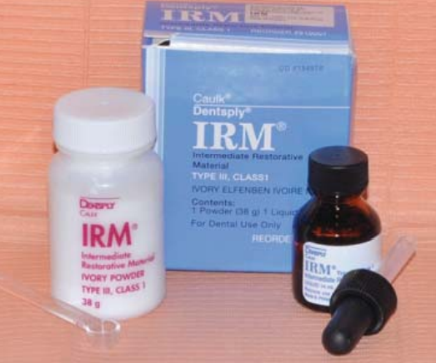 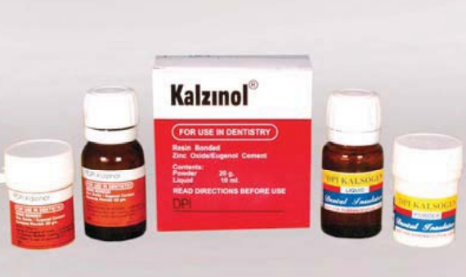

**2) ETHOXYBENZOIC ACID (EBA) MODIFIED ZINC OXIDE EUGENOL**

**(SUPER EBA)**

**COMPOSITION**

Powder

• Zinc oxide: 60%–75%

• Alumina: 20%–35%

• Hydrogenated rosin: 6%

Liquid

• Eugenol: 37%

• Ethoxybenzoic acid (EBA): 63%

The EBA encourages the formation of a crystalline structure and thereby improves strength considerably.

**TOXIC EFFECTS OF EUGENOL**

Eugenol is bactericidal at relatively high concentrations. Dentin adjacent to a ZOE-filled cavity may be exposed to bactericidal euenol levels. ZOE fillings act to prevent bacterial penetration of dentinal cavities.106 This clinically important effect was attributed to the ability of ZOE to prevent microleakage of contaminated oral fluids. Direct measurements of leakage suggest that the seal created by ZOE is not particularly tight when compared with other materials. Brief exposure to 10-2 mol/L eugenol kills mammalian cells. Prolonged exposure to10-3mol/L also kills cells. Hume’s data from these studies show that eugenol concentrations that diffuse through dentin are not cytotoxic. Even lower concentrations, however, can inhibit cell respiration and cell division.107 Recent studies tested the ability of phenolic compounds to inhibit enzymes in cultured rat pulp cells. Inhibitory eugenol concentrations were significantly higher than concentrations that had anti inflammatory effects.108

Severe inflammatory reactions to ZOE cements applied to deep cavities were reported in human teeth by Brannstrom and Nyborg.109 These studies highlight an important principle concerning eugenol’s clinical use. Direct (contact between vital tissue and eugenol-containing material can cause damage to tissue.

**ANESTHETIC PROPERTIES OF EUGENOL**

The ability of eugenol to allay tooth pain is the main reason it is so widely used in dentistry. Chewing on cloves produces topical anesthesia of the oral mucosa. Brodin and Roed110 tested the effect of eugenol and ZOE cement on compound action potentials in the phrenic nerve. At low concentrations eugenol inhibited nerve activity in the reversible manner like a local anesthetic. After exposure to high concentrations of eugenol, nerve conduction was irreversibly blocked, indicating a neurotoxic effect. Eugenol also reduced synaptic transmission at the neuromuscular junction.

The observation that eugenol inhibits nerve activity may be critical in understanding its possible anti-inflammatory effects, because nerve activity and the vascular components of the inflammatory response appear to be related.

**CLINICAL IMPLICATIONS OF EUGENOL’S PROPERTIES**

The pharmacologic effects of eugenol are likely to be complex and to depend on the free eugenol concentration to which the tissue is exposed. Low concentrations can be obtained by eugenol diffusion from a ZOE filling through a layer of intact dentin. Placement of a ZOE filling after excavation of deep caries should exert a sedative and anti-inflammatory effect. Clinically this should be manifested by a decrease in sensitivity of the tooth to cold, hot, and sweets. Alternatively, high concentrations capable of cytotoxic effects can be delivered to tissues by placing eugenol or ZOE in direct contact with vital tissue. The evidence strongly suggests that direct pulp capping with eugenol-containing materials should be avoided if long-term maintenance of pulp vitality is to be achieved. Direct placement of a eugenol-soaked pellet over a vital exposure should be done when an endodontic procedure can be performed within a few days. Like other drugs, eugenol is not a panacea. The effectiveness of eugenol is limited in the face of severe tissue injury. In some instances deep caries or traumatic tooth preparation may induce irreversible effects not amenable to pharmacologic intervention. Although eugenol may reduce the response to mild trauma, the nature of the pulp’s reaction depends on the severity of the damage. No pharmacologic treatment can mitigate the effect of poor technique. To preserve tooth vitality, there is no substitute for early, conservative, and atraumatic tooth preparation.

**NON EUGENOL CEMENTS**

As eugenol inhibits free radical polymerization, noneugenol cements were developed to be used for interim luting purposes in clinical cases which are to receive resinous restorations. Instead of eugenol, carboxylic acids and other chemicals are used to react with zinc oxide. They are not brittle and excess is difficult to remove.

**USES**

Noneugenol cement is used to lute temporary crowns, when a resin cement has to be used to lute the fi nal restoration. It can also be used for patients who are allergic to eugenol. Examples of some commercially available products are Tempbond NE (Kerr) and Pre VISION (Haereus Kulzer).

**SILICATE CEMENT**

Silicate cement is the oldest of the direct tooth-coloured materials. It was first introduced by Fletcher in 1873. It became popular in 1904 when an improved version was introduced. Although it is not in use nowadays, understanding the composition and properties of this material helps in understanding our contemporary cements better.

**COMPOSITION**

It is available in both powder and liquid forms.

**Powder**

It consists mainly of silicon dioxide and aluminum trioxide with a large percentage of fluorides in the form of sodium, calcium, and aluminum fluorides, which act as fluxes during processing and later contribute to anticariogenicity of silicates. It also contains some calcium salts such as Ca(H2PO4)2.H2O and CaO. All the ingredients are fused together at a temperature of 1400°C to form glass. Some colouring additives are added to impart shade variations in the cement.

**Liquid**

It is a 35% – 50% phosphoric acid solution with sodium and aluminum phosphate being added as buffers.

**SETTING REACTION**

The setting reaction of silicates is an acid–base reaction; the powder particles are attacked by the liquid, releasing Ca2+, Al3+ and F– ions. These metal ions precipitate as phosphates, which form the continuous cement matrix along with silicic acid that forms the silica gel. Fluoride ions do not take part in the reaction and are present as free ions in the cement matrix. Most of the powder particles are not totally dissolved; only the surfaces are dissolved. Hence, the unreacted core of the particles coated with silica gel is present in the matrix.

As a result of this reaction, the set cement contains a phosphate matrix containing unreacted powder particles surrounded by silicic acid gel and fluoride ions.

**PROPERTIES**

1. Anticariogenicity: The matrix and gel peripheries of the cement contain large amounts of fluoride ions that make the cement highly anticariogenic.

2. Biocompatibility: The pH of the cement may remain as low as 3 for a few days and is hence a source of pulpal irritation. The pH remains below 7 even after a month of insertion. Hence, it is known to be a severe pulpal irritant, and proper pulpal protection is required when silicate cements are used.

3. Solubility: It is soluble in saliva, especially in acidic conditions.

4. Microleakage: It has a coefficient of thermal expansion closely matching the tooth structure (8 ppm/ οC) and hence minimizes microleakage.

5.Disintegration: This process involves a gross loss of material and is very obvious in silicates due to the combination of solubility, abrasion, erosion, and low strength properties. Disintegration leads to varied features of failure such as surface roughness, leakage, and partial or complete loss of material.

6.Esthetics: The optical properties are good because silicates are transparent when compared to GIC, which are opaque. The refractive index of silicates is also close to enamel and dentin, thus making it a good esthetic material.

7. Adhesion: The mechanism of adhesion of silicate cement is purely mechanical in nature.

**ADVANTAGES**

1. Used as initial tooth-coloured restorative material due to its translucency

2. Anticariogenic property

**DISADVANTAGES**

1. High pulpal irritant

2. Due to its high solubility, it is easily attacked by the oral fluids resulting in a rough surface, which easily takes up stains.

**CALCIUM HYDROXIDE CEMENTS**

Calcium hydroxide [Ca(OH)2] is a white, odourless powder with a molecular weight of 74.08 g/mol. It is a strong base with a high pH (12.5–12.8) and low solubility in water (about 1.2 g/L at 25°C). Owing to its low solubility, a long period of time is necessary before it becomes soluble in tissue fluids when in direct contact with vital tissues.

Nygren (1838) used Ca(OH)2 for the treatment of “fistula dentalis.” Codman (1851) was the first to attempt to preserve the involved dental pulp. Calcium hydroxide became more widely known in the 1930s through the pioneering work of Hermann.

After the Second World War, the clinical indications for its use were expanded and now Ca(OH)2 is considered as the best medicament to induce hard tissue deposition and promote healing of vital pulpal and periapical tissues.

### MANUFACTURE

Limestone is a natural rock, mainly composed of calcium carbonate (CaCO3). The calcination of limestone at a temperature between 900°C and 1200°C produces calcium oxide (quick-lime), which has a strong corrosive ability. Calcium hydroxide is then obtained through the hydration of calcium oxide.

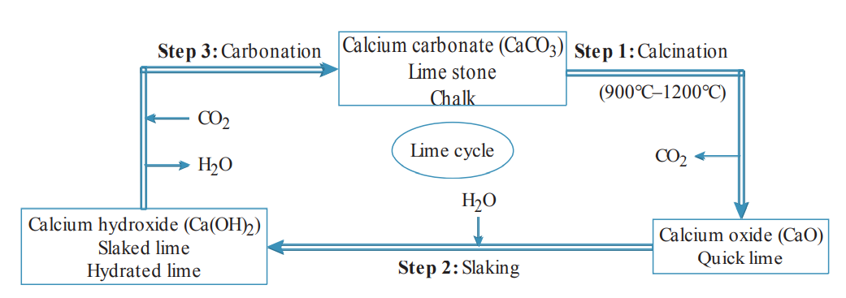

**LIME CYCLE**

**MECHANISM OF ACTION**

The mechanism of action of calcium hydroxide is not fully understood. Its biological properties are achieved by its dissociation into Ca2+ and OH− ions. The percentage of Ca2+ and OH− ions in calcium hydroxide is 54.11% and 45.89%, respectively.

Ca(OH)2 → Ca2+ + OH–

The action of these ions on vital tissue and bacteria generates the induction of hard tissue deposition and the antibacterial effect.

Calcified barrier is formed by Ca(OH)2 when it is in contact with healthy pulpal (pulp capping) or periodontal tissue (apexification). The high pH of the material (up to 12.5) leads to the formation of a superficial layer of necrosis in the pulp to a depth of 2 mm and a layer of mild inflammation. The calcium ions that form the barrier are derived entirely from the bloodstream and not from the Ca(OH)2. Calcium ions may activate the calcium-dependent adenosine triphosphatase reaction associated with hard tissue formation. The hydroxyl ion provides the alkaline pH that neutralizes lactic acid, thus preventing dissolution of the mineral components of dentin, and also activates alkaline phosphatases, which play an important role in hard tissue formation. The barrier (composed of osteodentin) is porous and not always complete. Calcium hydroxide shows two different modes of healing depending on the pH of the particular formulation. The vehicle also plays an important role in the overall process because it determines the velocity of ionic dissociation, causing the paste to be solubilized and resorbed at various rates.

**AVAILABLE FORMS**

Calcium hydroxide material as a cement is available in various forms based on its function. It is available in simple non settable powder form which is mixed with aqueous or viscous vehicles and is used as an intracanal medicament. It is available in other settable forms such as single paste and two-paste systems as well.

Paste Form

It contains base in one paste and catalyst/accelerator in the other. Once mixed, the cement hardens.

Dycal is a popular paste form of Ca(OH)2.

Its composition is as follows:

Base paste: Calcium tungstate, calcium phosphate, and zinc oxide in glycol salicylate. Also contains pigments, radiopacifiers and inert fillers.

Catalyst paste: Zinc oxide and zinc stearate in toluene sulfonamide. Zinc stearate is the accelerator.

Both pastes are dispensed in equal amounts and mixed to a uniform color. Setting results from the formation of amorphous calcium disalicylate.

**PROPERTIES**

**STRENGTH**

Calcium hydroxide has a low compressive and tensile strength which continues to increase with time. The compressive strength of Ca(OH)2 is 10 – 27 MPa after 24 hours. The tensile strength is as low as 1 MPa.

**MODULUS OF ELASTICITY**

Calcium hydroxide has low elastic modulus (0.37 GPa/m2), which limits its use to areas that are not critical to the support of the restoration. Hence, it is not recommended as a sole base or luting cement.

**SOLUBILITY, DISINTEGRATION AND MICROLEAKAGE**

Calcium hydroxide is highly soluble in water when compared to other cements (ranges between 0.4% and 7.8%). The solubility or resistance to disintegration and microleakage of dental cements are important criteria in assessing the quality of materials to be used as bases or liners in dental restorations. It has been observed that there is some dissolution of the cement bases present under restorations that is much more than the solubility values of the cement. This can be attributed to the presence and contact of dentinal fluid from the underlying dentinal tubules. A certain extent of solubility is necessary for Ca(OH)2 to produce its therapeutic effects. However, the solubility increases when it is exposed to phosphoric acid; hence, care should be taken during acid etching and during application of varnish in the presence of this cement.

**THERMAL INSULATION**

It can be noted that Ca(OH)2, when used in sufficient thickness, can provide thermal insulation. However, a thickness greater than 0.5 mm is not recommended due to its low strength. Hence, thermal protection should be provided with a separate high strength base.

**BIOLOGICAL PROPERTIES**

Anti-inflammatory action: The elevated pH inhibits the substrate adherence capacity of macrophages and decreases or eliminates the amount of matrix metalloproteinase-8 (MMP-8), thereby improving tissue circulation and controlling exudation.

Calcific barrier formation: Calcium hydroxide produces an organic matrix which will mineralize within 4–6 weeks. Calcium hydroxide stimulates the dentin matrix sequestration, ATP activation, and diffusion of growth factors (transforming growth factor [TGF]), and, also activates alkaline phosphatases by its high pH. This induces signalling of odontoblast-like cell differentiation followed by reparative dentin secretion.

Antibacterial effects: Most of the pathogens in the root canal are unable to survive in the highly alkaline environment of Ca(OH)2. Hence, they are eliminated after direct contact for a short period.

Tissue-dissolving property: Interim dressing with Ca(OH)2 for 1 week or more may ensure dissolution of pulpal fragments due to its long-term solvent effect. The combined use of sodium hypochlorite and Ca(OH)2 has a good potential for removing autolyzed pulpal tissue.

**LIGHT-CURED CALCIUM HYDROXIDE**

Light-cured Ca(OH)2 is a combination of urethane dimethacrylate (UDMA) resin with Ca(OH)2 and barium sulfate fillers along with low viscosity monomers. It is a hydrophilic monomer which can absorb water and release Ca(OH)2.

**ADVANTAGES**

1. It is alkaline in nature with a high pH ranging from 11 to 12. The antibacterial and protein-lysing effects of cement is due to this high alkalinity.
2. Only Ca(OH)2 cement induces reparative dentin formation due to its alkalinity.
3. Though highly soluble, this property of inducing reparative dentin formation is advantageous when used as a pulp capping agent for its therapeutic effect.

**DISADVANTAGES**

1. The cement has high solubility; hence, it cannot be used at the cavosurface margins when used as a liner.
2. It does not provide effective thermal and electrical insulation.

## 

**GLASS IONOMER CEMENT**

Glass ionomer cement (GIC) was first reported by Wilson and Kent in 1972, though it was developed in the UK much earlier. As the name suggests, it is a combination of glass powder particles and polyacids, which forms ionic bonds with the tooth structure. GIC is a combination of the powder of silicate cements with the liquid of polycarboxylates, hence the name “aluminosilicate polyacrylic acid” (ASPA). Other names for GIC include polyalkeonates, dentin substitute, man-made dentin, etc. It is a versatile material with many clinical applications. The material has evolved over a period of time and has undergone various modifications with improved properties. Only two cements, namely, polycarboxylates and glass ionomers, have the property of chemical adhesion to tooth.

**CONVENTIONAL GIC**

**COMPOSITION**

Conventional GICs are usually available as powder and liquid.

**POWDER**

The powder is an acid-soluble calcium fluoroaluminosilicate glass.

Silica, alumina, calcium, and fluoride form the basic constituents of GIC powder.

Manufacture

The ingredients of the powder are heated together at temperatures ranging from 1100°C to 1500°C, resulting in a fused or sintered mass. This mass is then ground to a fine powder of particle size ranging from 15 mm to 50 mm.

Alumina is added in the Si/Al atomic ratio of < 2:1 to make the glass basic enough so that it becomes susceptible to acid attack to release various ions. Hence, this powder is termed ion leachable glass. Too much alumina results in the separation of alumina as a separate phase (corundum), and this makes the glass increasingly opaque. Similarly, presence of calcium fluoride is essential for good cement-forming property, but too much of it makes the material opaque. CaF2 also lowers the fusion temperature of the glass. Other glass modifiers such as AlPO4 and Na3 AlF6 (Cryolite) are added to adjust the setting reaction and other properties. In addition, ZrO2 may be added to increase the final strength.

The fluoride fluxes used in the glass matrix do not completely dissolve during the manufacture of glass ionomer powder; a large proportion is found in the final glass powder as small (solid) droplets dispersed in the glass. These act as light scattering centres and contribute to the final translucent, opal-like appearance.

**LIQUID**

The liquid, typically, is a 47.5% solution of 2:1 polyacrylic acid/itaconic acid copolymer in water. The average molecular weight is 10,000 daltons. The polyacrylic acid is copolymerized with itaconic, maleic and tricarboxylic acids to stabilize the liquid and increase its reactivity. The itaconic acid/maleic acid reduces the viscosity of the liquid and inhibits gelation caused by intermolecular hydrogen bonding between polyacid molecules. Tartaric acid (5%–10%) is added to the liquid to improve the handling characteristics. It increases the working time by preventing the premature formation of calcium polyacrylate chains. It shortens the setting time by enhancing the formation of aluminum polyacrylate chains, thus having a beneficial effect during the early stage.

The liquid has a tendency to gel over time. The reason for this gelation is the establishment of a hydrogen bond which cross-links between polyacid chains, the number of which increases steadily with time. This is a kind of crystallization which can be reversed by stirring and shaking (thixotropic behaviour) or warming (e.g., hydrogen-bonded gel such as agar). This is the reason why the liquid of GIC should not be refrigerated.

The addition of copolymers responsible for reduction of cross-linking decreases the bond strength with the tooth structure and makes it more susceptible to acid attack in the oral cavity. Increasing the concentration of polyacid increases the strength of the set cement. But it increases the viscosity, which makes it difficult to manipulate the cement during mixing. Hence, a proper balance of the percentage of copolymers in the polyacid is required to optimize the properties.

**WATER SETTABLE GLASS IONOMER CEMENT (ANHYDROUS GIC)**

This is another formulation of the GIC, where the polyacrylic acid copolymers of the liquid are freeze dried and added to the glass powder in a single bottle. The liquid now consists of water or water with tartaric acid. The mechanism behind this formulation can be explained thus. Ideally, the properties of GIC can be improved by increasing the concentration and molecular size of the polyacrylic acid. But in the process, the viscosity is increased, working time is lost, and setting time is shortened, thereby making it difficult to manipulate. This can be overcome by incorporating the high molecular weight polyacrylic acid in higher concentrations into the powder in the form of freeze-dried powder. This will result in increased working time and will improve the physical properties as well.

**MODE OF SUPPLY**

1. Powder–liquid form for manual mixing

2. Capsulated form for mechanical mixing

3. Twin syringe form for mechanical mixing

The advantages of capsulated and twin syringe forms are numerous - proper proportioning and mechanical mixing ensure uniform mix, consistency and ease of placement.

**SETTING REACTION**

The setting reaction of GIC is an acid–base reaction. For ease of understanding, the setting reaction of glass ionomer has been discussed under the headings “Dissolution,” “Initial Setting,” “Final Setting,” and “Maturation.” However, the process is continuous and sometimes overlapping.

**DISSOLUTION**

When the powder and liquid are mixed together, the acid attacks the glass particles resulting in the release of Ca2+, Na+, SiO4 4−, and F− ions into the aqueous medium. About 20% – 30% of the glass is decomposed by the acid attack.

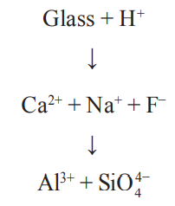

**INITIAL SETTING - CALCIUM CROSS-LINKING**

The polyacrylic acid chains are cross-linked by Ca2+ ions during the initial setting reaction in the first 4–10 minutes from the start of mixing. Since Ca2+ ions are doubly charged and ionically bonded to the glass particles, they are readily liberated by ion exchange with H+ ions of the acids and are thus responsible for the initial cross-linking. This initial set material is carvable, its strength and hardness being not high enough to resist sharp instruments.

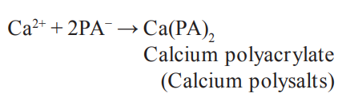

**FINAL SETTING – ALUMINUM CROSS-LINKING**

Gelation occurs during the next 24 hours when the less mobile trivalent Al ions react or crosslink with the polyacid chains. (Since Al3+ is covalently bonded to the glass and can only be liberated by slower hydrolysis, these ions are less mobile and are released much later than the initial ions). As hydrolysis continues, there is release of more Al3+ and SiO4 4− ions. The silicate forms the silica gel whereas Al3+ ions chelate with carboxylic groups displacing even Ca ions because of their higher charge and stronger bonding, thus enhancing the final strength of the set cement. Sodium and fluoride ions do not participate in the cross-linking of the cement. Some of the Na ions may replace the H ions of the carboxylic groups, whereas the remaining ions along with F ions are dispersed uniformly within the set cement.

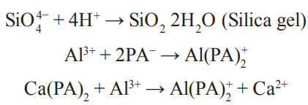

The charge on the aluminum complex [Al(PA)2 + ] indicates greater strength of the aluminum polyacrylate bond. It also shows the capacity for binding water more strongly than calcium, thus enhancing the strength of the gel.

**MATURATION AND STRUCTURE OF SET CEMENT**

The Calcium and Aluminium polyacrylate cross-linked chains become hydrated over time with water being present in the liquid. This process is called maturation. The Aluminium ions, initially surrounded by four oxygen atoms in the glass, are now surrounded by six atoms in the set cement matrix. The unreacted glass particles are sheathed by the hydrogel that is found to increase the resistance of the glass particles to acid attack since the reactivity of the glass surface controls the nature of the set cement. Thus, the microstructure of the set cement consists of agglomeration of unreacted glass particles (glass core which serves as fillers in the cement matrix) surrounded by silica gel embedded in an amorphous matrix of hydrated calcium and aluminum polysalts.

**ROLE OF WATER**

GIC’s are described as water-based cements since water constitutes between 11% and 24% of the set cement. Water plays a critical role in the setting reaction of GIC. It initially serves as a reaction medium and then slowly hydrates the cross-linked matrix, thereby increasing the strength of the mix. During the initial setting, the water is loosely bound and can be easily removed by desiccation when exposed to ambient air. On the other hand, any contamination by water at this stage can also cause dissolution of the matrix releasing the Ca2+ ions from the polyacrylate chains. Both loss and uptake of water result in weak and more soluble cement with reduced translucency. Hence to prevent loss/uptake of unbound water, the cement should be protected with a coating of varnish immediately after placing the restoration. As the setting continues, the same water hydrates the matrix and cannot be removed by desiccation, yielding a stable gel structure. This is called tightly bound water.

**ROLE OF FLUORIDE**

Fluoride is incorporated into the glass in the form of fine droplets as a flux during the manufacture of the glass powder to lower the glass fusion temperature and improve handling properties, strength, and translucency. Though fluoride was initially added to the powder as a flux, its antibacterial property was noted later and considered as an advantage. The fluoride in GIC is in the form of CaF2, SrF2, lanthanum fluoride (LaF2), sodium hexa-fluoro-aluminate (Na3AlF6), and aluminum trifluoride (AlF3). During setting, the Fluoride ions form strong, soluble aluminofluoride complexes (AlF2+) which prevent premature gelation of polyions by aluminum ions. In fully set cement, Fluoride ions do not play an important role in the matrix; they are present primarily in the unbound form of the soluble aluminum complexes. Fluoride ions in the set glass ionomer sometimes replace the hydroxyl ions of enamel hydroxyapatite (HA) crystals, resulting in fluorapatite crystals.

**FLUORIDE RELEASE**

The exact mechanism of fluoride release is not clearly understood. Two mechanisms of Fluoride release can be explained:

1. Short-term initial high fluoride release: During the post setting maturation process, the fluoride ions are liberated due to the formation of aluminum polysalts, resulting in high Fluoride release initially.

2. Long-term low fluoride release: This is attributed to the equilibrium diffusion process. In the presence of water, the Fluoride ions migrate out of the cement into the surrounding saliva from where they may be taken up by the adjacent tooth structure and get accumulated in the pellicle-plaque complex. This movement of Fluoride ions out of the cement will create an electrolytic imbalance on the surface of the restoration.

**FLUORIDE UPTAKE**

On the other hand, when the concentration of fluoride in the saliva and the plaque is high enough, the excess fluoride may be incorporated back into the GIC. Hence, it is said that GIC will act as a fluoride reservoir. This will reinstate the electrolytic equilibrium, thereby returning the material into a balanced state. This will lead to a degree of maturation and strengthening of the surface. Many studies have shown that Fluoride ions released from GIC inhibit the progression of secondary caries.

**MECHANISM OF ADHESION**

The GIC chemically bonds (ionic bond) to enamel and dentin. Though the precise mechanism of bonding is unclear, there are two probable theories of adhesion:

1. A simple theory suggests that polyacid molecules chelate with the calcium on the tooth interface. This is supported by the formation of the interfacial calcium polyalkeonate salt.
2. The acid present in the fresh mix when contacts the tooth structure acts as a self-etching agent causing dissolution of the HA crystals, resulting in release of calcium and phosphate ions. The hydrogen ions are rapidly buffered by the phosphate ions from the HA crystals and the pH begins to rise. To maintain an electrolytic balance, the phosphate ions take with them a calcium ion; these Calcium ions are then taken up by the carboxylic groups adjacent to the tooth to form an ion-enriched layer composed of calcium-phosphate-polyalkeonate complexes that are firmly bound to both enamel and dentin. Thus, the polyacid chains are bound to a reprecipitated layer on the tooth surface.

Hence, the adhesive mechanism of GIC primarily involves chelation of carboxyl groups of the polyacids with the calcium in the hydroxyapatite of the enamel and dentin. When there is greater homogeneity and inorganic content of enamel, GIC’s bond better to enamel than to dentin.

Adhesion to the organic component of the dentin can also occur by either hydrogen bonding or metallic ion bridging between the carboxyl groups of the polyacid and the reactive groups within the collagen of dentin.

**TYPES**

Classification of GIC has been proposed and modified by Wilson and McLean in 1988. GIC is classified into the following types depending on their uses:

* Type I: Luting and bonding cements

– For cementation of inlays, crowns, bridges, and orthodontic appliances

– The powder/liquid ratio is 1.5:1.

* Type II: Restorative cements

– The powder/liquid ratio is 3:1.

* Type III: Liners and bases

– The powder/liquid ratio is 1.5:1.

* Type IV: Pit and fissure sealants

**PROPERTIES**

**BIOCOMPATBILITY**

Glass ionomers are both bioactive and biocompatible. According to the studies done by several authors, pulpal tolerance to GIC is high. The reasons are as follows:

1. pH of the mix: Though the pH of the freshly mixed cement is 0.9–1.6 (highly acidic), the pH rises very rapidly within the first 20 minutes. Hence, it is quite tolerant by the pulp, and no liner/base is required when adequate thickness of dentin is present.

2. An RDT (remaining dentin thickness) of 1 mm or more is in itself an efficient buffer.

3. The molecular weight of the polyacids ranges from 30,000 daltons to 50,000 daltons. This high molecular weight along with the large, complex molecular chains of polyalkenoic acid prevents penetration into the dentinal tubules to any greater depth. This along with the high molecular weight of the polyacid eliminates the need for pulpal protection when the dentin thickness is 1 mm and above. When the RDT is less than 1 mm, a thin layer of a protective liner such as Ca(OH)2 should be given in deeper cavities. This is because the buffering action of dentin is not very effective and the diameter of the dentinal tubules is more near the pulp.

**PHYSICAL PROPERTIES**

GIC’s have compressive strength comparable to that of zinc phosphate. However, their diametral tensile strength is slightly higher than that of zinc phosphate. Type II GIC has a compressive strength of about 150 MPa whereas type I GIC has a much lower value (about 75 MPa) owing to the lower P/L ratio. The modulus of elasticity is about one-half of that of zinc phosphate. Thus, GIC’s are less stiff and more susceptible to elastic deformation. Due to this property, GIC’s are not recommended for luting of all ceramic crowns as they induce greater tensile stresses in the crown under occlusal loading.

**COEFFICIENT OF THERMAL EXPANSION**

Ideally, restorations should contract or expand along with the tooth structure during a change in temperature in the oral cavity; i.e., their coefficient of thermal expansion should match that of the enamel and dentin. GIC’s have coefficient of thermal expansion very close to that of the tooth structure.

(Enamel: 11.4 × 10−6/°C; Dentin: 8.3 × 10−6/°C; GIC: 10–11 × 10−6/°C).

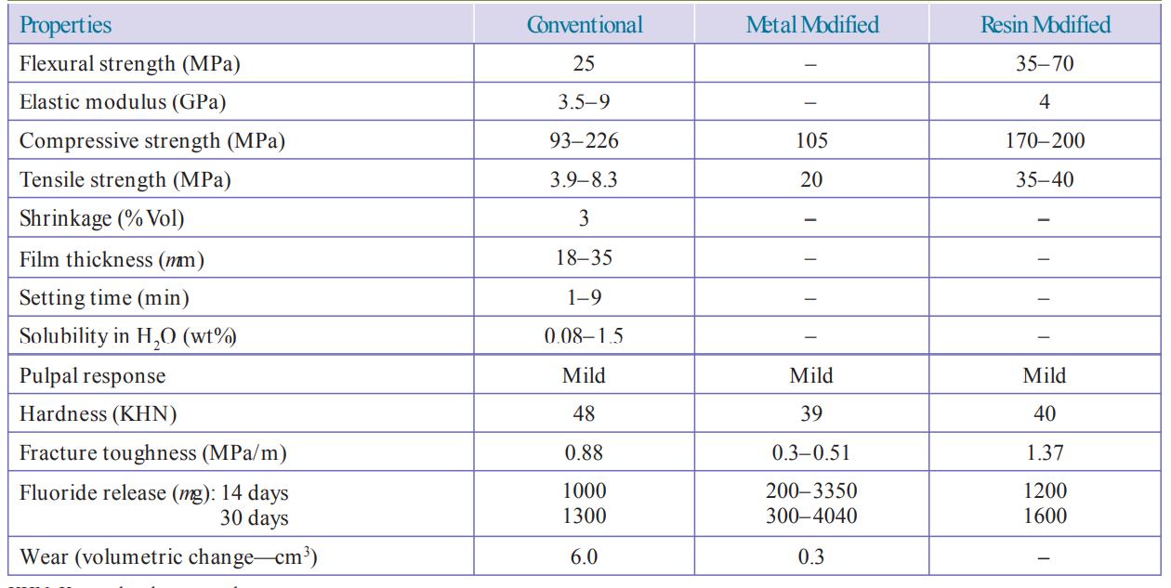

Comparison of properties of conventional GIC and its modifications

**THERMAL DIFFUSIVITY**

Thermal diffusivity is the measure of the rate at which a body with a nonuniform temperature reaches a state of thermal equilibrium. This property governs the insulating efficiency of a material.

Restorative materials should have diffusivity values similar to those of the tooth structure to have a thermal, insulating effect on the pulp. Since thermal diffusivity of GIC is close to that of dentin, it protects the pulp from thermal trauma. The thermal diffusivity increases with an increased P/L ratio.

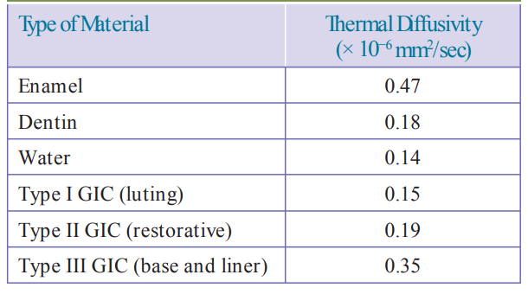

**SOLUBILITY**

The solubility of GIC (1.25 wt% for type I and 0.4 wt% for type II) is greater than that of other cements in water. However, in the acidic environment (clinical conditions), the solubility is much lower than that of zinc phosphate and zinc polycarboxylate cements.

**RADIOPACITY**

Conventional GIC has low radiopacity though metallic ions are present. This is because these metal ions have low atomic numbers and therefore fewer electrons capable of absorbing X-rays. Some products have substituted calcium with strontium without alteration in the chemical reaction, resulting in better radiopacity. (The atomic number of strontium is 38, which is higher as compared to the atomic number of calcium which is 20).

**ESTHETICS**

Though GIC’s are tooth-coloured materials, they cannot be considered as esthetic materials since they lack translucency and are very opaque.

**ANTICARIOGENICITY**

The anticariogenic potential of GIC could be attributed to the free fluoride ions present in the set GIC matrix. Three mechanisms for the anticariogenic property of fluoride can be explained, namely, formation of acid-resistant fluorapatite, inhibition of demineralization/enhancing remineralization, and inhibition of the enzyme

enolase thereby preventing glycolysis and lactic acid production/carbohydrate metabolism of microorganisms.

When the pH of the extracellular fluid decreases (due to the acids produced by the bacteria), the fluoride ions enter the microorganism and interfere in the carbohydrate metabolism by inhibiting the enzyme glucosyl transferase, thereby leading to a slower rate of acid production. Since fluoride also increases cell permeability, it can readily leach out of the microorganism into the plaque matrix, hence available again for anticariogenic activity.

**ADVANTAGES**

1. Chemical adhesion to the tooth structure
2. Anticariogenic potential
3. Biocompatibility
4. Tooth-coloured restorative material
5. GIC is considered to be the best restorative material in children because of its good marginal integrity

**DISADVANTAGES**

1. Inferior mechanical properties such as low tensile strength and fracture toughness
2. Poor wear resistance
3. Highly moisture sensitive
4. Though it is tooth coloured, it has poor esthetics

**MODIFICATIONS OF GIC**

Though GIC’s exhibited good biological properties, their use as a restorative material in posterior teeth was limited due to their poor mechanical properties such as fracture toughness, wear resistance, etc. Attempts to improve their properties included increased particle size and incorporation of metal fillers or resins. Some such modifications of GIC are discussed in the following text.

**HIGHLY VISCOUS GLASS IONOMER**

Atraumatic restorative treatment (ART) technique was adopted in underdeveloped countries that lacked basic amenities such as water, electricity, and basic equipment. This procedure was introduced as an alternative to extractions and to retain as many teeth as possible under these adverse conditions. This technique involves manual excavation of caries with hand instruments and use of a fluoride-releasing adhesive material such as GIC. To simplify the insertion of the material, the GIC has to be pressed into the cavity. To achieve this, the particle size of the powder and the P/L ratio are increased to obtain a highly viscous mix that can be easily packed. This modified, highly viscous GIC has high strength and better physical properties. Fifty percent of the particles have an average particle size of about 8 mm while about 90% of the particles have a particle size of less than 9.6 mm. This resulted in a mix with thicker consistency that could be easily inserted with minimal hand instruments and pressed into place.

**METAL MODIFIED GLASS IONOMERS**

In an attempt to improve the mechanical properties of GIC’s and use them in posterior teeth, metal filler particles such as silver alloy were incorporated in conventional GIC. This was achieved in two ways:

1. By adding spherical silver alloy particles in the proportion of 8 parts of cement powder to 1 part of alloy by volume (8:1 ratio) and mixed to a suitable consistency with polyacrylic acid at a ratio of approximately 3:2 by weight. Introduced by Simmons in 1983, this is known as silver alloy admix. Since this was introduced during the 1980’s when the mercury controversy was increasingly evident, this material, incorporating only the silver alloy powder without the mercury, was introduced as a “miracle mix” (e.g., Miracle Mix, GC India).
2. Glass powder was fused to silver alloy particles through high temperature sintering. Microfine silver alloy particles of 40% weight and less than 3.5 mm in diameter are mixed with the glass powder particles and then sintered together at 800°C under pressure. Unreacted silver particles are washed out. Up to 5% of titanium dioxide was added to modify the colour. The pellet that is formed is then ground into fine particles. This is referred to as cermet. Cermet was first introduced by McLean and Gasser in 1985.

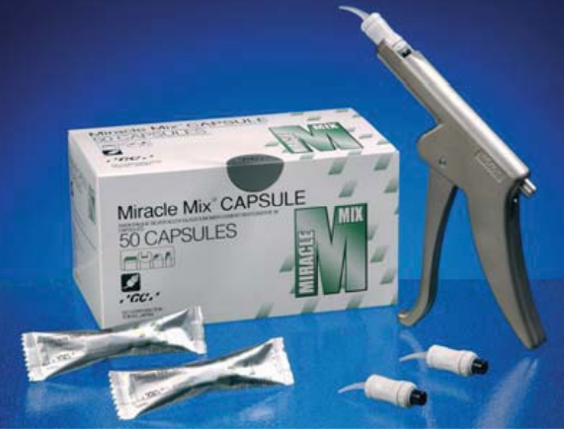

The glass particles produced by the high-temperature sintering mentioned in the preceding text were covered with a layer of metallic silver. This contributed to the increase in wear resistance of the restoration. The material had improved handling properties with high density and low porosity in the finished restoration. The material can also be burnished during restoration, resulting in proper adaptation to the margins.

**PROPERTIES**

There is a significant improvement in the wear resistance of metal-modified glass ionomers, which is more for cermet. Compressive strength and fracture toughness are improved to a limited extent. Adhesion to tooth structure is slightly reduced due to the presence of silver. Radiopacity is similar to amalgam owing to its silver alloy content.

**FLUORIDE RELEASE**

Both the metal-modified GIC—miracle mix and cermet—release fluoride in appreciable amounts. Less fluoride is released with cermet as compared to silver alloy admix owing to the glass particles being coated with the metal. In silver alloy admix, the cement matrix contains unbound metal particles; the filler–cement interfaces become pathways for fluoride exchange, thereby greatly increasing the surface area available for leaching of fluoride.

**USES**

They are mainly used as core buildup materials. Their use is restricted to class I cavities in primary teeth prone to caries. Otherwise, their use in stress-bearing areas is still restricted since the fracture toughness is only marginally improved from the conventional GIC. Hence, they can be used with reinforcement such as pins and posts to a certain extent.

**RESIN MODIFIED GLASS IONOMERS**

The main problem faced with conventional GIC’s is maintaining water balance during setting. The longer setting time results in early moisture sensitivity and low early strength, making it more susceptible to hydrolytic degradation (during the first hour of placement). This leads to the development of resin-modified GIC’s, by the addition of resins and photo initiators to the conventional GIC’s. Though resin-modified glass ionomer is a more appropriate term, however this modification has also been termed hybrid ionomer or resin ionomer.

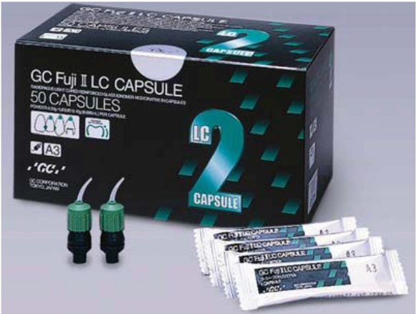

The first resin-modified GIC introduced commercially was lining cement (Vitrebond, 3M ESPE) developed by Sumita Mitra. The translucency of the resin-modified GIC improves because of the inclusion of monomers which bring the refractive index of the liquid close to that of the particle. Hence it is more esthetic than conventional GIC, which is more opaque. However, this translucency may decrease over a period of time; this is due to the residual hydrophilic HEMA, which imbibes water and degrades. Hence, the shade of the final restoration is slightly darker than the initial shade and should be taken into consideration during shade selection.

**COMPOSITION**

The powder consists of ion-leachable fluoroaluminosilicate glass particles and photo initiators/ chemical initiators for light curing/chemical curing. The liquid component consists of an aqueous solution of polyacrylic acid copolymer that contains pendant methacrylate groups together with approximately 10% of 2-hydroxyethyl methacrylate (2-HEMA), which is responsible for polymerization. The overall water content is less in order to accommodate the polymerizable ingredients.

**SETTING REACTION**

Two types of reactions take place, namely, acid - base reaction and polymerization reaction. When the powder and liquid are mixed together, the initial setting reaction is by the polymerization of the methacrylate group. Since it is also possible to light cure and initiate the setting reaction of the resin immediately, this set resin provides an umbrella effect and protects the ongoing acid–base reaction within the cement. This reduces the early moisture sensitivity and gives high early strength to the mix. The slower acid–base conventional reaction will complete the setting reaction and will ultimately be responsible for the final strength of the cement. The set mix thus consists of HEMA polymer and polyacid linked by hydrogen bonding. The mixing time should be no more than 30 seconds. The working time is 2.5 minutes.

Once placed, the cement can be “command set” by light curing. Hence, this mechanism is known as dual cure, i.e., two reactions, acid–base and polymerization (either chemical cure or light cure). Some resin-modified cements have three types of reactions taking place, namely, polymerization reaction by chemical cure, polymerization reaction by light cure, and acid–base reaction of the glass ionomer. This setting mechanism is then known as tri-cure.

The residual HEMA content in the set mix ranges from 4.5% to 15% depending on the P/L ratio. This residual HEMA over a period of time will absorb water because of its hydrophilic nature which results in degradation of the cement with HEMA being released into the surrounding dentin.

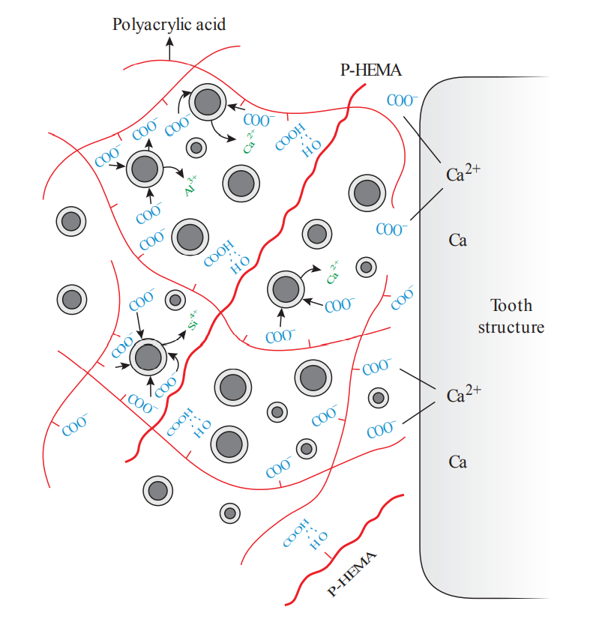

Setting reaction of resin-modified GIC. P-HEMA, polyhydroxyethyl methacrylate.

**PROPERTIES**

**BONDING TO TOOTH STRUCTURE**

Bonding to enamel and dentin is the same as that of conventional GIC. Due to the reduction in carboxylic acids in the liquid of resin-modified GIC, there is less ionic activity which results in lesser bonding to the tooth structure. However, it has been found that the bond strength is higher than conventional GIC (14 MPa). This could be attributed to the bonding between the resin component and the tooth structure.

**BIOCOMPATIBILITY**

The initial pH is less acidic (around 3.5) compared to conventional GIC (pH 2); hence, there is less irritation to pulp. Fluoride release levels are comparable to those of conventional GIC’s.

**COMPRESSIVE STRENGTH**

Compressive strength is slightly lower than that of conventional GIC’s whereas tensile strength, flexural strength, and fracture toughness are improved. Resin-modified GIC’s lower modulus of elasticity. The increase in strength is attributed to the lower elastic modulus and to the greater amount of plastic deformation that can be sustained before fracture occurs.

**FLOURIDE RELEASE**

It is comparable to conventional GIC.

**DIMENSIONAL CHANGE**

A dimensional change of 1% shrinkage occurs due to the polymerization of the methacrylate in the resin component.

**ESTHETICS**

The translucency of resin-modified GIC’s is better than that of conventional GIC’s owing to the presence of monomers which bring the refractive index close to that of enamel.

**ADVANTAGES**

1. Shorter setting time results in the cement being less susceptible to water loss or gain.
2. Rapid setting results in better initial colour stability/translucency.
3. Improved physical properties.
4. More esthetic due to its improved translucency.

**COMPOMER**

The term compomer is derived from a combination of composite resin and glass ionomer. This class of restorative material combines some of the chemical and mechanical properties of composite resins and the ion-leachable glass particles of GIC’s as fillers. By adding the aluminosilicate glass, it was thought that a better composite resin with fluoride-releasing property will be achieved.

It is a one-component material. The typical acid–base reaction of glass ionomers does not occur due to the absence of polyacrylic acid liquid. The term polyacid-modified resin was suggested by McLean in 1994. They are another form of hydrophilic composite resins. There is no chemical adhesion, and bonding to tooth structure is typical of composite resins.

When placed in the oral cavity, compomers do undergo a very minimal or negligible acid– base reaction as it imbibes water. This is due to the presence of a very minimal amount of dehydrated polyalkeonic acid which when hydrated by water may lead to an acid–base reaction.

**PROPERTIES**

Mechanical properties such as tensile and flexural strength and wear resistance are superior to GIC but inferior to resin composites. There is some amount of fluoride release, but it is not comparable to conventional GIC’s.

**CLINICAL CONSIDERATIONS OF GLASS IONOMER CEMENTS**

The uses of GICs are as follows:

1. In paediatric and geriatric restorations owing to its good marginal adaptation
2. Luting of indirect metal and metal ceramic restorations (except all ceramic restorations)
3. As liners and bases under metallic and non-metallic restorations
4. As a restorative material for permanent teeth in non–stress-bearing areas such as in Class III and V
5. As pit and fissure sealants in posterior teeth
6. As core build up during post endodontic restorations (especially metal-modified GIC)
7. As a root canal sealer, luting posts and retrograde filling material in endodontics

**COMMERCIAL MODE OF SUPPLY**

Some of the commercially available GIC’s are as follows:

1. Type I: Fuji I (GC Dental), Meron (Voco) 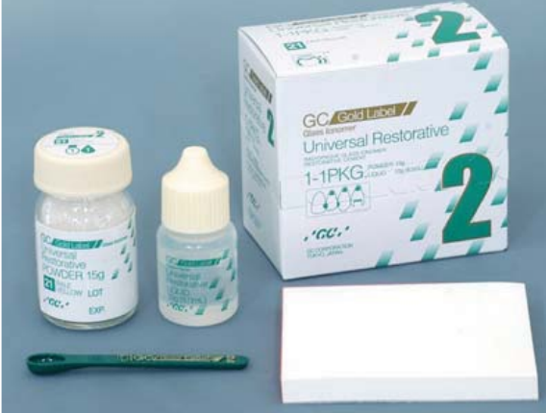
2. Type II: Fuji II (GC Dental) (Fig. 15.8), Fuji IX GP (Packable GIC, GC Dental)
3. Silver alloy admix: Miracle Mix (GC Dental)
4. Cermet: Ketac Silver (3M ESPE)

**MANIPULATION**

The P/L ratios for GIC and for anhydrous GIC’s are 1.3:1 and 3.3:1, respectively. An oil impervious paper pad and stiff agate/ plastic spatula are used for mixing. Stainless steel spatula should not be used because the glass particles of the powder tend to scratch the stainless-steel incorporating impurities from the spatula into the cement mix.

**RECENT ADVANCES IN GLASS IONOMER CEMENTS**

**1) WATER – HARDENING GLASS IONOMER CEMENTS**

In the conventional glass ionomers, when the polyacid is present in solution, an increase in either molecular weight or concentration will increase the viscosity of the liquid, thus making the cement paste more difficult to manipulate. Hence there is a limitation from the usage of polyacrylic acid in solution and it is used more in solid form for blending with glass ionomer powder. To overcome this, in water hardening glass ionomer cements, the liquid for cement formation is either plain water or an aqueous solution of tartaric acid.

**2) CERMET IONOMER CEMENTS**

To improve the resistance to abrasion, McLean and Gasser developed cermet ionomer cements. It was found that by sintering the metal and glass powders together, strong bonding of the metal to the glass was achieved.

**3) HIGHLY VISCOUS CONVENTIONAL GLASS IONOMER CEMENT**

To simplify the insertion of the material similar to that used for amalgam, high viscous glass ionomers were developed. They were designed as an alternative to amalgam for posterior preventive restorations. Examples of highly viscous glass ionomer cements are Fuji IX and Ketac Molar.112

**4) STRONTIUM OXIDE ADDED GIC**

Strontium is a cement forming ion and it slows down the setting reaction at both 21°& 37°centigrade; hence imparting more radiopacity as compared to calcium aluminate added glass ionomer.113

**5) CALCIUM ALUMINATE GIC/CERAMIR**

Calcium aluminate component in the cement contribute to increased strength and retention over time, biocompatibility, better sealing of tooth-material interface, bioactive because of apatite formation, stable, shows sustained long-term properties, lack of solubility/ degradation.114

**6) AMALGOMER**

This (ceramic reinforced glass ionomer cement) is introduced into restorative dentistry to match the strength and durability of dental amalgam. It contains a high level of fluoride with good aesthetics and it requires only minimal cavity preparation. It bonds to tooth structure and has excellent biocompatibility.115

**7) GIOMERS**

This fluoride-releasing, light-cured restorative material is touted as true hybridization of glass ionomer and composite restorative materials. Other advantages of giomers are its good esthetics, ease of handling and improved physical properties of the set material.116

**8) HAINOMERS**

These are newer bioactive materials developed by adding hydroxyapatite within glass ionomer powder. They are mainly being used as bone cements in oral maxillofacial surgery and can be used as retrograde filling material. They bond directly to bone and affect its growth and development.117

**9) FLUORINATED GRAPHENE**

Sun et al in his study concluded that the addition of fluorinated graphene to conventional GIC enhanced their mechanical, biological and antibacterial properties. Also, the incorporation of fluorinated graphene to GIC had no negative affect on the color, solubility and fluoride ion release property of the material.118

**10) STAINLESS STEEL GLASS IONOMER**

Kerby et al, in his study suggested that the stainless-steel cements provided the most desirable physical properties including high compressive and tensile strength, favourable working and setting times and low acid solubility. The main disadvantage is the greyish color which makes it an unsuitable choice for anterior tooth restoration.119

**11) REACTIVE GLASS FIBERS: FIBER REINFORCED GLASS IONOMER CEMENTS**

Lohbauer et al reported that a reactive glass fiber has the ability to increase the fracture toughness of glass-ionomer cements. Yli-Urpo et al found that bioactive glass particles likely acted as fillers that do not adhere to the matrix of GIC leading to decreased compressive strength and modulus of elasticity. Hence, their usage ought to be restricted to applications where their bioactivity can be beneficial, such as root surface fillings and liners.120

**12) INCORPORATION OF HYDROXYAPATITE (HA) AND HA/ZrO2 IN GIC**Lucas et al found that HA-ionomers are promising dental filling materials and the incorporation of HA particles into the powder of glass-ionomer cements increased the mechanical properties of the set cement.121

**13) GIC’s CONTAINING YBF3 AND BASO4**

Prentice et al found that nanoparticles of YbF3 and BaSO4 when added to conventional glass-ionomer cement powder significantly reduced 24 h compressive and surface hardness of glass-ionomers. Also, YbF3 accelerated the glass-ionomer curing reaction, as did low concentrations of BaSO4, but higher amounts of BaSO4 had opposite effects.122

**14) YTTRIA STABILIZED ZRO2-GICs**

Gu et al. added nano-sized Yttrium stabilized ZrO2 (YSZ) (8 mol%) powder and 7 m% Y2O3 stabilized ZrO2 powders to the glass ionomer cement powder composition and the results showed that Yttrium stabilized ZrO2 containing GIC’s are promising restorative materials only if the appropriate particle size distribution is used.123

**15) NIOBIUM SILICATE GIC’s**

Bertolini et al used the following composition as the powder for glass-ionomer cements: 4.5 SiO2: 3Al2O3: x Nb2O3: 2CaO and the results showed that the new glass composition has a similar structure to the commercial glass-ionomers with SiO4 and AlO4 tetrahedral structures with the bridging oxygen as an acid attack site. Still, it was found, that the micro hardness and DTS of the experimental glass-ionomer were decreased.124

**16) ZINC BASED GICs**

Boyd et al. found that zinc based GIC had approximately one quarter the strength of their aluminium silicate glass counterparts after 30 days of maturation (57 MPa after 30 days). The flexural strength of these cements was comparable to the flexural strength of conventional GIC’s.125

**17) BORIC ACID ADDED GIC’s**

Prentice et al, added boric acid into the glass powder and found a significant reduction in the compressive strength of the GIC.126

**18) SRO ADDED GICs**

Deb et al in his study found that an increase in the amount of strontium oxide led to increase in both working and setting times, indicating that strontium oxide retarded the rate of reaction. Also, the compressive strength of strontium oxide modified cement was increased significantly by (0–5% m/ m) SrO addition.127

**19) FE2O3 ADDED GICs**

Hurrell-Gillingham et al developed an FeO3 based glass-ionomer cement with no release of Al3+ for use as a bone cement. They found that it was possible to develop cements from all of the Fe2O3 based ionomer glasses and Fe2O3 based cements showed good in vitro biocompatibility.128

**20) INCORPORATION OF CASEIN PHOSPHOPEPTIDE-AMORPHOUS CALCIUM PHOSPHATE (CPP-ACP) IN THE GIC’s**

Mazzaoui et al. found that incorporation of nanoparticles of CPP-ACP into the cross-linked matrix of GIC caused a 23% increase in compressive strength and 33% increase in micro tensile bond strength.129

**21) TITANIUM TETRAFLUORIDE ADDED GIC’s**

Pamir et al. in their study indicated that when TiF4 was incorporated to GIC, fluoride release was reduced with the exception of 1% TiF4. Also, compressive strengths of 0.5% and 1% TiF4 were higher, but not significantly, than the control group (commercial GIC).130

**22) GLASS IONOMERS CONTAINING SPHERICAL SILICA FILLER (SSF)**  
Tjandrawinata et al in their study found that the addition of SSF increased the compressive strength value by 1.1 times, while the increase of modulus of elasticity was 1.10 to 1.35 times increased.131

**23) SILICON CARBIDE ADDED GIC’s**

Silicon carbide added GIC showed improved transverse strength, enhanced fatigue resistance and long-term bond to enamel, while not inhibiting fluoride release and forming a thicker intermediate layer. Disadvantage is the risk of Silicon carbide particles migrating to vital organs since they do not bond to the matrix of GIC and therefore they can be potentially hazardous to human health.132

CELLULOSE MICROFIBERS/CELLULOSE NANO-CRYSTALS ADDED GIC’s

Silva et al concluded that the addition of only small concentrations of cellulose nano crystals to GIC led to significant improvements in all the mechanical properties.133

**24) CELLULOSE NANO-CRYSTALS AND TITANIUM OXIDE ADDED GIC’s**

In a recent study conducted it was found that the physical properties of the modified GIC reinforced with 2 wt. % TiO2 nano-particles and 1 wt. % of cellulose nano crystals showed significant improvement; similarly, compressive strength was increased by 18.9% and the shear bond strength increased to 151% when tested on enamel of extracted teeth.134

**25) FORSTERITE ADDED GIC’s**

It was reported that the addition of 1 wt. % forsterite to conventional GIC leads to an increase in compressive, flexural, and tensile strength of the modified material. However, the fluoride ion release property of the modified material was slightly less than the conventional GIC.135

**26) MONTMORILLONITE CLAY ADDED GIC’s**

Dowling et al in their study successfully combined two types of nano-clay, a Ca-MMT and an organic ADA-MMT clay to conventional GIC at 0.5 to 2.5 wt. %. It was reported that the compressive strength of the cement increased with the addition of ADA-MMT. However, the addition of Ca-MMT resulted in the reduction in compressive strength of the modified material as compared to conventional GIC.136

**27) OXALIC ACID ADDED GICs**

It is expected that by adding this acid to glass-ionomer liquids, the degree of cross-linking increases and polysalt bridge formation can be seen. Hence the mechanical properties of the set cement improved due to the presence of the two carboxylate groups.137

**28) PHOSPHORIC ACID ADDED GIC’s**

It was observed that the phosphate ions in phosphoric acid, can act as a network former and increase the degree of the cross linking in GIC systems. The incorporation of phosphoric acid up to 2% by weight, considerably increases the compressive strength of the cement, but the compressive strength decreases as the concentration of phosphoric acid increases.138

**29) POLYPHOSPHONATE CEMENTS**

This cement is the result of reaction between specially formulated calcium aluminosilicate glass and poly vinyl phosphonic acid (PVPA), the composition of the glass is slightly different from conventional glass-ionomers. Higher amounts of aluminium in glass leads to the formation of stiffer glasses. This reduction may have a negative effect on the stiffness of the final cement. Thus, the aluminium level in glass composition should be in balance between the reactivity and mechanical properties.139

**30) AMINO ACID CONTAINING POLYELECTROLYTE**

Since carboxylic acid groups are closely attached to the backbone of the polyelectrolyte; as the cement vitrifies, it prevents the conversion of all carboxylic acid groups to ion bonding carboxylate groups during setting reaction, hence reducing the formation of the salt-bridges. Therefore, the introduction of monomers with various spacer lengths of the carboxylic acid groups to the polymeric backbone seems to be a solution to improve the properties of the cement by enhancing salt bridge formation.140

**31) N-VINYLPYRROLIDONE CONTAINING POLYELECTROLYTE**

Studies showed that the cement formed from a copolymer of N-Vinylpyrrolidone and acrylic acid with commercial Fuji II glass ionomer powder at the recommended powder to liquid ratio improved the flexural strength (10%) and diametral tensile strength (25%) compared to conventional GIC.141

**32) N-VINYL CAPROLACTAM (NVC)-CONTAINING POLYELECTROLYTE.**

Experimental results demonstrated that the addition of NVC into GIC polymers significantly increase the mechanical strength compared to the unmodified cement.142

**33) APPLICATION OF SUPER CRITICAL CO2 IN GIC COPOLYMERIZATION**

Studies showed that, both the mechanical and working properties of glass-ionomer cement samples formulated using polymers prepared in supercritical solutions were comparable or higher than those of samples formulated using polymers prepared in water.143

**34) HYPERBRANCHED AND STAR-SHAPED POLYACRYLIC ACIDS**

Zhao and Xie in their study concluded that the resin-modified glass-ionomer cement system composed of newly synthesized hyperbranched polyacrylic acid is a clinically attractive dental restoration with potential application for high-wear and high stress-bearing site restorations.144

**35) AMPHIPHILIC MOLECULES IN POLYELECTROLYTE**

Even though limited reports on the modification of polyelectrolytes with amphiphilic comonomers exist in literature, there might be a possible improvement in general properties of GIC such as shrinkage, handling and mechanical properties by using modified surfactants.145

**36) POLYELECTROLYTES WITH ANTIBACTERIAL PROPERTIES**

Studies reveal all the poly quaternary ammonium salt containing cements showed a significant antibacterial activity, accompanying an initial reduction in compressive strength.146

**37) CHLORHEXIDINE ADDED GICs**

According to Yap et al addition of 0.5% chlorhexidine improves the antimicrobial properties of the glass ionomer cement. However, addition of chlorhexidine digluconate at different concentrations can interfere with physical and mechanical properties of GIC.147

SILK FIBER REINFORCED GICs

Mina et al in their study found that silk fiber reinforcement significantly increased the compressive strength, flexural strength, and tensile strength of the conventional glass ionomer restorative material.148

**37) CHITOSAN MODIFIED GICs**

A study conducted by Karthik et al has found that the micro shear bond strength of 10% Chitosan modified glass ionomer cement is significantly greater than conventional glass ionomer cement.149

**38) BASALT FIBER REINFORCED GICs**

A study conducted concluded that introducing basalt fibers could significantly increase the mechanical properties of GIC. However, because of the weak interaction between basalt fibers and GIC matrix, mechanical properties, water sorption and solubility of basalt, reinforced GIC’s were not indicated.150

**39) INCORPORATION OF ALL-CERAMIC ADDITIVE TO GICs**

A study conducted in 2020 concluded that the addition of 10% concentration of the two all-ceramic powders successfully increased the strength of glass ionomer cements used.151

**COMPOSITE RESIN**

A composite is a physical mixture of more than two materials. Composites can be defined as a three-dimensional combination of two or more chemically dissimilar materials with a distinct interface between them. Its properties are superior or intermediate to those of the individual components. The three primary organic components are the resin, the coupling agent, and the initiator, with the primary inorganic component being the filler.152

Composites typically involve a dispersed phase of filler particles distributed within a continuous phase of resin matrix. Dental composites traditionally consist of a mixture of silicate glass particles within an acrylic monomer that is polymerized during application. The proper material science term for such a material is particulate reinforced polymer matrix composite resin.

**EVALUATION OF COMPOSITES**

History of composite restorations begins in the middle of the 20th Century when Dr. Michael Buonocore discovered that phosphoric acid can increase mechanical bonding to tooth structure in 1955. RL Bowen is credited with the invention of dental composites in 1962.

In the 1970’s, the first commercially successful restorative composite resins (Concise [3M] and Adaptic [Dentsply Sirona]) were introduced. They were considered macrofills, containing very large filler particles, measuring 0 to 5 μm. The irregular-edged, large particle size made them very difficult to polish even though they were rather strong.153

In the 1980’s, microfill composites made their debut, including Durafill VS (Kulzer) and Renamel (Cosmedent). They continue to have properties that are virtually the opposite of the macrofills: excellent polishability and aesthetics. However, most did not exhibit the strength required for use in occlusal load-bearing areas, with one notable exception: a microfill formulated for posterior teeth called Heliomolar.

During the 1990’s, hybrids and the layering of composites became popular. The earliest hybrids were not easily polishable. Subsequent products were stronger, but their aesthetics did not match today’s composite resin options.

The 2000’s brought multiple new formulations along with better aesthetics. Translucent and opaque shades have allowed us to truly mimic tooth structure for the first time. In fact, many of today’s products create a need to buy kits that contain around 30 shades. This has created problems for offices that needed to stock all of these shades; namely, that many of the shades would not be used during the product life span. In addition, as this millennium arrived, nanofilled composites were introduced. These consisted of nano particles (5 to 75 nm) and nanocluster fillers. They include particles from 5 to 20 nm in size. A smoother finish and shine resulted as well as stronger restorations. These products include Tetric EvoCeram (Ivoclar Vivadent) and Filtek Supreme Plus (3M).

Bulk-fill composites have become accepted by a larger population of dentists in the 2010’s. Companies have promoted less polymerization shrinkage and a higher depth of cure up to 4 mm. The first highly accepted flowable bulk fill, SureFil SDR flow (Dentsply Sirona), was limited to use as a base under restorations. Newer flowable bulk-fill agents, including Tetric EvoCeram Bulk Fill (Ivoclar Vivadent) and Estelite Bulk Fill Flow (Tokuyama Dental America), require no capping layer of another composite. They show higher strength and aesthetics; however, some bulk fills can be more translucent. This can be a positive or negative attribute, depending on the situation.154

Bioactive and bioceramic products have made inroads during this past decade. The Activa bioactive restorative (Pulpdent) line of products, TheraCal LC (BISCO Dental Products) cavity liner, and Ceramir (Doxa Dental) cement exhibit positive properties that stand to benefit diverse groups of patients. The essence of bioactivity is the ability to continue to be reactive during the entire product lifetime as opposed to an inert material that fills a space but does not continue as an active material. Fluoride release and the active transport of minerals and water may increase the longevity of these restorations, repair damaged tooth structure, and help them to withstand decay.155

Activa bioactive restorative (Pulpdent) is one of the first bioactive composites. Produced in restorative, cement, and base consistencies, this family of products allows fluid and mineral transport between the material and the tooth throughout the lifetime of the restoration.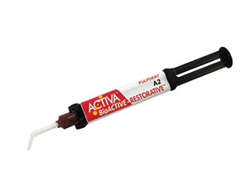

In 2007, Tokuyama Dental America introduced the first 100% supra-nano spherical filled resin composite called Estelite Sigma Quick. This is a universal composite that allows for high polishability due to the spherically designed particles that are manufactured without irregular edges. This concept also led to the development of the acclaimed premium polychromatic composite, Estelite Omega (Tokuyama Dental America).156

In 2018, we have witnessed the launch of other spherical-particle-based composites, notably Harmonize (KaVo Kerr) and Brilliant Everglow (COLTENE). Brilliant Everglow is termed an “all-round” material with dual shade compules, whereas Harmonize relies on “crosslinks of spherical silica and zirconia particles together with positive and negative charges.”

The year, 2019, marks the introduction of several products that buck the trends of the last 20 years in restorative dentistry. The first, Tokuyama Universal Bond, is a truly universal agent that bonds to virtually everything. This includes direct, indirect, light-cure, self-cure, and dual-cure materials in self-etch, total-etch, and selective-etch modes. What makes this material a paradigm shifter is that no light curing, primers, or activators are needed.

Tokuyama Universal Bond (Tokuyama Dental America) is a next-generation bonding agent that bonds to all tooth surfaces and dental materials and does not require light activation.

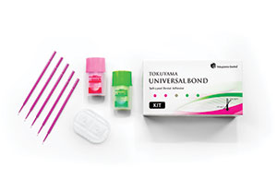

Also, 2019 brings the introduction of another truly ground breaking material, Omnichroma (Tokuyama Dental America). This is the first omnichromatic composite resin-based material that will match any tooth, any shade, on any patient. In an era when many composite materials require having multiple shades available for use in any given clinical situation, poses a unique opportunity for dental offices that cannot stock dozens of product shades for financial or space reasons.

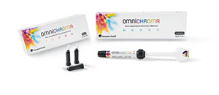

Omnichroma (Tokuyama Dental America) is a next-generation composite material with fillers that changes the way light is transmitted. This allows a single shade of the material to match virtually every tooth.

Omnichroma does not attempt to match the value of the tooth shade the way other composites do by using pigments and dyes. Instead, Tokuyama Dental America debuts its Smart Chromatic Technology with this product. The material uses uniformly sized spherical filler particles, similar to other composites in the Tokuyama Dental product line; however, Omnichroma fillers change the way that light is transmitted. Ambient light is altered along the red-to-yellow area of the color spectrum, allowing it to match the colour of the patient’s surrounding dentition. It includes UDMA/TEGDMA monomers and 260-nm silica and zirconia fillers.

Omnichroma material characteristics include high polishability, excellent handling, and resistance to ambient light effects. Wear of the composite and opposing tooth structure, are also excellent. The paste is opaque-white prior to curing, making the material more visible for the clinician during manipulation. The application of a light source during curing causes the material to blend with the colour of the surrounding tooth. A chamfered margin is suggested to make marginal borders disappear.

**APPLICATION IN DENTISTRY**

They are used as direct and indirect aesthetic restorative material.

They are a component of the fiber reinforced composites used in FRC posts, fiber splints, etc.

They are also used for direct splinting of mobile teeth with or without glass fiber or metal wire.

They are also used as luting agents and as root canal sealers.

Chemical cure and dual cure resins are also used as core buildup materials in post endodontic restorations.

Filled and unfilled composite resins are used in preventive dentistry as pit and fissure sealants and in preventive resin restorations (PRR).

They are used in bonding of orthodontic brackets during orthodontic treatment.

**COMPOSITION**

Although the details of the composition of individual brands vary, modern composite resins are all broadly similar.

They consist of the following components:

1. A matrix phase generally made from a dimethacrylate monomer or blend of monomers.
2. Reinforcing fillers made of finely divided silicate or glass particles, possibly with added radio-opacifying agent, such as barium oxide.
3. A silane coupling agent to attach the filler to the matrix.
4. An initiator system to promote the setting polymerization reaction.

**RESIN MATRIX**

It is the chemically active component of the composites, which undergoes polymerization to convert the carbon double bonds in the monomer into single bonds of polymers during addition polymerization reaction. Thus, the fluid monomer converts to the rigid polymer. It is this ability of the composites to convert from a plastic mass into a rigid solid that allows it to be used for restoration of the teeth. Most composite resins use monomers that are aromatic or aliphatic diacrylates. The most commonly used monomer is the bisphenol A-glycidyl methacrylate (bis-GMA), a dimethacrylate derived from the reaction of bisphenol A and glycidyl methacrylate. This resin is commonly referred to as “Bowen’s resin” after its inventor R.L. Bowen (1962). Since it has a higher molecular weight than methyl methacrylate, the density of methacrylate double bond groups is lower in the bis-GMA monomer, which results in lower polymerization shrinkage. The use of a dimethacrylate also results in extensive cross-linking that consequently enhances resistance to degradation by solvents and also improves the properties of the polymer. Other difunctional molecules used in composites are urethane dimethacrylate (UDMA) and triethylene glycol dimethacrylate (TEGDMA). UDMA replaces the bisphenol A backbone with a linear isocyanate one. Both bis-GMA and UDMA, because of their high molecular weight, are highly viscous at room temperature. For practical reasons, they are diluted with another diluent monomer with an aliphatic backbone, TEGDMA, which has a much lower viscosity. A 50/50 blend of bis-GMA and TEGDMA has a very low viscosity of 200 cP (centipoises), whereas a blend of 25% TEGDMA and 75% bis-GMA has a viscosity of 4300 cP. Both bis-GMA and TEGDMA contain two reactive double bonds, which during polymerization form covalent bonds between the polymer chains in a cross-linked network. This cross-linking improves the properties of the composite produced, such as increase in modulus and reduction in solubility. Other diluent monomers used are methylmethacrylate (MMA) and ethylene glycol dimethacrylate (EGDMA).

**FILLERS**

The role of the fillers in composite resins is to reinforce their mechanical properties and provide a blended material whose overall properties make it suitable for the clinical repair of teeth. A limited range of materials has been used, with greater emphasis on variations in the particle size and size distribution than on chemical composition. Early materials were filled with powdered quartz, whereas modern composites are more likely to be filled with finely divided barium silicate or a radio-opaque silicate glass.157 Filler loadings are typically of the order of 55% by volume, as they were in Bowen’s original formulation.158

Incorporation of filler particles into the resin matrix significantly improves the properties of the composite if the filler particles are well bonded to the matrix. Filler particles are of inorganic composition. The first filler particles used were quartz (silicon dioxide/silica). Filler particles may also be composed of borosilicate or lithium aluminum silicate glasses, or barium, strontium or zinc glasses, which are radiopaque. Colloidal silica and elements of high atomic weight such as barium, strontium, zirconium, or ytterbium are also incorporated into the filler particles. Inorganic quartz has been used extensively as a filler in the first generation of composites. It is chemically inert and extremely hard and difficult to polish and may cause more abrasion of the opposing teeth.

In addition to the filler, a coupling agent is employed. This is typically a silicon-based substance that contains two types of functionality in the same molecule, an alkoxy end which binds to the filler particle surface, and a vinyl end which undergoes an addition reaction to become incorporated into the resin matrix.159 The most commonly used substance for this purpose is γ-methacryloxy-propyl tri-methoxysilane.160 This substance not only promotes bonding between the filler particles and the resin matrix, thereby proving mechanical reinforcement, it also resists ingress of water at the interface. Water would otherwise migrate to the inorganic surface, attacking the interface and destroying the bond between the filler and the resin. Silanes provide a water-resistant bond at the interface between the inorganic and the organic components, and this makes the resulting composite durably in clinical service. 159

The size range of the filler particles was the basis of an early classification of composite resins. Though the range of particle sizes has now been extended to include nano-particles, this is still a useful approach to classifying these materials.

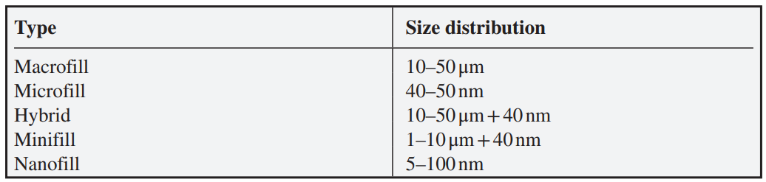

The abovetable shows the order of development of composite resins based on the particle size of fillers.

The earliest commercial composites for use in dentistry had particle sizes in the range 10–50 μm and would now be considered ‘macrofill’ materials. They were strong mechanically but difficult to polish. In addition, wear caused the surfaces to roughen readily, resulting on poor long-term aesthetics. To overcome these problems, composites were blended with much smaller particles to create ‘microfill’ materials. However, because these particles are harder to blend into the monomer mixture due to adsorption of monomer molecules on their much larger relative surface areas, the total volume fraction of filler that could be achieved was lower than for macrofills. Consequently, the mechanical properties were inferior. This led rapidly to the approach of blending the large and the small filler particles to create the so-called ‘hybrid’ composites. These had good mechanical properties, mainly because of the higher filler loadings that could be achieved with the larger particles, and were less susceptible to wear due to the influence of the smaller particles.161

Since these developments, there have been further refinements in filler technology, which have mainly involved the use of still finer filler particles (typically in the μm range), often in conjunction with slightly larger particle sizes. One version of minifill, also known as microhybrid composites. They are considered to be universal composites because they can be used for most anterior and posterior repairs, due to their combination of mechanical strength, polishability and long-term aesthetic properties.

Nanofilled materials are the most recent of the composite types, and these are based on fillers of nanoparticle dimensions. Full details of their composition are typically confidential because of commercial considerations, but one approach to problems caused by incorporating such fine particles has been to incorporate them first into composite that is pre-polymerized, then fractured and dispersed in further amounts of resin monomer, usually with slightly larger filler particles.162

Physical properties of these materials are generally very good and their volumetric shrinkage and water sorption properties also compare favourably with composites containing larger particle size fillers. Studies have shown them to combine the mechanical strength of hybrid composites with the polishability of the microfills. They also have good wear resistance and good optical properties.163

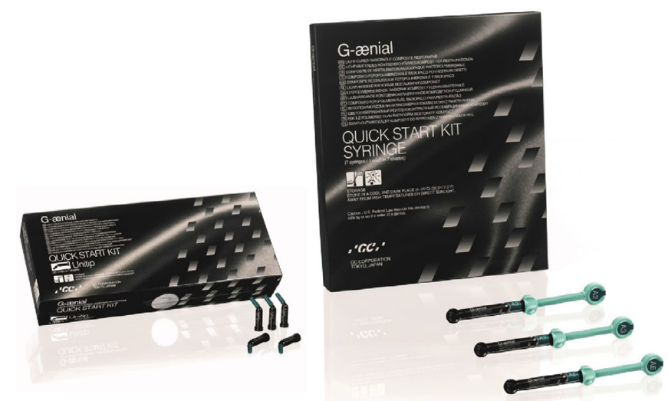

As composite resins are classified by their particle size and size distribution, modern composites are distinguished by their consistency. The two broad groups are termed ‘packable’ (sometimes referred to as ‘condensable’) and ‘flowable’, and they differ in their viscosity. Packable composites are more viscous as a result of modifications to the filler particle size distribution, though they generally do not have higher overall levels of filler than universal composites. Flowable composites, by contrast, are of lower viscosity. As a result, they can be dispensed from syringes with very fine bore needles into small spaces, thereby enhancing the adaptation of the composite restoration. Their lower viscosity is achieved by a slight reduction in the filler content and also by adding other compounds such as surfactants to enhance their flow properties. Though the details of these alterations to composite formulations are not made public by manufacturers, it is known that they do not compromise the mechanical strength properties of the set cement.164

The different consistencies influence the ways in which these types of composites are used in the clinic. While a universal restorative may have either a stiff consistency or a more fluid one, depending on the details of its composition, they are designed to be capable of use both for fine margins of restorations and for bulk (incremental) filling. By contrast, packable and flowable composites are designed for different purposes, and usually are used together for different parts of a single cavity restoration.

Packable composites are designed to be placed with the aid of an amalgam condenser or other instrument and, when cured, they have good mechanical and wear properties. Their high viscosity prevents them from slumping and enhances the ability to obtain tight interproximal contacts in practical use. Flowable composites, because of their lower viscosity, are able to penetrate into irregularities, thereby ensuring a good seal at the margins of restorations. It is claimed that they can be used to prepare thin layers of cured material that do not entrap air and also that, when set, they are flexible enough to be able to survive in regions of high stress, such as the margins of Class I or Class II cavities and in Class V cavities. However, this seems somewhat questionable and is not supported by any scientific evidence.

Filler particles are most commonly produced by grinding or milling quartz or glasses to produce particles in the size range of 0.1–100 mm. Smaller particles with the size ranging from 0.06 mm to 0.1 mm are produced by a pyrolytic or precipitation process. During the pyrolytic process, low molecular weight compounds such as silicon tetrachloride (SiCl4) are polymerized by burning in an atmosphere of oxygen and hydrogen. During this process, macromolecules consisting of silicon dioxide (SiO2) are formed. Hence, these particles are called pyrogenic silica particles. (Pyrogenic means born in fire.) Colloidal silica is produced through sol-gel chemistry having almost monodispersed particle sizes. This is of advantage, since various sizes of particles can be produced and blended in controlled volumes to produce composite resin of optimum required properties. The volume of fillers particles, their size, size distribution, index of refraction, radiopacity, and hardness are the important factors that determine the properties and clinical applications of the resulting composite resin. As silica filler particles are approximately three times as dense as the resin monomer, 75 wt% of the filler is equivalent to approximately 50 vol% of the filler. The amount of fillers that can be incorporated into the resin matrix is determined by the surface area of the filler particles. When comparing equivalent weight percentages of fine (0.4–3 mm) and microfine (0.04–0.2 mm) fillers, the surface area of the microfillers is much larger. This large surface area can form polar bonds with the monomer molecules and thicken the resin.

The advantages of fillers are as follows:

1. Fillers decrease polymerization shrinkage. The resin matrix per se is subject to a high degree of polymerization shrinkage, be it MMA, bis-GMA, UDMA, or TEGDMA matrices (ranges between 4% and 7%). By incorporating large amounts of glass fillers, the amount of resin matrix in the same volume is reduced. The lesser the matrix, the lesser the percentage of polymerization shrinkage, since the fillers do not take part in the polymerization process. However, polymerization shrinkage cannot be totally eliminated.

2. They decrease the coefficient of thermal expansion (CTE). MMA monomers have a high CTE (80 ppm/°C). This can also be reduced by the addition of ceramic fillers which have a CTE similar to that of the enamel and dentin (8–10 ppm/°C).

3. Water sorption is less for composites as compared with unfilled resins.

4. Fillers improve the mechanical properties of the composites such as hardness, compressive strength, tensile strength, wear resistance, and modulus of elasticity.

5. The use of heavy metals such as barium and strontium incorporated into the glass provides radiopacity.

6. Fillers prove an ideal means of controlling various esthetic features such as colour, translucency, and fluorescence.

To ensure acceptable aesthetics of the composite restoration, the refractive indices of the fillers and the resin should closely match those of the tooth structure to achieve translucency similar to enamel and dentin. The resin commonly used in all composites consists of a mixture of bis-GMA and TEGDMA which yields a refractive index of about 1.5. Most glass and quartz fillers have refractive indices of approximately 1.5, which is adequate to achieve sufficient translucency.

**NANOTECHNOLOGY IN FILLERS**

Nanofillers are very different from traditional fillers and require a shift from a top-down to a bottom-up manufacturing approach. For traditional fillers, large quartz, glasses, or ceramic particles are milled down to smaller particle sizes. However, these milling procedures usually cannot reduce the filler particle size to below 100 nm (0.1 mm). Nanomeric particles, on the other hand, are monodispersed, nonaggregate, and non-agglomerated silica nanoparticles in the size range of 20–75 nm, nanoparticles measuring 25 nm, and nanoaggregates measuring approximately 75 nm made of zirconium/ silica or nano silica particles. The distribution of these filler particles gives a high filler loading of up to 79.5%.

Nanohybrid and nanofilled composite resins are two types of composite resins that are generally referred to as nanocomposites. The decreasing filler particle size allows an increased interfacial area between the matrix and the fillers leading to better dispersion. This in turn will increase the flexural strength and surface microhardness.

Nanoclusters typically consist of primary zirconia–silica particles (average size of 2–20 nm) agglomerated as spheroidal particles having a broad size distribution with an average particle size of 0.6 mm. Though similar in size to hybrid or microhybrid particles, the nanoclusters behave differently in clinical situations of wear. The nanoclusters wear by breaking off individual primary particles rather than plucking out the larger nanocluster particle. Nanofillers also offer advantages in optical properties. Larger particles scatter light passing through the composite giving an opaque appearance if these particles are mismatched in their refractive indices. The size of the nanofillers, on the other hand, is far below the wavelength of light, making them unmeasurable by the refractive index. When light passes through the composite resin, long wavelength light passes directly through and the material shows high translucency. In addition, when placed against a dark background, the nanoparticles referentially scatter blue light, giving the composite an opalescent effect.

**COUPLING AGENT**

The properties of the composite resin depend on the bond between the resin matrix and the filler particles. The filler particles are not soluble in the resin matrix since the resins are hydrophobic, whereas the silica-based glass particles are hydrophilic due to a surface layer of hydroxyl groups bound to the silica. Hence, the glass particles do not bond to the resin matrix naturally. This problem is addressed by the incorporation of coupling agents such as an organic silicone compound called silane. The silane coupling agent most commonly used is g-methacryloxypropyl trimethoxysilane.

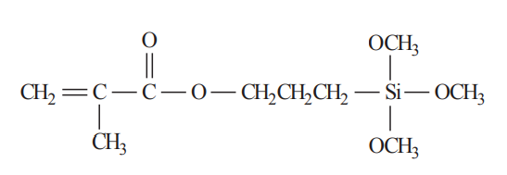

g-Methacryloxypropyl trimethoxysilane, the silane coupling agent.

The silanes have a hydroxyl group and a methacrylate group on either end. The hydroxyl group reacts with the hydroxyl group on the hydrophilic fillers by a condensation reaction at the interface between the glass particles and the silane. This creates covalent bonds at the glass–silane interface. On the other hand, the methacrylate group (similar to conventional resin composites) reacts with the resin matrix forming a bond from the filler through the silane coupling agent to the polymer matrix.

The aforementioned coupling reaction binds the filler to the resin matrix to enable the stresses produced during the polymerization reaction to be transferred from one filler particle to the adjacent filler particle through the lower stiffness polymer matrix. As a result, the strength of the composite is intermediate to that of the resin matrix and the filler separately. A bond between the filler particle and the resin matrix allows the distribution of stresses generated under function.

**PHOTOINITIATORS**

When composite resins were first introduced, their polymerization involved free radical initiation by a combination of benzoyl peroxide with tertiary amine activator, delivered in two different pastes, known respectively as base and catalyst. Contemporary composites are visible light-activated one-paste systems and the principal photo initiator used is camphorquinone. It is used in conjunction with a co-initiator, typically an amine. This latter compound does not absorb light, but is necessary to react with the light-activated camphorquinone molecule to generate free radicals and hence initiate the chain polymerization.165

When camphorquinone is irradiated by light of the appropriate wavelength, the carbonyl groups react. For camphorquinone there are two carbonyl groups, both of which can undergo the processes to generate radical centres. This means that a total of four radical centres are produced from one camphorquinone molecule. It is also the reason that the optimum ratio of camphorquinone to amine is 1:2, and this is the ratio typically included in a composite formulation.166

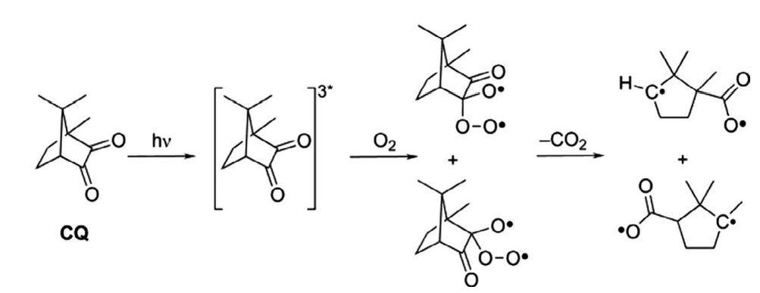

Free radical generation by camphorquinone

Camphorquinone has an absorbance range between 400 and 500 nm wavelength, with a maximum at 468 nm. This is in the blue region of the visible spectrum, and is the reason that camphorquinone appears yellow in white light. Inclusion of camphorquinone in a composite formulation introduces a yellow colour, some of which remains after curing. As this affects the overall aesthetics, it is considered undesirable and alternative photo initiators have been sought. The most widely studied of these is 1-phenyl-1,2 propanedione (PPD).167

PPD absorbs in a slightly different region of the spectrum from camphorquinone, since the molecule mainly absorbs in the near UV region, with a maximum absorption at 398 nm, and absorption extends only slightly into the visible region. It thus appears less yellow than camphorquinone. It generates free radicals by the homolytic fission process.168

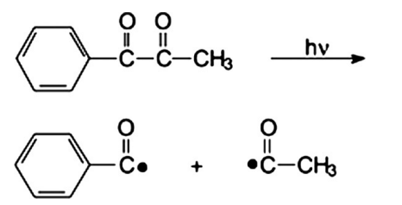

Free radical generation by PPD.

This process yields a total of two free radicals per PPD molecule. An advantage of this is that the radical fragments are smaller and more independent than those produced by camphorquinone, where two of the radical centres are on the same molecular pieces and the molecular fragments relatively large. This means that diffusion apart of the radicals is more difficult, so that there is a greater likelihood of radical recombination in the camphorquinone system than in the PPD one. This, in turn, implies that PPD would have a greater efficiency than the camphorquinone system. Against that, the rate of formation of free radicals from camphorquinone is higher than that from PPD.

The effectiveness of these photo initiators is dependent on the lamp used to bring about cure with them. Initially, cure lamps employed quartz-tungsten-halogen (QTH) bulbs, which emit blue light with a maximum emission around 470 nm and a wide spectral output. These favour the camphorquinone system and give effective degrees of conversion in composites that contain this system. More recently, cure lamps using light-emitting diodes (LEDs) for their light emission have been used. These have a narrower spectral output than QTH bulbs and a slight shift in the maximum output into the region 450–460 nm. In principle, this may make them marginally more effective with PPD than with camphorquinone. In practice, however, experimental studies have shown no significant differences in depth of cure for different cure lamps applied to formulations containing either of these two initiator systems. Experiments of this type can thus be seen to confirm the effectiveness of the camphorquinone-amine initiator and explain its continuing pre-eminence as the initiator system in visible light-cured composite resins.166

**OTHER COMPONENTS**

**INHIBITORS**

To prevent a spontaneous start of polymerization of monomers, a very small number of inhibitors are added to the resin. These inhibitors have a strong reactivity potential with free radicals. In situations where the composite is exposed to ambient light briefly when the material is dispensed, free radicals may be formed. The inhibitor present in the composite resin reacts with these free radicals, thus inhibiting the ability of the radicals to initiate the polymerization process. It is only after all the inhibitor molecules are consumed that the polymerization process can be initiated. The inhibitor used is butylated hydroxytoluene in concentrations of 0.01%.

**COLOUR MODIFIERS**

To achieve the various shades of dentin and enamel, dental composites must have visual colouration and translucency that can simulate the tooth structure. Shading can be achieved by adding different pigments such as various metal oxides in minute quantities. Titanium dioxide and aluminium oxide are added in minute amounts (0.001–0.007 wt%) as effective opacifiers. All colour modifiers and opacifiers affect the light transmitting ability of the composite resin. Darker shades of composites transmit less light than lighter shades, suggesting that different shades and opacities of composites have different depth of cure when cured with light. Studies have suggested that darker shades of composites be placed in thinner layers or cured for a longer period of time to ensure optimal polymerization.

**POLYMERIZATION REACTION**

Most polymerization reactions are of two types, addition polymerization in which byproducts are not formed and condensation polymerization in which a low molecular weight byproduct such as water or alcohol is formed. Free radical addition polymerization as occurs in composite resins takes place in three stages: initiation, propagation, and termination. Chemical cure composites are activated by mixing two pastes, one which contains the benzoyl peroxide initiators and the other paste which contains the tertiary amine activator. When both the pastes are mixed, the benzoyl peroxide reacts with the amine to produce free radicals that attack the double bonds of the dimethacrylate molecules and begin the process of addition polymerization.

Visible light-activated composites use camphoroquinone as the source of free radicals. Upon cessation of the initiator molecule (camphoroquinone) by visible light in the blue spectrum, in the presence of the aliphatic amine activator, free radicals are produced which initiate the polymerization. Since the dimethacrylate and diluent monomers have reactive double bonds at each end of the molecules, polymerization results in a highly cross-linked polymer.

**CURE LAMPS**

As the majority of composites used in contemporary dentistry are light-cured, it follows that the nature and effectiveness of the cure lamp is critical to the performance of the composite in clinical practice. As previously mentioned, the original cure lamps used QTH bulbs.169 These emit light of wavelength around 430–500 nm, ie, at the blue end of the visible spectrum, and hence they are well suited for compositions containing the camphorquinone-amine initiator system. However, the wavelength of maximum absorption for camphorquinone (468 nm) represents only a fraction of the spectral output of such lamps, so that most of the energy is outside the range useful for promoting cure, and hence wasted. On the other hand, QTH lamps also emit heat, which may help to increase the degree of cure, particularly within the material. This may be a useful adjunct to the cure induced by the light itself.170

More recently there have been moves to replace QTH lamps with LEDs. These have very narrow emission ranges and their output is concentrated in the blue wavelength region of the spectrum, ie, in the range 440–480 nm. They are therefore able to cure composites at least as well as QTH lamps, while generating much less heat. Composites cured using LEDs appear at least as well polymerized as those cured with QTH lamps and to have similar mechanical properties.171

Wavelength of emitted light is not the only criterion when considering the effectiveness of dental cure lamps. The power output is also important. This is because high power emission results in the generation of more free radicals per unit time than lower power emission. On the other hand, higher concentrations of free radicals in a polymerizing system result in lower molar mass polymers. This is because each free radical generated by an initiator molecule begins a chain reaction involving the available monomer molecules. If there are more such free radicals, each has fewer monomer molecules available from which to build its polymer.

High power versions of both QTH and LED are available, and offer the prospect of shorter cure times with improvements in the speed with which a restoration can be completed. Despite the anticipated change in the detailed structure of the polymerized composite resin, physical properties of materials cured with these high-power systems are comparable with those of composites cured with lower power units.172

It is difficult to draw hard and fast conclusions concerning the relative merits of the various types of cure lamp on the market. All types seem capable of producing an acceptable degree of cure, and differences found in scientific studies probably do not translate into significant differences in clinical performance. In practice, the performance of all cure lamps appears to give acceptable degrees of cure of commercial composite resins, and so any type of commercial dental cure lamp can safely be used for activating the cure of composites.

**POLYMERIZATION SHRINKAGE AND SHRINKAGE STRESS**

When composite resins undergo polymerization, they shrink slightly. This is because, in an addition polymerization, the free volume occupied by the double bonded end of a monomer molecule is greater than that occupied by the equivalent single bond in the polymer molecule. This effect classically allows addition polymerization to be studied by the technique of dilatometry, whereby the reduction in volume of a substance such as methyl methacrylate is followed by observing the contraction in a narrow-bore tube of a device known as a dilatometer. There is a link between contraction and depth of cure. Shrinkage has important clinical consequences for these materials, and can result in either interfacial gap formation at the margins of the restoration or cuspal movement in repaired teeth. As composites undergo curing, stresses develop within the material. These are the result of complex interplay between the forces due to polymerization shrinkage, polymerization rate, onset of gelation and elastic modulus of the set composite. Another important factor is the shape of the cavity being restored, since it imposes restrictions on the possible volumetric change of the composite. Also, compliance of the walls of the cavity towards flexure has an influence on the resulting stresses. The phenomenon of polymerization shrinkage in composite resins based on either bis-GMA or UDMA is considered to be their most important drawback. For many years now, a substantial effort has been devoted to the search for alternative monomer systems that show lower or even no contraction when they polymerize. These efforts have led to some amount of success, as demonstrated in research publications. For example, a series of monomers, such as spiro-orthocarbonates, have been employed which undergo expansion on polymerization due to differences in configuration between the tightly coiled monomer and the less tightly coiled polymer. In addition, epoxy-polyol molecules have been studied, and these cure by a ring-opening reaction that shows up to 50% less shrinkage than the polymerization of monomers used in conventional composites. Despite these findings, the current dental composites remain mainly formulated from bis-GMA and/or UDMA systems. Moreover, the clinical technique of incremental build-up is able to mitigate partly against the problems caused by polymerization shrinkage, since by placing the composite in thin layers and curing them individually, contraction takes place in that part of the restoration, and the next layer is placed so as to fill some of the space vacated by the contraction. In this way, correct clinical handling of the material ensures that problems arising from polymerization shrinkage are minimized.173

**SOFT-START POLYMERIZATION**

The technique of the so-called soft-start polymerization was developed in the late 1990s in order to reduce the rate of initial shrinkage and potentially maintain the integrity of the bond to the tooth. It employs a cure lamp that either emits only low irradiance for the first 10s, after which it switches to maximum output for the remaining duration of the light exposure; or emits a progressively increasing irradiance in the early stages, after which it, too, emits maximum output for a brief period. At the molecular level, the effect of soft-start polymerization is to extend the gelation time of the composite. By reducing the rate of early polymerization, the rate of shrinkage is also reduced. This helps to maintain the seal at the margins of the restoration, and may allow relaxation processes to take place, so that stresses do not build up to the same extent as in conventional cure regimes. Laboratory studies have suggested that soft-start polymerization may be beneficial. In particular, marginal adaptation appears to be improved, with a corresponding reduction in marginal leakage. However, these findings do not seem to translate to measurable improvements in clinical performance. Though soft-start polymerization undoubtedly improves the marginal seal, as well as increasing the micro-hardness of the set composite, it did not reduce sensitivity to a cold stimulus in patient evaluations. Two cure regimes were employed on composites in Class I and Class II restorations, one a soft-start technique, and the other a conventional steady irradiation technique. Sensitivity to a cold stimulus was evaluated using a standardized approach at 2 weeks, 3, 12 and 24 months, and no differences were found between the two cure techniques. Patients reported equal discomfort with both approaches to the cure of their composite restorations. This suggests that soft-start polymerization does not offer any advantages, and that it is not necessary with these materials.

**OXYGEN INHIBITION**

When composite resins undergo polymerization, a thin layer exposed to the air fails to react. This is due to the presence of oxygen. The oxygen molecule is a di-radical, that is, it has two unpaired electrons. This makes it reactive towards the free radicals within the setting composite, and it reacts readily with these free radicals to form unreactive electron pair bonds. This quenches the radical centre and inhibits the polymerization process. Studies have shown that this layer is of the order of 13–20μm thick in commercial methacrylate-based composite resins. When restorations are placed in increments, the thin oxygen-inhibited layer of one increment is covered by the next increment. This shields it from ingress of further oxygen, so that it cures when irradiated through the next increment. As the oxygen-inhibition layer is unpolymerized, in principle there can be some limited mixing when a new layer of uncured paste is placed over it. This has been considered to be important in bonding the increment layers together. However, recent studies have shown this not to be the case. In one study, for example, shear bond strength was determined for specimens prepared in increments both in the presence of air and in an inert atmosphere. No significant differences in shear bond strength were found, a result that was taken to show that the free radical polymerization reactions were able to proceed equally in both conditions. This, in turn, meant that oxygen inhibition was not significant in these systems. In another study, the interfacial bond strength between the increments was determined at various times in air and in a nitrogen atmosphere, and again no significant differences were found. From these findings, it must be concluded that, though a thin oxygen-inhibition layer undoubtedly occurs in these materials, it is too thin to influence the eventual properties of the cured composite resin, and its presence is not responsible for the layers bonding together.

**CLINICAL APPLICATIONS OF COMPOSITE RESINS**

The main application of composite resins in contemporary dentistry is as direct repair materials in a variety of cavitated teeth and it is estimated that 95% of all anterior restorations and 50% of all posterior restorations are now made with composite resin. In addition, they are also being increasingly used as indirect repair materials for a number of uses, including as onlays and inlays, and as fissure sealants.

The main material used for many years for the direct repair of teeth was silver amalgam. This combined ease of placement with adequate physical properties made it the material of choice. However, there are increasing concerns about its use, and direct composites are replacing it in clinical practice in many parts of the world. Composites have the considerable advantage of superior aesthetics, being fully capable of matching the natural tooth in terms of shade and translucency. Regarding amalgam, there is also a growing concern with environmental issues of waste disposal and the misplaced perception of their toxicity, due to the mercury that they contain. Modern direct composites survive well in the mouth and numerous clinical studies attest to their ability to remain functional for extended periods of time, i.e., 10–15 years or more. There is a problem with claims of longevity, however, and that is, by the time long-term studies have been completed, the brands in question are obsolete and have been replaced on the market. As far as durability is concerned, we can assume that the newer formulations do not differ significantly from the earlier brands, though this is not what the manufacturers claim.

**CURING OF COMPOSITE RESINS**

Composite resin pastes generally set by free radical polymerization, a process which is a chain reaction that involves opening of the terminal carbon–carbon double bonds in the dimethacrylate monomers.

There are three steps in the overall process, beginning with initiation, followed by propagation and termination. In the initiation step, the initiator is typically irradiated with light at the appropriate wavelength, and this causes it to fracture into free radicals. This fracture involves the formation of two reactive species containing an unpaired electron, and splitting of a chemical bond. Breaking a chemical bond in this way is termed homolytic fission. The high reactivity of the resulting free radicals means that they will react readily with nearby monomer molecules, forming an enlarged radical as a complete molecule of monomer becomes incorporated. This process is repeated many times in rapid succession, causing the polymer to grow quickly. This rapid sequence of additions of monomer molecules is known as propagation, and is characterized by retention of the unpaired electron, with consequent high reactivity. Eventually, there are so many growing polymer molecules in the system that the possibility of two unpaired electron radical centres coming together increases. When this happens, the result is that the radical centres are extinguished. This can occur either by combination, in which the individual unpaired electrons of the free radicals pair up to form a covalent bond, or by disproportionation. In the latter case, one free radical removes a hydrogen atom from the other free radical, leading to the formation of two molecules, each with different end groups. One is terminated in a methyl group (CH3–), and the other in a double bond (>C=CH2). The extent of polymerization can be quantified by comparing the proportion of double bonds in the set material with those in the composite paste as formulated initially. This is typically expressed as a percentage, and called the degree of polymerization (DP), or depth of conversion (DC). Values vary widely in practical dental composites, ranging from 35% to 77%. The majority of the polymerization of a dental composite resin occurs very quickly, typically during the 20–40 s or so of light irradiation from the dental cure lamp. However, when the free radicals within the material do not terminate immediately, the lamp switches off. Hence, they are able to continue their propagation steps for some time after this initial cure, as growing polymer molecules containing free radical centres continue to incorporate extra monomer molecules. Shrinkage, which is associated with polymerization, has been shown to continue for up to 24 h after initial setting in a process known as ‘post-polymerization’. As dimethacrylate monomers have at least two double bond sites capable of undergoing polymerization, their reaction leads to the formation of a highly crosslinked network. Immediately after light irradiation begins, there is a rapid reaction that causes the DC to rise quickly, and the crosslink density to develop with similar speed. This brings about a rapid increase in the viscosity of the system leading to gelation of the viscous liquid composite. At gelation, there is a substantial reduction in the mobility of the molecules in the system, though this affects the higher molar mass species more than the lower mass one. Since the higher molar mass species are the polymer chains containing several monomer molecules and retaining the free radical centre, whereas the low molar mass species are unreacted monomer molecules, it follows that the polymer chains become almost completely immobile. This prevents the termination reactions from occurring, while leaving both initiation and propagation processes to continue. Hence the rate of reaction takes off dramatically, causing the phenomenon of auto acceleration to occur. As it does so, the viscosity becomes so high that even the monomer molecules become unable to move through the network. When this stage is reached, there is another change of state, this time from rubbery polymer to a glassy one. This vitrification prevents further reaction and traps unreacted monomer molecules and partly polymerized free radicals in the structure. This explains why the maximum DC is limited to about 75–80% in these systems. It also explains why there are still radical centres in existence at the end of the setting process. Their presence explains the post-polymerization phase of setting, which probably occurs due to slight molecular motion within the vitrified structure that allows further polymerization to take place at a very slow rate. Free radicals may continue to be detected for several weeks after vitrification, though there is little further polymerization beyond 24h.

**DEGREE OF CONVERSION**

The DC achieved within a composite is important because it controls several properties of the cured material, including mechanical strength, polymerization shrinkage, wear behaviour and monomer released. It is most commonly determined by Fourier transform infrared spectroscopy (FTIR) since the double bond in the monomer molecules gives rise to a sharp and distinct peak at 1640 cm−1. DC can be determined by measuring the reduction in the intensity of this peak relative to a reference peak that is known to be unaffected by polymerization. The peak usually chosen as the reference peak is the one at 1608 cm−1, which arises from absorption by the aromatic rings in bis-GMA. FTIR may be complicated because there are several functional groups capable of absorbing infrared radiation in the region of interest for carbon–carbon double bonds. These peaks may reduce the signal-to-noise ratio at 1640 cm−1, and thereby interfere with the quantification process. There is also a problem caused by the presence of double bonds in the silane coupling agent at the filler–matrix interface. These may also complicate the determination of the DC. An alternative spectroscopic technique that has been used in studies of DC is Raman spectroscopy. Raman bands appear at the same wavelength as those used in FTIR, as they are active in both infrared and Raman absorption modes. No particular advantages arise from the use of Raman spectroscopy over FTIR, and as a technique it has not been used quite as much for studies of this type. In addition to spectroscopic techniques, DC has been studied indirectly using micro-hardness methods, either Vicker or Knoop hardness. There is a good relationship between the DC and micro-hardness, though the relationship is complicated because micro-hardness is affected not only by DC but also by extent of crosslinking. It can also be affected by accidentally placing the micro-hardness indenter directly on a filler particle. A further disadvantage of the use of micro-hardness is that measurements cannot provide quantitative information on the fraction of double bonds that have undergone polymerization.

**CROSSLINKING**

DC is not the only feature of the polymerization process that affects mechanical properties. Another important aspect is the degree of crosslinking between the molecules. This not only affects mechanical strength and hardness of the cured composite materials for the direct restoration of teeth it also affects stability and appearance because materials with lower crosslink density can take up moisture and hence swell more easily. This can lead to hydrolytic degradation. Swelling may also alter the appearance of the composite, either because coloured substances are taken up and the shade changes, or because uptake of saliva causes the translucency to change. Crosslinking cannot be measured directly, because it arises from the same reaction as the polymerization of the monomers, namely conversion of the C-C double bonds to single bonds. However, an indirect technique can be used instead. One possibility is to determine the extent of softening of the composite when immersed in ethanol. This technique involves comparing values for the surface hardness before and after storage in ethanol. An alternative possibility is to measure the glass transition temperature. This property can be determined either by differential scanning calorimetry or by dynamic mechanical analysis. The glass transition temperature is the temperature at which vitrification occurs during the cure reaction, and above this temperature the polymer is rubbery, while below this temperature, the polymer is glassy. As with other means of studying crosslinking, it gives only an indication of the crosslink density, because its value depends not only on degree of crosslinking but also on DC and other factors, such as the viscosity of the monomer phase.

**DEPTH OF CURE**

Depth of cure is influenced by the way light is transmitted through the composite resin. The interaction of light with the material is complicated and affected by several factors. Some of the light may be reflected from the surface and not enter the composite at all. Some light may be absorbed by the filler and especially by the pigments, which is the reason that darker shades have lower depths of cure than lighter ones. Filler particles can reduce the transmission of light by scattering, an effect that depends on both the particle size of the filler and the wavelength of the light. This effect is most pronounced with filler particles of the order of half the wavelength of the light i.e., in the region of 200–250 nm. Fillers also interfere with the transmission of light because of the difference in refractive index between them and the matrix phase. This causes refraction at the interface between the filler and the polymer, which results in altered light intensity and thus recued conversion of monomer to polymer. This effect is particularly severe in the so-called flowable formulations which contain relatively high levels of diluent molecules because the mismatch in the refractive index between these substances and the fillers is greater than that with bis-GMA or UDMA.

**DEGREE OF CURE**

One of the most important parameters of an initiating system is the resulting degree of cure. This is a measure of how many methacrylate groups are polymerized, divided by the number of starting methacrylate groups. Light-cured composites have a degree of cure ranging from 55% to 75%. In general, the higher the degree of cure, the greater the mechanical properties. This is true of elastic modulus, tensile strength, and other physical parameters such as water sorption and wear. Condon et al found that increasing the degree of cure from 56% to 66% increased the resistance of the composite to wear. A higher degree of cure also reduces the amount of unpolymerized monomer that can be leached out of the composite. Anseth et al estimated that at 75% cure, 6.25% of the monomer is unreacted and not incorporated into the cross-linked network. As with the hydrolytic breakdown products, there are concerns about the effect of unpolymerized monomer escaping from the composites.174

**PARAMETERS THAT AFFECT CURE**

Many factors will affect the degree of cure. Two of the most important are viscosity and the presence of oxygen. Oxygen is known to terminate free radical polymerization and is observed in the oxygen inhibition layer common to sealants and composite resins. At the surfaces, where oxygen concentration is high, the inhibition is sufficient that polymerization is effectively prevented. The viscosity of the unpolymerized resin will also affect the degree of cure. For a free radical to propagate, it must come into contact with an unpolymerized methacrylate group. Once the resin matrix has reached a certain viscosity, termed vitrification, no further polymerization is possible. As the curing process proceeds, the viscosity increases until vitrification is reached. There is insufficient molecular mobility for the free radicals to bond with the monomer. For any given resin system, the vitrification point is a fixed value; the greater the initial viscosity, the less conversion is needed to reach the vitrification point. Two other significant factors that will affect the degree of cure are the light source and the length of exposure.175

**PARTICLE SIZE**

The average particle size has a significant influence on the wear and polishability of a composite resin. The smaller the particle size, the greater the wear resistance, and the better the polishability. The drawback of a smaller particle size is that as the surface area increases, the viscosity increase is greater per unit weight. Flowable or microfine composites contain nanosized particles but are limited to 50% filler whereas standard composites have 65-75% filler. Composite resins with only nanosized particles have lower elastic modulus and greater shrinkage compared to conventional composites. Hybrid composites incorporate both nanomer sized and micron-sized fillers. This compromise allows for composite resins that are highly filled but have some of the desirable wear and polishing properties imparted by the nanofillers.176

The resistance of various dental materials to abrasion fatigue and flexural fatigue is examined and the results measure the number of cycles of either abrasion or flexural stress before the test specimen fails. Of particular note is the difference between Silux Plus, a microfill, and Z100, a hybrid composite. Silux plus has a very high value for contact fatigue because the nanofillers provide excellent wear resistance. However, only modest resistance to flexural fatigue is observed because of lower levels of filler. Z100 displays the opposite behaviour because of the higher levels of loading and overall larger average filler size.177

**WEAR**

Wear is an important property for composite resins and is a quantification of the material lost due to repeated contact with another surface. Abrasion and attrition are the two main ways in which wear is quantified in the literature. Abrasion corresponds to a situation that is analogous to sandpaper abrading a surface. Attrition adds a force vector normal to the surface and is equivalent to hitting a surface with an object and then dragging the object along the surface. The concepts are more precisely described elsewhere, but these descriptions provide a mental picture of how wear is quantified.178

**VISCOSITY**

Viscosity is the flow response of a fluid to an applied force. The lower the viscosity, the more easily a fluid can flow. For composite resins, the overall viscosity of the unpolymerized paste is a function of the dimethacrylate viscosity and the amount of filler. The higher the filler content, the greater the viscosity. Parameters such as the degree of cure and handling properties are influenced by the viscosity of the unpolymerized composite. In addition, the viscosity of the dimethacrylate component will influence how much filler can be incorporated into the composite. There is an upper limit to the unpolymerized viscosity, so the dimethacrylate component will influence the amount of filler that can be incorporated into the formulation. The reason for a mixture of dimethacrylates is the balance between mechanical properties and viscosity. bis-GMA will produce a very strong, rigid polymer network. However, the monomer has very high viscosity, and the addition of fillers would result in a paste that is unworkable. TEGDMA is referred to as a reactive diluent. It is clear that the overall viscosity of the system can be easily manipulated by the formulation to suit the desired outcome. For applications where flow is important, such as sealants or a flowable composite, resins could use a different monomer composition. However, many other properties can be negatively affected by the choice of monomer ratio, such as water sorption, degree of curing, polymerization shrinkage, and mechanical properties.179

**RECENT ADVANCES**

**1) CONDENSABLE/PACKABLE OR POLYMERIC RIGID INORGANIC MATRIX MATERIAL (PRIMM)**

This new concept was developed by Dr Lars Ehrnford of Sweden in 1995. This system is composed of a resin matrix, and an inorganic ceramic component. Rather than incorporating the filler particles into the composite resin matrix, he devised a unique system by which the resin is incorporated into the fibrous ceramic filler network. The filler mainly consists of aluminium oxide and silicone dioxide glass particles or barium aluminium silicate or strontium glasses. The glass particles are liquefied to form molten glass which is forced through a die to form thin strands of glass fibers. The diameter of these fibers being approximately 2- 3 µm. These glass fibers are crushed into small fragments and then reheated to a sufficient temperature to cause superficial fusion of glass fibers at selected sites (silanation). This forms a continuous network of small chambers or cavities (dimensional interfacial chambers = 2 µm). The manufacturers then infiltrate these spaces within the fibrous network with an optimized resin depending upon the final application use of the restorative material (BISGMA/UDMA resin). This concept provides a basis for fabricating packable or condensable posterior composite resin. Colloidal silica ultrafine particles are also incorporated to control the handling characteristics such as viscosity, resistance to flow, condensability and reduced stickiness. Greater the condensation pressure used, greater is the expression of residual resin, and greater is the density of the inorganic phase. Hence this new concept resulted in advantages like better marginal adaptation, lower potential for incorporation of microscopic porosities, lesser polymerization shrinkage (as any polymerization shrinkage that takes place will be localized within the small ceramic chambers/spaces), optimal mechanical characteristics like flexural strength, modulus of elasticity and coefficient of thermal expansion and greater wear resistance.

**2) FLOWABLE COMPOSITES**

Flowable composites were developed mainly in response to requests for special handling properties for composite resins rather than any clinical performance criteria. Hence their physical properties had limitations. They were created by reducing the filler content of traditional hybrid composites and retaining the same filler size and adding increased resin to reduce viscosity of the mixture. Since the filler content was reduced in these composites, they lack sufficient strength to withstand high stresses and because of the increased resin content these composites show more polymerization shrinkage and have lower elastic moduli and high fracture toughness. They cannot be used in high stress bearing areas and also difficult to manipulate because of stickiness.

**3) INDIRECT COMPOSITE RESINS**

Because of the major clinical problems clinicians have experienced with direct posterior composite resins, the indirect inlay or onlay systems were introduced. Since the restoration is made on a die rather than directly on the tooth the restoration has superior adaptation, contour and proximal contact. On the whole there is a dramatic improvement in the general clinical performance. A number of highly improved indirect resin restorative systems have been introduced with unusually good properties like wear resistance, esthetics, marginal adaptation, control over polymerization shrinkage.180

**4) ARTGLASS**

Artglass is a non-conventional dental polymer marketed since 1995. It is most commonly used in inlays, onlays and crowns. The resin matrix is composed of BISGMA/UDMA. This configuration provides a higher level of cross linking and better control over the positions along the carbon chain where cross linking occurs. This aids in improving the wear resistance and other physical and mechanical properties of the resin matrix. Filler is radiopaque barium glass (mean particle size 0.7 µm). A moderate amount of colloidal silica is also incorporated for the purpose of enhancing certain handling characteristics. Artglass is photocured using a special xenon stroboscopic light. The emission ranges from 320 – 500 nm. This range is significant because excitation of the initiator, camphoroquinone, is optimized at about 470 nm. Artglass has the advantages of having considerably more wear resistant than conventional light cured composites, good marginal adaptation, esthetics and superior proximal contact.

**5) BELLEGLASS HP**

Belleglass HP was introduced by Belle de St. Claire in 1996 as an indirect restorative material. Resin matrix contains BISGMA and fillers. The Belleglass is polymerized under pressure of 29 psi at elevated temperature of 138 0C and in the presence of nitrogen, an inert gas. The elevated temperature increases the polymerization rate. The increased atmospheric pressure reduces the vaporization potential of the monomers at elevated temperatures. Use of nitrogen gas during polymerization process relates to an increase in the wear resistance i.e., nitrogen provides an oxygen free environment, which in turn results in higher levels of polymerization; more translucency of cured mass. Oxygen if gets entrapped in the composite, it interferes with polymerization and reduces translucency. It is aesthetically appealing and highly wear resistant.180

**6) NANOCOMPOSITES**

The use of nanoparticles in dental composites is not new. Colloidal silica particles of a diameter of approximately 40 nm have been in use in dental micro filled and hybrid composites for more than 10 years. Nanoparticle filled composites exhibit outstanding esthetics, are easy to polish and possess an enhanced wear resistance. Nanoparticle fillers may include colloidal silica or Ormocers, such as in Ceram X from Dentsply. Similar particles may be used in resin-based bonding systems. Nanoparticle particle filled dental composites may show an enhanced fracture toughness and adhesion to tooth tissue.181

**7) ANTIMICROBIAL MATERIALS**

Antimicrobial properties of composites may be accomplished by introducing agents such as silver or one or more antibiotics into the material. Microbes are subsequently killed on contact with the materials or through leaching of the antimicrobial agents into the body environment. Silver and titanium particles were introduced into dental composites, respectively, to introduce antimicrobial properties and enhance biocompatibility of the composites. Dental composites containing 1% (w/w) quaternary ammonium polyethylenimine (PEI) nanoparticles were tested for their antimicrobial activity. The antibacterial properties of these composites were based on contact mechanism rather than on leaching. The mechanical properties were not significantly affected by introducing the PEI nanoparticles. The antimicrobial effect lasted for at least 1 month. Alkylated ammonium chloride derivatives and chlorhexidine diacetate have also been introduced as antimicrobial agent into dental composites.182

**8) STIMULI RESPONSE MATERIALS / SMART MATERIALS**

Stimuli response materials possess properties that may be considerably changed in a controlled fashion by external stimuli. Such stimuli may be for example changes of temperature, mechanical stress, pH, moisture, or electric or magnetic fields. Stimuli responsive dental composites may be quite useful for example for “release-on-command” of antimicrobial compounds or fluoride to fight microbes or secondary caries, respectively.181

**9) SELF-REPAIRING MATERIALS**

One of the first self-repairing synthetic materials reported, interestingly shows some similarities to resin-based dental materials, since it is resin based. This was an epoxy system which contained resin filled microcapsules. If a crack occurs in the epoxy composite material, some of the microcapsules are destroyed near the crack and release the resin. The resin subsequently fills the crack and reacts with a Grubbs catalyst dispersed in the epoxy composite, resulting in a polymerization of the resin and repair of the crack.181

**DIRECT FILLING GOLD**

**INTRODUCTION**

The quest to search the ideal restorative material has been a challenge for both the researchers and academicians in the fraternity of restorative dentistry. With the rapid advancement in biomaterial science and biotechnology, most of the material properties have drastically improved in the recent years.

Gold is the oldest dental restorative material, having been used for dental repairs for more than 4000 years. The vision to utilize this noble metal for the replacement of lost tooth structure stemmed from the perfect harmony of its biological and mechanical properties, excluding aesthetics. Pure gold can be cold welded and made to adhere to each other at room temperature. This property, coupled with strain hardening by cold working or welding, increases the strength and hardness of the material and makes DFG unique.183

In spite of many favourable properties, the placement of gold foil restorations is at a decline. In the minimally invasive era, tooth coloured material with both optical and physical properties similar to those of tooth structure is the current emphasis of research. Metallic restorations, including DFG, definitely cannot satisfy the aesthetic demands.

Dr G.V. Black pointed out in 1908 that there is no restorative material as good as gold foil to take the full advantage of the modulus of elasticity of the dentin. Gold foil stands best with its marginal integrity, and with current advancement and availability of mat and precipitated gold it is possible to carry out an exact replica of both cast gold and DFG restoration with the gold foil.

**INDICATIONS/APPLICATIONS**

1. Gold is the material of preference in all Class I cavities, where sufficient access is obtainable.
2. It is the ideal material in Class V cavities with easy access and where it will not be exposed to view.
3. Class III direct gold restorations can be used on the proximal surfaces of anterior teeth where the lesions are small enough to be treated with aesthetically pleasing results.
4. Class II direct gold restorations are an option for restoration of small cavitated proximal surface carious lesions in posterior teeth in which marginal ridges are not subjected to heavy occlusal forces (e.g., the mesial or distal surfaces of mandibular first premolars and the mesial surface of some maxillary premolars).
5. Class VI direct gold restorations may be used on incisal edges or cusp tips.
6. A defective margin of an otherwise acceptable cast gold restoration also may be repaired with direct gold.

**CONTRAINDICATIONS**

1. It is usually not indicated in disto-occlusal cavities in molars, where it is difficult to apply correct angles of force in adapting it to cavity walls.
2. Teeth with very large pulp chambers.
3. Severe periodontally weakened teeth with poor prognosis.
4. When economics is a limiting factor.
5. If the skill of the operator is questionable, then gold fillings should not be attempted.
6. Handicapped patients who are unable to sit for the long dental appointments required for this procedure.
7. Root canal filled teeth are generally not restored with direct gold because these teeth are brittle.

**CLASSIFICATION (BASED ON THE MODE OF SUPPLY)**

1. Foil
   1. Sheets can be cohesive or non-cohesive
   2. Ropes
   3. Cylinders
   4. Laminated gold
   5. Platinized gold
2. Electrolytic precipitate
   1. Matt gold
   2. Matt foil
   3. Gold cadmium alloy
3. Granulated gold

**PHYSICAL PROPERTIES OF DFG**

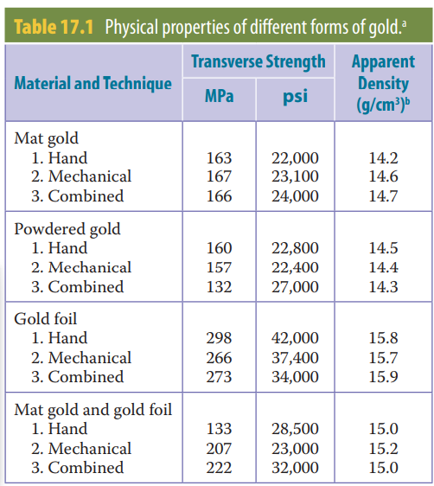

An important property for porcelain-fused-to-metal alloys is the coefficient of thermal expansion (CTE) which must be compatible to that of the porcelain to avoid internal stresses in the porcelain veneer during cooling from the firing temperature. Porcelain can withstand higher compressive stresses than tensile stresses, and it is therefore desirable that the thermal expansion of the alloy should be slightly above that of the porcelain. In this way compressive stresses are generated in the porcelain shell during cooling. Thermal expansion of porcelain, in contrast to that of a metal or an alloy, is not independent of the cooling rate. Slow cooling rates after firing lead to a higher thermal expansion of porcelain, so a higher CTE of the alloy can be compensated by slower cooling. The CTE’s of high gold/platinum alloys, are mostly balanced to high fusing porcelains. For the low fusing porcelain, only high gold/silver/PGM alloys are available. The reason for the presence of base metals, such as copper, indium, and tin even in such small quantities in high gold alloys, is the necessary precipitation hardening, as well as the ability to bond the porcelain to the metal surface. The oxides of the base metals are formed at the surface of the alloy during the firing cycle. The required bond strength can be obtained by means of a very thin oxide layer of less than 1 μm on the surface of the alloy. In alloys with a higher content of base metals, because of the lower content of gold and PGM’s, oxide layers are thicker and lead to unsatisfied aesthetics and in bad cases to cracks and breakoffs in the porcelain veneer.

An interesting new variation on these established dental alloys is the recent development by a major alloy producer of an extremely high gold content alloy (99.7% Au), with small additions of indium (0.2%) and zinc (0.1%). It has been claimed that the high gold content means that this alloy imparts a warm, dentin-like colour to the porcelain. Because of this feature, there is a complete elimination of gingival ‘black line disease’ associated with traditional porcelain fused-to-metal fixed restorations. The lower strength of this alloy means that it is not suitable for long span bridgework. For several years, other extremely high gold content alloys (98.2% Au) with additions of Titanium, Iridium, Rhodium and/or Niobium have been used. They are fine grained, have a sufficient strength for crown and bridgework, but they have to be melted and cast under a protective gas atmosphere.184

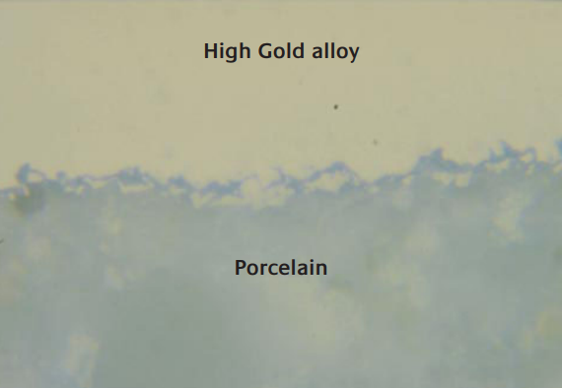 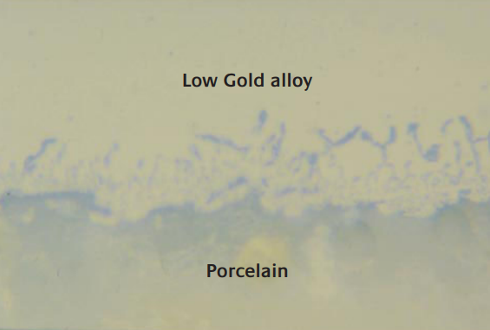

**ELECTROFORMING**

The electroforming process with pure gold was first used in conservative dentistry for inlays in 1961 and has been reported in Gold Bulletin previously.

The major advantage of the process is that the production of a very precise coping of pure gold, which does not change its dimensions during firing on porcelain, can be achieved with only one piece of equipment and there is no further need of wax modelling, investing, preheating of moulds and casting.185

Electroforming baths suitable for dental restorations are non-cyanide and contain a gold sulphite electrolyte.

Electroformed pure gold has a hardness of 100 HV and a fineness between 99.9 and 99.99%. The crystal structure of the deposit shows a very fine grain size of less than 1 μm.

After firing on porcelain, recrystallisation leads to a very acceptable average grain size of 50 μm. Cast pure gold on the contrary is very coarse grained with a typical grain size of 400 μm.

The use of high or low fusing porcelains with CTE’s between 13.8 and 17.2 μm/mK generally has no influence on the successful production of a porcelain-fused to-metal prosthesis based on electroforming. The reason for this is probably that stresses arising in the porcelain during cooling down from the elevated firing temperature will be absorbed by the ductile pure gold.

**VARIETIES OF GOLD FOR RESTORATIVE PURPOSES**

Gold for restorative purposes is categorized based on its microscopic structure into two varieties:

1. Fibrous gold/gold foil

2. Crystalline gold

Fibrous forms make stronger restorations, although they have a tendency to draw away from cavity walls while being manipulated, owing to a certain amount of resilience or spring in the fibers as they have numerous fibers interlacing each other in every direction.

Fibrous gold is supplied in the form of sheets about 4 inches square, ranging in numbers 2, 3, 4, 5, 6, 8, and 10. The higher numbers are rolled by the manufacturers from an ingot, while the lower numbers are beaten by machinery. These numbers indicate the number of grains to the sheet, e.g., No. 4 foil contains 4 grains, No. 10 foil contains 10 grains, etc. These sheets are available in thickness as low as 0.6 mm, the numbering system referring to weight and thickness of the standard sheet.

They are also dispensed in the form of rolls and cylinders, or pellets of various sizes or weights. Fibrous gold is classified as

(a) cohesive

(b) semi cohesive

(c) non cohesive.

**COHESIVE GOLD**

The cohesive foil, which was used extensively, is annealed by heat and put up in books containing 1/10 ounce, or in packages containing rolls or cylinders. The gold foil that the manufacturer supplies to the dentist is essentially free of any surface contaminants and can be placed directly in the cavity preparation. This type of gold is called cohesive gold. Although it is free of surface contaminants, some of the gases may still get adsorbed during storage, thus degassing is required.

Hence, annealing before packaging plus the purity of the gold used enables it to be welded to itself under pressure to form a solid mass and a dense surface. Several types of cohesive gold foils are described here:

1. Soft-type cohesive foil is annealed before trimming and is treated in ammonia fumes to reduce cohesion. After this, it is cut and rolled into the desired sizes, the ammonia gas is driven off (by annealing in the flame of the alcohol lamp or over an electric annealer) to restore its entire cohesion. It may then be condensed into the cavity.

2. Dead-soft-type foil is soft due to the fact that it has not been annealed. It is softer and much less cohesive than the soft-type but may be rendered cohesive by careful annealing.

3. Extra- or special-soft foil has been deliberately alloyed with a trace of silver to limit its cohesiveness. It is moderately cohesive when annealed.

4. Platinized soft gold foil has been alloyed with platinum, usually by placing a layer of platinum foil between two layers of gold, and then malting again until the original thickness is established. It is indicated on the incisal edges of anterior teeth as a protection against abrasion (class IV preparations). It is moderately cohesive when annealed, but its working qualities are a little harsh. The motive behind adding platinum is to increase the hardness and wear resistance.

The commonest type of cohesive gold now used is the No. 4 soft-type gold foil. This is prepared in the form of books with sheets 4 inches square. Each sheet is rated on the basis of the number of grains of gold it contains.

It is the only dental material that, if carefully placed and finished, can approximate the cavosurface margin with zero marginal gap, and lasts longer than any other dental material.

**SEMI COHESIVE GOLD**

Some foils are supplied as semi cohesive. In these, the cohesive property is not developed to its fullest extent. By controlling the annealing, any degree of cohesiveness may be obtained. These foils are preferred by some operators. This type of gold is protected after manufacture by subjecting its surface to chlorine and ammonia gases. Although these gases will make the surface temporarily non cohesive, they can be eliminated immediately before inserting the gold into the cavity preparation by use of heat. It is necessary to treat the gold surfaces with ammonia or chlorine since these gases react with polluting elements to prevent them from permanently contaminating the gold surfaces. They themselves can be eliminated very easily with thermal energy.

**NON-COHESIVE GOLD**

The non cohesive foils have certain non-volatile substances, such as salts of iron, sulphur, ammonia, or phosphorus, deposited on their surfaces which permanently destroy their cohesive property. Non cohesive gold maybe used, on account of its rapidity of manipulation, in simple cavities with four strong walls, located on surfaces not subject to wear. It may also be used in combination with cohesive gold for beginning restorations on the gingival wall in proximo-occlusal cavities, or on the pulpal wall in occlusal cavities, as a timesaver. It is not indicated on surfaces subjected to stress of mastication or for contour work.

The non cohesive and semi cohesive forms are also supplied in rolls, cylinders, or in 1/10-ounce books containing sheets or foils, the numbers running the same as for the cohesive foils.

**CRYSTALLINE GOLD**

Made by chemical precipitation or electrodeposition, the crystalline forms appear more granular in character. In contrast to fibrous gold, the crystalline forms do not possess the tendency to draw away from the cavity walls and are more easily manipulated. But they are deceptive and treacherous for use.

**OTHER TYPES OF GOLD**

**FOIL CORRUGATED/CARBONIZED GOLD FOIL**

Corrugated gold is made by burning gold-foil sheets between paper in the absence of air. This type was discovered in 1871 after the Chicago fire but has questionable value in dentistry.

Gold foil is supplied in four forms:

1. Plain gold foil: It is the product of cold working procedure without any modification.

2. Corrugated gold foil: It is manufactured by placing thin leaf of paper between two sheets of gold foil after which the container containing the paper leaves and gold foil is ignited.

3. Platinum gold foil: It is an old type of gold foil.

4. Laminated gold foil

a. It is produced by combining two or three leaves of gold, each of different ingots which have been cold worked in different directions.

b. The laminates are now available as preformed but can be made in the dental office by placing a number of sheets on top of each other and then cutting the laminates of desired sizes.

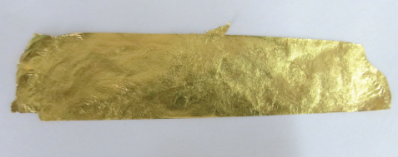

**GOLD FOIL CYLINDERS**

They are is produced by rolling cut segments of No. 4 foils into desired width, usually 3.2, 4.8, and 6.4 mm using a modified No. 22 tapestry needle.

**EXTRA PLIABLE GOLD FOIL**

The purpose of this is to make gold more cohesive. This material is produced by wrapping a loosely formed, regular gold rope with an extra sheet of gold foil. The rope is then used as it is or cut into pellets. It can also be heated and condensed in the same manner as other gold.

**ELECTROLYTIC PRECIPITATED GOLD**

Sponge gold, a crystalline form, was introduced into dentistry in 1853. This is manufactured by amalgamating the gold with mercury and then driving off the mercury by heat.

1. Mat gold

a. It is precipitated through electrodeposition and is accumulated in the form of strips or cones. These strips are cut by the dentist into desired sizes.

b. Mat gold is placed in a mould at room temperature to become compacted and is then sintered in an oven.

Advantages - It is of sponge type and adapts well to cavity walls.

Uses - It is used for building up the internal bulk of the restoration.

2. Mat foil

a. Sandwich of mat gold between sheets of No. 3/4 gold foil.

b. Sandwich is sintered by heating below melting point of gold and cut into strips of differing widths.

Advantages - 1. Ease of placing gold in retention forms

2. Reduction in placement time especially in larger preparations

Disadvantage - Greater tendency for voids which show as pits on outer surface of the restoration.

**ELECTRALLOY**

Electralloy is a combination of gold and calcium; calcium content is 1%.

Advantage - Product form provides stronger restoration.

Disadvantages - 1. Inharmonious colour

2. High conductivity

3. Difficulty in manipulation.

**POWDERED GOLD**

Powdered gold is also known as EZ gold. It is a blend of atomized and precipitated powder embedded in a wax-like organic matrix. It is available in pellets of various sizes which are enclosed in gold foil wrappers and packaged for use. Prior to its condensation, the matrix is burned away leaving only pure gold to be packed in the cavity.

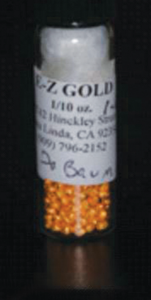

**GOLDENT**

Goldent is a combination of powdered gold and gold foil. The ratio is 95% powder to 5% foil. It is provided in cohesive form.

Uses - It is used in many types of restorations. It can be purchased in assorted 1/10-ounce plates.

Advantage - The envelope holds the powdered particles during condensation, making handling easier.

**ANNEALING/DEGASSING OF GOLD FOIL**

The gold is heated as a precautionary measure to remove any surface gases and to ensure a totally clean surface. Consequently, the term annealing is a misnomer. A more appropriate term would be desorption, because the objective is to remove adsorbed ammonia gas and other surface impurities.

As the gold is forced and compressed into a tooth preparation, succeeding increments cohere to those previously placed. For successful welding to occur during restoration, the gold must be in a cohesive state before compaction, and a suitable, biologically compatible compacting force must be delivered. Although cohesive gold is annealed by the manufacturer, it quickly becomes contaminated by the presence of carbonic acid, sulfurated hydrogen, and other gases in the atmosphere of poorly ventilated or unhygienic rooms or surroundings. Carbonic acid gas is derived from the exhalations of the lungs and other sources, while sulfurated hydrogen gas, as well as phosphoric acid gas, results from decaying animal or vegetable matter, such as blood, pus, and other substances left on soiled linen, in the fountain cuspidors, or in receptacles in the dental office. Sulfurous acid and phosphoric acid gases also are derived from burning matches, and the former emanates from sulfurous coal gases in the air and from rubber and vulcanite.

All DFG products are degassed immediately before use, except when non cohesive foil is specifically desired. Underheating during degassing is to be avoided, because it fails to render the gold surface pure. Overheating should also be avoided, because it may cause the gold to become brittle or melt and render it unusable. The annealing temperature ranges from 650°C to 700°C depending on the selection method and heating time. The idea behind this is to heat the gold until it exhibits a dull red colour to drive off the adsorbed ammonia gas.

Degassing is accomplished by heating the gold foil on a mica tray over a flame or on an electric annealer or by heating each piece of gold over a pure ethanol flame.

**BIOCOMPATIBILITY – DEFINITION, TESTING AND STANDARDS**

To predict the biocompatible properties of a material, it is necessary to obtain information about dissolution behaviour, cytotoxicity and, with regard to metals and alloys in the mouth, data about electrochemical potentials.

A large number of tests have been developed with this aim in mind and elements of them are defined in standards which must be met in order to confirm to the EU Directive 93/42/EWG.

High gold alloys show a moderate ion release, except for a palladium-free alloy with a very high release of zinc ions. Research suggests that palladium seems to be necessary in gold alloys in order to prevent corrosion of base metals. This is confirmed by the relatively low ion release from palladium and silver/palladium-based alloys. Generally, it is found that copper, zinc and indium ions are passing into solution. High gold alloys have been studied in order to find an alloy resistant to corrosion and it has been found that there are alloys containing 92-93% of gold, 3-4% of palladium and additional quantities of platinum, silver and tin that have a total ion release of less than 0.1 μg/cm2 after seven days.

Electrochemical tests are carried out by measuring the electrochemical potential of an alloy against a reference electrode of saturated calomel. A general guideline is that the breakdown potential should not be less than 600 mV. The maximum potential of the gold alloys is reached at 40% gold content. Gold and high gold alloys do not need any passivation, since they are noble by nature. To form a passivation layer, non-precious alloys need a very dense oxide layer with strong adherence.

Cell proliferation tests, according to the previously described standards, have been carried out on the alloy groups. The percentage of proliferation in a 75% eluate concentration is calculated as cell activity. There appears to be a slight correlation to the total release of metal ions, which is more obvious for the nickel- and copper-based alloys.

In another series of patch tests, gold alloys with different contents of nickel and palladium were assessed and the results compared with the release of nickel and palladium ions. It is considered that there is a cross allergy between nickel and palladium, and that if a patient is allergic to nickel, no palladium containing material should be incorporated.

It is clear that electroformed crowns exhibit superior performance over other systems, particularly in terms of biocompatibility and aesthetics, with porcelain veneered cast gold crowns ranked in second place.186

**THE FUTURE OF GOLD IN DENTISTRY**

If longevity, functionality, aesthetics, and biocompatibility, together with ease of manufacture are considered as the most important requirements, the optimum material for dental restorations is still a well-approved high gold alloy. It is no co-incidence that in all testing and development of competing materials, gold is always defined as the standard material to be judged against.184

Nonetheless, attention is increasingly focusing on the extensive range of alternative materials. These new materials include titanium and cobalt/nickel base alloys and all-ceramic crowns. The latter have excellent aesthetic properties, but do not have the long-term clinical approval that gold has. For example, zirconia has only passed clinical tests during the last 4 years. In addition, the CAD/CAM techniques associated with the use of these materials are, in many instances, prohibitively expensive. Furthermore, the problems of poor aesthetics often associated with porcelain-fused-to-metal techniques might be addressed through the use of extremely high gold content alloys, which have recently been patented. It is considered that as CAD/CAM technology progresses, special high gold alloys should be developed, which are well suited to milling and grinding operations and have sufficiently high strength for long span bridges and small cross sections.185

Of the other competing materials, problems encountered with casting titanium remain, preventing widespread use of this material. Long-term use of cobalt/chromium alloys are increasing, and there are fewer problems with casting compared to titanium. Besides long-term clinical approval and longevity, the most important advantages of gold alloys are easy workability, biocompatibility and maximum range of indications.183

The development of electroforming technology with pure gold offers new opportunities for future research. For highly stressed parts in dental restorations, electroformed pure gold is still too soft and thus has limited uses. Efforts have been made in recent years to develop increased strength through dispersion strengthening by incorporating a suspension of ceramic particles. Another area for electroforming research may focus on the deposition of multilayers by electrochemical structure modulation. Both of these research efforts should have the objective of developing thick deposits of pure gold with high strength.186

**CONCLUSIONS**

Dentists, materials scientists and toxicologists have listed all the required and well-known demands for the perfect restorative material like biocompatibility, conservative tooth preparation, ease of handling (must allow technically simple, reliable and reproducible working procedures), fast and exact finishing techniques without tooth destruction wear resistance equivalent to that of enamel, high fluoride release, long-term bonding to vital tooth tissue, dimensionally stable under occlusal forces during use, long-term stability (no shrinkage, no water absorption), radiopacity at least greater than that of enamel, tooth-coloured and adequate transparency and long shelf-life. None of the currently available restorative materials described can fulfil all of these requirements. Resin-based composite restorative materials are of high quality, are dominant as filling materials in the anterior region, and are an alternative for amalgam for small posterior restorations. Compomers may be positioned between composites and glass ionomer cements; they are definitely not as strong as composites. Glass ionomer cements have proved successful in limited indications such as Class V restorations and for smaller deciduous fillings (primarily Class I). Ormocers are interesting and promising materials; however, their development is incomplete. Dental materials research in different parts of the world is now focusing on so-called nanoparticle containing composites (‘nanocomposites’) with novel fillers to achieve less or even no polymerisation shrinkage. Another approach to find the perfect restoration is the use of modified resins: for example, using cyclic silicon compounds, ortho-spirocarbonates, and epoxides. Government-funded joint research between the dental industry and university institutions is conducted in several countries; however, many years of additional research will be required until a significantly better or ‘ideal’ material is available. 187

Basic dental treatment is different especially in developing countries, depending on social security systems, access to clinical facilities, education, diet habits, life expectancy and industrial evolution. Dental companies are already offering easy-to-handle restorative materials for semipermanent fillings which can be manipulated even in areas without electricity. Mobile dental clinics are a familiar sight in many remote areas. Thus, future developments may be focused on ‘user-friendly’ materials that will yield biocompatible, aesthetically superior and high quality restorations, making the clinical practice more effective, effortless and quick.

REFERENCES

1. Vaderhobli RM. Advances in dental materials. Dental Clinics. 2011 Jul 1;55(3):619-25.
2. Kenneth J. Anusavice, Chiayi Shen, H. Ralph Rawls. Phillips’ science of dental materials. Elsevier Health Sciences;12th ed.
3. Van Nieuwenhuysen, J.P., D'Hoore, W., Carvalho, J., Qvist, V. (August 2003). "Long-term evaluation of extensive restorations in permanent teeth". J Dent 31 (6): 395– 405. doi:10.1016/S0300-5712(03)00084- 8. PMID 12878022.
4. Rekow ED, Fox CH, Watson T, Peterson PE. 2013. Future innovation and research in dental restorative materials. Adv Dent Res. 25(1):2–7.
5. Chantler PM, Hu X, Boyd NM. 1999. An extension of a phenomenological model for dental composites. Dent Mater. 15(2):144–149.
6. Ferracane JL, Greener EH. 1984. Fourier transform infrared analysis of degree of polymerization in unfilled resins—methods comparison. J Dent Res. 63(8):1093–1095.
7. Mills RW, Jandt KD, Ashworth SH. 1999. Dental composite depth of cure with halogen and blue light emitting diode technology. Br Dent J. 186(8):388– 391.
8. Czasch P, Ilie N. 2013. In vitro comparison of mechanical properties and degree of cure of bulk fill composites. Clin Oral Investig. 17(1):227–235.
9. Buonocore MG. 1955. A simple method of increasing the adhesion of acrylic filling materials to enamel surfaces. J Dent Res. 34(6):849–853.
10. Wilson AD, Crisp S, Lewis BG, McLean JW. 1977. Experimental luting agents based on the glass ionomer cements. Br Dent J. 142(4):117–122.
11. McLean JW, Hughes TH. 1965. The reinforcement of dental porcelain with ceramic oxides. Br Dent J. 119(6):251–254
12. Kosmac T, Oblak C, Jevnikar P, Funduk N, Marion L. 1999. The effect of surface grinding and sandblasting on flexural strength and reliability of Y-TZP zirconia ceramic. Dent Mater. 15(6):426–433.
13. Burwell AK, Thula-Mata T, Gower LB, Habelitz S, Kurylo M, Ho SP, Chien YC, Cheng J, Cheng NF, Gansky SA, et al. 2012. Functional remineralization of dentin lesions using polymer-induced liquid-precursor process. PLoS One. 7(6):e38852.
14. Albers HF. Tooth-colored restoratives. 8.ed. Santa Rosa: Alto Books; 1996.
15. Posted by [mrzezo](https://pocketdentistry.com/author/mrzezo/) in Pocket dentistry [Dental Materials](https://pocketdentistry.com/category/dental-materials/), Mechanical Properties of Dental Materials,Chapter 4 | Feb 12, 2015.
16. Darvell BW. Mechanical testing. In. Materials science for Denstistry. 6th ed. Hong Kong:University of Hong Kong; 2000. p. 1-34.
17. Craig RG. Mechanical properties. In. Restorative dental materials. 10.ed. St. Louis: Mosby, c1997. p. 56-103.
18. International Organization for Standardization. Technical report ISO 9917 Dental water-based cements, Switzerland, 1993.
19. Anusavice KJ. Recent developments in restorative dental ceramics. J Am Dent Ass 1993; 24: 73-84.
20. Anusavice KJ. Propriedades mecânicas dos materiais dentários. In. Phillips materiais dentários. 10. ed. Rio de Janeiro: Guanabara Koogan; 1983. p.28-43.
21. Vieira DF. Propriedades mecânicas. In. Propriedades dos materiais odontológicos. São Paulo: Universidade de São Paulo, 1965. p. 31-89.
22. Microhardnesstest.Disponívelnohttp://www.gordonengland.co.uk/hardness/microhardness.htm). 12 fev. 2003.
23. Shinkai RS, Cury AADB, Cury JA. In vitro evaluation of secondary caries development in enamel and root dentin around luted metallic restoration. Oper Dent 2001; 26:52-9.
24. Wang L, D'Alpino PH, Lopes LG, Pereira JC. Mechanical properties of dental restorative materials: relative contribution of laboratory tests. Journal of Applied Oral Science. 2003;11:162-7.
25. Bouschlicher MR, Cobb DS, Boyer DB. Radiopacity of compomers, flowable and conventional resin composites for posterior restorations. *Oper Dent* 1999; 24: 20–25. [PubMed](https://www.ncbi.nlm.nih.gov/pubmed/10337294). [ISI](http://gateway.webofknowledge.com/gateway/Gateway.cgi?GWVersion=2&DestApp=WOS_CPL&UsrCustomerID=5e3815c904498985e796fc91436abd9a&SrcAuth=atyponcel&SrcApp=literatum&DestLinkType=FullRecord&KeyUT=000077784000005).
26. Hara AT, Serra MC, Rodrigues AL. Radiopacity of glass ionomer/composite resin hybrid materials. *Braz Dent J* 2001; 12: 85–89. [PubMed](https://www.ncbi.nlm.nih.gov/pubmed/11445919).
27. Attar N, Tam LF, McComb D. Flow, strength, stiffness and radiopacity of flowable resin composites. *J Can Dent Assoc* 2003; 69: 516–521. [PubMed](https://www.ncbi.nlm.nih.gov/pubmed/12954140).
28. Murchison DF, Charlton DG, Moore WS. Comparative radiopacity of flowable resin composites. *Quintessence Int* 1999; 30: 179–184. [PubMed](https://www.ncbi.nlm.nih.gov/pubmed/10356571). [ISI](http://gateway.webofknowledge.com/gateway/Gateway.cgi?GWVersion=2&DestApp=WOS_CPL&UsrCustomerID=5e3815c904498985e796fc91436abd9a&SrcAuth=atyponcel&SrcApp=literatum&DestLinkType=FullRecord&KeyUT=000079206100006).
29. Sabbagh J, Vreven J, Leloup G. Radiopacity of resin-based materials measured in film radiographs and storage phosphor plate (Digora). *Oper Dent* 2004; 29: 677–684. [PubMed](https://www.ncbi.nlm.nih.gov/pubmed/15646224). [ISI](http://gateway.webofknowledge.com/gateway/Gateway.cgi?GWVersion=2&DestApp=WOS_CPL&UsrCustomerID=5e3815c904498985e796fc91436abd9a&SrcAuth=atyponcel&SrcApp=literatum&DestLinkType=FullRecord&KeyUT=000225727300012).
30. Pires de Souza FCP, Pardini LC, Cruvinel DR, Hamida HM, Garcia LFR. In vitro comparison of the radiopacity of cavity lining materials with human dental structures. *J Conserv Dent* 2010; 13: 65–70. [Crossref](https://doi.org/10.4103/0972-0707.66713). [PubMed](https://www.ncbi.nlm.nih.gov/pubmed/20859477).
31. Lachowski KM, Botta SB, Lascala CA, Matos AB, Sobral MA. Study of the radio-opacity of base and liner dental materials using a digital radiography system. Dentomaxillofacial Radiology. 2013 Feb;42(2):20120153.
32. Brodbelt RH, O’Brien WJ, Fan PL, Frazer-Dib JG, Yu R. Translucency of human dental enamel. J Dent Res 1981;60: 1749–53.
33. Ceylan G, Dede DÖ, Külünk Ş, Öngöz Dede F. Effects of refractive index solutions on the color of different luting cements. Acta Odontologica Scandinavica. 2013 Jan 1;71(1):88-91.
34. Dietschi D. Layering concepts in anterior composite restorations. J Adhes Dent 2001;3:71–80.
35. Felippe LA, Monteiro S Jr, Andrada MAC, et al. Clinical strategies for success in proximoincisal composite restorations. Part I: understanding color and composite selection. J Esthet Restor Dent 2005;17(1):11–21.
36. Fahl N Jr. A polychromatic composite layering approach for solving a complex class IV/direct veneer-diastema combination: part I. Pract Proced Aesthet Dent 2006;18(10):641–5.
37. LiSANTI, V. F., and ZANDER, H. A. Thermal Conductivity of Dentin, J. D. Res., 29:493, 1950.
38. SIMERAL, W. G. Thermal Conductivity of Dental Maternals, Microfilm of papers presented at the Annual I.A.D.R. Dental Materials Group Meeting, March 17-18, 1951, J. D. Res., 30:499, 1951 (abstr.).
39. PHILLIPS, R. W., REINKING, R. H., and PHILLIPS, L. J. Thermal Conductivity of Dental Cement, J. D. Res, 33:511, 1954.
40. Craig RG, Peyton FA. Thermal conductivity of tooth structure, dental cements, and amalgam. Journal of Dental Research. 1961 May;40(3):411-8.
41. Brown WS, Dewey WA, Jacobs HR. Thermal properties of teeth. Journal of dental research. 1970 Apr;49(4):752-5.
42. Panas AJ, TERPIŁOWSK J, Trykowski J, Zaborowski P, ZMUDA S. Thermophysical properties of dental filling materials. Part I: thermal properties. High Temperatures. High Pressures (Print). 2001;33(5):581-7.
43. McParland, H. and Warnakulasuriya, S. (2012) ‗Oral lichenoid contact lesions to mercury and dental amalgam—a review‘, Journal of biomedicine & biotechnology, 2012. Available at:
44. Craig, R. G. (2019) ‗Restorative dental materials‘.
45. Suzuki, S. et al. (1995) ‗A new copolymerized composite resin system: a multiphased evaluation‘, The International journal of periodontics & restorative dentistry, 15(5), pp. 482–495.
46. Wataha, J. C. et al.(1999) ‗Long-term cytotoxicity of dental casting alloys‘, The International journal of prosthodontics, 12(3), pp. 242–248.
47. Lakshmi, T., Ezhilarasan, D., Vijayaragavan, R., Bhullar, S. K., &Rajendran, R. (2017). Acacia catechu ethanolic bark extract induces apoptosis in human oral squamous carcinoma cells. Journal of advanced pharmaceutical technology & research, 8(4), 143– 149..
48. Wylie, C. M. et al. (2007) ‗Corrosion of nickel-based dental casting alloys‘, Dental materials: official publication of the Academy of Dental Materials, 23(6), pp. 714–723.
49. Geurtsen, W. (2002) ‗Biocompatibility of dental casting alloys‘, Critical reviews in oral biology and medicine: an official publication of the American Association of Oral Biologists, 13(1), pp. 71–84.
50. Batchelor, J. M. and Todd, P. M. (2010) ‗Allergic contact stomatitis caused by a polyether dental impression material‘, Contact dermatitis, 63(5), pp. 296–297.
51. Mittermüller, P. et al.(2012) ‗A rare allergy to a polyether dental impression material‘, Clinical Oral Investigations, pp. 1111–1116.
52. Gangemi, S. et al.(2009) ‗Fatal anaphylactic shock due to a dental impression material‘, The International journal of prosthodontics, 22(1), pp. 33–34.
53. Silvestre, J. F. et al. (2005) ‗Allergic contact gingivitis due to eugenol present in a restorative dental material‘, Contact dermatitis, 52(6), p. 341.
54. Deshpande, A., Verma, S. and Macwan, C. (2014) ‗Allergic reaction associated with the use of eugenol containing dental cement in a young child‘, Austin J Dent, 1(2), p. 1007.
55. Subbarao, C., Neelakantan, P. and Subbarao, C. V. (2012) ‗In vitro biocompatibility tests of glass ionomer cements impregnated with collagen or bioactive glass to fibroblasts‘, The Journal of clinical pediatric dentistry, 36(3), pp. 269–274.
56. Tamilselvam, S., Divyanand, M. J. and Neelakantan, P. (2013) ‗Biocompatibility of a Conventional Glass Ionomer, Ceramic Reinforced Glass Ionomer, Giomer and Resin Composite to Fibroblasts: In vitro Study‘, Journal of Clinical Pediatric Dentistry, pp. 403–406.
57. Hurrell-Gillingham, K. et al.(2003) ‗Devitrification of ionomer glass and its effect on the in vitro biocompatibility of glass-ionomer cements‘, Biomaterials, pp. 3153– 3160.
58. Pameijer CH. Biocompatibility of luting cements for dental applications. InBiocompatibility of Dental Biomaterials 2017 Jan 1 (pp. 77-94). Woodhead Publishing.
59. Blatz, M.B., Mante, F.K., Saleh, N., Atlas, A.M., Mannan, S., Ozer, F., 2013. Postoperative tooth sensitivity with a new self-adhesive resin cement—a randomized clinical trial. Clin. Oral Investig. 17, 793–798.
60. Lööf, J., Svahn, F., Jarmar, T., Engqvist, H., Pameijer, C.H., 2008. A comparative study of the bioactivity of three materials for dental applications. Dent. Mat. 24, 653–659.
61. Jefferies, S.R., Pameijer, C.H., Appleby, D., Boston, D., Lööf, J., Glantz, P.-O., 2013. Ceramir C&B, A bioactive dental luting cement—its retentive properties and three year clinical findings. Compend. Contin. Educ. Dent. 34, 2–9.
62. Autian J. The use of rabbit implants and tissue culture tests for the evaluation of dental materials. Int Dent J 1970;20:481–90.
63. Soares DG, Basso FG, Hebling J, de Souza Costa CA. Concentrations of and application protocols for hydrogen peroxide bleaching gels: effects on pulp cell viability and whitening efficacy. J Dent 2014;42:185–98.
64. Grayson WL, Martens TP, Eng GM, Radisic M, Vunjak-Novakovic G. Biomimetic approach to tissue engineering. Semin Cell Dev Biol 2009;20:665–73.
65. Soares DG, Ribeiro AP, Sacono NT, Coldebella CR, Hebling J, Costa CAS. Transenamel and transdentinal cytotoxicity of carbamide peroxide bleaching gels on odontoblast-like MDPC-23 cells. Int Endod J 2011;44:116–25.
66. Galler KM, D’Souza RN, Hartgerink JD, Schmalz G. Scaffolds for dental pulp tissue engineering. Adv Dent Res 2011;23:333–9.
67. Sato C, Rodrigues FA, Garcia DM, Vidal CPM, Pashley DH, T.Jaderhane L, et al. Tooth bleaching increases dentinal protease activity. J Dent Res 2013;92:187–92.
68. Soares DG, Basso FG, Hebling J, de Souza Costa CA. Concentrations of and application protocols for hydrogen peroxide bleaching gels: effects on pulp cell viability and whitening efficacy. J Dent 2014;42:185–98.
69. Anderson JM. Biological responses to materials. Annu Rev Mater Sci 2001;31:81–110.
70. Bayne SC. Dental restoration for oral rehabilitation-testing of laboratory properties versus clinical performance for clinical decision making. J Oral Rehabil 2007;34:921–32.
71. Wataha JC. Principles of biocompatibility for dental practitioners. J Prosthet Dent 2001;86:203–9.
72. Cochrane Collaboration Website: http://www.cochrane.org
73. Recommended standard practices for biological evaluation of dental materials (ANSI/ADA Specification No. 41). Chicago: American Dental Association; 1979.
74. Biological evaluation of medical devices. I. Evaluation and testing (ANSI/AAMI/ISO 10993–1:2003). Geneva (Switzerland): International Organization for Standardization; 2003.
75. Standard practice for selecting generic biological test methods for materials and devices (F748). In: ASTM standards on disc, vol. 13.01. West Conshohocken (PA): ASTM International; 2005.
76. Hoffmann-Axthelm W, History of dentistry. Trans by Koehler HM. Quintessence, Chicago, pp:43, 156, 1981.
77. Cattell DM, Amalgam: its history and metallic phenomena, Dent Cosmos 64:855, 1922; Taylor  JA, History  JA, History of dentistry: of dentistry: a practical a practical treatise for treatise for the use of dental students and practitioners. Lea and Febiger, Philadelphia, 1922, pp:126-7; Prinz H, Dental Chronology Dental Chronology: a record of the record of the more important more important historic events in the evolution of dentistry. Lea and Febiger, Philadelphia,1945, p:87; Davidson RL, Amalgam — its early history. Oral Health  24:91-2, 1934.
78. White JD, Amalgam and metallic compounds for plugging teeth. 1865.  Dent Cosmos  ns 6:561
79. Bumgardner E, Amalgam, is it poisonous? Western Dent J  22:881, 1908.
80. Eames WB. Preparation and condensation of amalgam with low mercury alloy ratio. *J Am Dent Assoc.*1959;58:78–83.
81. Demaree NC, Taylor DF. Properties of dental amalgam from spherical alloy particles. *J Dent Res.*1962;41:890–906.
82. Innes DB, Youdelis WV. Dispersion strengthened amalgam. *J Can Dent Assoc.*1963;29:587–93.
83. Asgar K. Behavior of copper dispersion alloy (abstract 15) *J Dent Res.*1971;50:56.
84. Mahler DB. Micro-probe analysis of a dispersion amalgam (abstract 14) *J Dent Res.*1971;50:56.
85. Probst RL, Karp PI, Sayre CH, Beebe AR., Jr Atomizing nozzle and pouring cap assembly for the manufacture of metal powders. US Patent No 2, 968,062 granted January 17, 1961.
86. Berry TG, Laswell HR, Osborne JW, Gale EN. Width of isthmus and marginal failure of restorations of amalgam. Oper Dent 1981;65:55-8.
87. Blaser PK, Lund MR, Cochran MA, Potter RH. Effect of designs of Class 2 preparations on resistance of teeth to fracture. Oper Dent 1983;8:6-10.
88. Mertz-Fairhurst EJ, Curtis JW Jr, Ergle JW, Rueggeberg RA, Adair SM. Ultraconservative and cariostatic sealed restorations: Results at year 10. J Am Dent Assoc 1998;129:55-66.
89. Skartveit L, Tveit AB, Ekstrand J. Fluoride release from a fluoridecontaining amalgam In vivo. Scand J Dent Res 1985; 93:448-52.
90. Nakaabayashi N, Watanabe A, Gendusa NJ. Dentin adhesion of modified 4-META/MMA-TBB RESIN: Function of HEMA. Dent Mater 1992;77:259-64.
91. Summitt JB, Burgess JO, Osborne JW, Berry TG, Robbins JW. Two year evaluation of amalgambond plus and pin-retained amalgam restorations (abstract 1529). J Dent Res 1998;77:297.
92. Berry TG, Summit JB, Chung AK, Osborne JW. Amalgam at the new millennium. J Am Dent Assoc 1998;129:1547-56.
93. W.H. Rollins, A contribution to the knowledge of cements, Dent. Cosmos 21 (1879) 574–576.
94. G.C. Paffenbarger, S.J. Sweeney, A. Isaacs, A preliminary report on zinc phosphate cements, J. Am. Dent. Assoc. 20 (1933) 1960–1982.
95. W.S. Crowell, Physical chemistry of dental cements, J. Am. Dent. Assoc. 14 (1927) 1030–1048.
96. A.D. Wilson, J.W. Nicholson, Acid–Base Cements, Cambridge University Press, Cambridge, UK, 1993.
97. P.J. Wisth, The ability of zinc phosphate and hydrophosphate cements to seal space bands, Angle Orthodont. 42 (1972) 395–398.
98. K.R. Anderson, P.R. Paffenbarger, Properties of silicophosphate cements, Dent. Prog. 2 (1962) 72–75.
99. M. Pourbaix, Atlas of Electrochemical Equilibria in Aqueous Solutions, National Association of Corrosion Engineers, Houston, 1974.
100. Dollimore, P. Spooner, Sintering studies on zinc oxide, Trans. Faraday Soc. 67 (1971) 2750–2759.
101. Zamanian A, Yasaei M, Ghaffari M, Mozafari M. Calcium hydroxide-modified zinc polycarboxylate dental cements. Ceramics International. 2013 Dec 1;39(8):9525-32.
102. Xie D, Faddah M, Park JG. Novel amino acid modified zinc polycarboxylates for improved dental cements. Dental Materials. 2005 Aug 1;21(8):739-48.
103. Wilson AD. Resin-modified glass-ionomer cement. Int J Prosthodont 1990;3:425–9.
104. Rae J, Ashokummar M, Eulaerts O, von Sonntag C, et al. Estimation of ultrasound induced cavitation bubble temperatures in aqueous solutions. Ultrason Sonochem. 2005;12:325–9.
105. Shahid S, Billington RW, Hill RG, Pearson GJ. The effect of ultrasound on the setting reaction of zinc polycarboxylate cements. Journal of Materials Science: Materials in Medicine. 2010 Nov;21(11):2901-5.
106. Cox C. Biocompatibility of dental materials in the absence of bacterial infection. Oper Dent 1987;12:146-51.
107. Hume WR. Effect of eugenol on respiration and division in human pulp, mouse fibroblasts, and liver cells in vitro. J Dent Res 1984b;63:1262-5.
108. Kasugai S, Hasegawa N, Ogura H. Application of the MTT calorimetric assay to measure cytotoxic effects of phenoiic compounds on established rat dental pulp cells. J Dent Res 1991;70:127-30.
109. Brannstrom M, Nyborg H. Pulp reaction to a temporary zinc oxide-eugenol cement. J Prosthet Dent 1976;35: 185-9 1.
110. Brodin P, Roed A. Effects of eugenol on rat phrenic nerve and phrenic nerve-diaphragm preparations. Arch Oral Biol 1984; 29:611-5.

RECENT ADVANCES (GIC)

1. Ref of org article
2. Nagaraja Upadhya P, Kishore G. Glass ionomer cement: The different generations. Trends Biomater Artif Organs,2005:18(2):158-65.
3. Sharma A, Singh M, Pandey V. Glass ionomer cement-a phoenix and its new flight. Int J Res Health Allied Sci,2015:1(1):9-12.
4. Gu YW, Yap AU, Cheang P, Khor KA. Effects of incorporation of HA/ZrO(2) into Glass Ionomer Cement. J. Biomaterials,2005:26:713-720.
5. Bariker RH, Mandroli PS. An in-vitro evaluation of antibacterial effect of amalgomer CR and Fuji VII against bacteria causing severe early childhood caries. J. Indian Soc Pedod Prev Dent,2016:34:10:23-29.
6. S. Mahalaxmi. Textbook on materials used in dentistry, 1st edition, Chapter 4: Direct Restorative Materials,273-274.
7. Dhoot R, Bhondwe S, Mahajan V, Lonare S, Rana K. Advances in glass ionomer cement (GIC): A review. IOSR– J Dent Med Sci,2016:15(11):124-26.
8. Sun L, Yan Z, Duan Y, Zhang J, Liu B. Improvement of the mechanical, tribological and antibacterial properties of glass ionomer cements by fluorinated graphene. Dent Mater,2018:34(6):e115–e127
9. Kerby RE, Bleiholder RF. Physical properties of stainless steel and silver-reinforced glass-ionomer cements. Journal of dental research,1991;70(10):1358-61.
10. Yli-Urpo H, Lassila LV, Närhi T, Vallittu PK. Compressive strength and surface characterization of glass ionomer cements modified by particles of bioactive glass. Dental Materials,2005:21(3):201-9.
11. Lucas ME, Arita K, Nishino M. Toughness, bonding and fluoride-release properties of hydroxyapatite-added glass ionomer cement. Biomaterials,2003:24(21):3787-94
12. Prentice LH, Tyas MJ, Burrow MF. The effect of ytterbium fluoride and barium sulphate nanoparticles on the reactivity and strength of a glass-ionomer cement. Dental Materials, 2006:22(8):746-51.
13. Gu YW, Yap AU, Cheang P, Koh YL, Khor KA. Development of zirconia-glass ionomer cement composites. Journal of non-crystalline solids,2005;351(6-7):508-14.
14. Bertolini MJ, Zaghete MA, Gimenes R. Development of an experimental glass ionomer cement containing niobium and fluoride. Journal of non-crystalline solids,2005;351(52- 54):3884-7.
15. Boyd D, Towler MR. The processing, mechanical properties and bioactivity of zinc-based glass ionomer cements. Journal of Materials Science: Materials in Medicine, 2005:16(9):843-50.
16. Prentice LH, Tyas MJ, Burrow MF. The effects of boric acid and phosphoric acid on the compressive strength of glassionomer cements. Dental Materials,2006:22(1):94-7.
17. Deb S, Nicholson JW. The effect of strontium oxide in glass– ionomer cements. Journal of Materials Science: Materials in Medicine,1999:10(8):471-4.
18. Hurrell-Gillingham K, Reaney IM, Brook IM, Hatton PV. Novel Fe2O3-containing glass ionomer cements: Glass characterisation. InKey Engineering Materials Trans Tech Publications Ltd,2005:284:799-802.
19. Mazzaoui SA, Burrow MF, Tyas MJ, Dashper SG, Eakins D, Reynolds EC. Incorporation of casein phosphopeptideamorphous calcium phosphate into a glass-ionomer cement. Journal of dental research,2003:82(11):914-8.
20. Pamir T, Sen BH, Celik A. Mechanical and fluoride release properties of titanium tetrafluoride-added glass-ionomer cement. Dental materials journal,2005:24(1):98-103.
21. . Tjandrawinata R, Irie M, Yoshida Y, Suzuki K. Effect of adding spherical silica filler on physico-mechanical properties of resin modified glass-ionomer cement. Dental materials journal,2004:23(2):146-54.
22. Arita K, Nakajima H, Nishino M, Okabe T. Effect of reinforcement on mechanical properties of glassionomer. J Dent Res,1992:72(special issue):631.
23. Silva RM, Pereira FV, Mota FA, Watanabe E, Soares SM, Santos MH. Dental glass ionomer cement reinforced by cellulose microfibers and cellulose nanocrystals. Mater Sci Eng C,2016:58:389–395.
24. Sun J, Xu Y, Zhu B, et al. Synergistic effects of titanium dioxide and cellulose on the properties of glass ionomer cement. Dent Mater J,2019;38(1):41-51
25. Sayyedan FS, Fathi MH, Edris H, Doostmohammadi A, Mortazavi V, Hanifi A. Effect of forsterite nanoparticles on mechanical properties of glass ionomer cements. Ceram Int 2014;407, Part B :10743–10748
26. Dowling AH, Stamboulis A, Fleming GJP. The influence of montmorillonite clay reinforcement on the performance of a glass ionomer restorative. J Dent,2006:34(10):802–810
27. Prentice LH, Tyas M. The effect of oxalic acid incorporation on the setting time and strength of a glass-ionomer cement. Acta Biomaterialia,2006:2(1):109-12.
28. Ellis J, Anstice M, Wilson AD. The glass polyphosphonate cement: a novel glass-ionomer cement based on poly (vinyl phosphonic acid). Clinical materials,1991;7(4):341-6
29. Ellis J, Wilson AD. Polyphosphonate cements: a new class of dental materials. Journal of materials science letters. 1990:9(9):1058-60.
30. Culbertson BM. Glass-ionomer dental restoratives. Progress in Polymer Science,2001:26(4):577-604.
31. Levy GB, Frank HP. Determination of molecular weight of polyvinylpyrrolidone. II. Journal of Polymer Science. 1955;17(84):247-54.
32. Moshaverinia A, Roohpour N, Darr JA, Rehman IU. Synthesis and characterization of a novel N vinylcaprolactam-containing acrylic acid terpolymer for applications in glass-ionomer dental cements. Acta Biomaterialia,2009:5(6):2101-8.
33. Darr JA, Poliakoff M. New directions in inorganic and metal-organic coordination chemistry in supercritical fluids. Chemical reviews,1999:99(2):495-542.
34. Zhao J, Xie D. A novel hyperbranched poly (acrylic acid) for improved resin-modified glass-ionomer restoratives. Dental Materials,2011:27(5):478-86.
35. Moshaverinia A, Roohpour N, Chee WW, Schricker SR. A review of polyelectrolyte modifications in conventional glass-ionomer dental cements. Journal of materials chemistry,2012:22(7):2824-33.
36. Xie D, Weng Y, Guo X, Zhao J, Gregory RL, Zheng C. Preparation and evaluation of a novel glass-ionomer cement with antibacterial functions. Dental Materials, 2011:27(5):487-96.
37. .Jedrychowski J, Caputo A, Kerper S. Antibacterial and mechanical properties of restorative materials combined with chlorhexidines. J Oral Rehab,1983:10:373-381.
38. Bahrami-Abadi M, Khaghani M, Monshi A, Doostmohammadi A, Alizadeh S. Reinforcement of glass ionomer cement: incorporating with silk fiber. Journal of Advanced Materials and Processing,2016:4(3):14-21.
39. Karthick A, Kavitha M, Loganathan S, Malarvizhi D. Evaluation of microshear bond strength of chitosan modified GIC. World J Med Sci,2014:10(2):169-73.
40. Bao X, Garoushi SK, Liu F, Lassila LL, Vallittu PK, He J. Enhancing Mechanical Properties of Glass Ionomer Cements with Basalt Fibers. Silicon,2020:12(8):1975-83.
41. Saran R, Upadhya NP, Ginjupalli K, Amalan A, Rao B, Kumar S. Effect on Physical and Mechanical Properties of Conventional Glass Ionomer Luting Cements by Incorporation of All-Ceramic Additives: An In Vitro Study. International Journal of Dentistry,2020.

Composites

1. Ferracane JL. Resin compositeestate of the art. Dent Mater 2011;27:29e38.
2. Hervás-Garcia AH, Martínez-Lozano MA, Cabanes-Vila JC, et al. Composite resins. A review of the materials and clinical indications . Med Oral Patol Oral Cir Bucal. 2006;11(2):E215-20
3. Sensi LG, Strassler HE, Webley W. Direct composite resins . Inside Dentistry. 2007;3(7):76.
4. Buonocore MG. A simple method of increasing the adhesion of acrylic filling materials to enamel surfaces. J Dent Res. 1955;34:849-853.
5. Lowe RA. Focus on: bioactive dental materials. Dent Today. 2017;36:16.
6. J.L. Ferracane, Resin composite – state of the art, Dent. Mater. 27 (2011) 29–38.
7. R.L. Bowen, Properties of a silica-reinforced polymer for dental restorations, J. Am. Dent. Assoc. 66 (1963) 57–64.
8. C.Y.K. Lung, J.P. Matinlinna, Aspects of silane coupling agents and surface conditioning in dentistry: an overview, Dent. Mater. 28 (2012).
9. J.F. McCabe, A.W.G. Walls, Applied Dental Materials, ninth ed., Blackwell Munksgaard, Oxford, 2008.
10. J.L. Ferracane, Resin composite – state of the art, Dent. Mater. 27 (2011) 29–38.
11. J.T. Blackham, K.S. Vanderwalle, W. Lein, Properties of hybrid resin composite systems containing prepolymerized filler particles, Oper. Dent. 34 (2009) 697–702.
12. S.B. Mitra, D. Wu, B.N. Holmes, An application of nanotechnology in advanced dental materials, J. Am. Dent. Assoc. 134 (2003) 1382–1390.
13. S.C. Bayne, J.Y. Thompson, E.J. Swift Jr., P. Stamatiades, M.A. Wilkerson, A characterization of first-generation flowable composites, J. Am. Dent. Assoc. 129 (1998)
14. D.C. Watts, A. al Hindi, Intrinsic ‘soft-start’ polymerization shrinkage-kinetics in an acrylate-based resin-composite, Dent. Mater. 15 (1999) 39–45.
15. W.C. Brandt, L.F.J. Scheider, E. Frollini, L. Correr-Sobrinho, M.A.C. Sinhoret, Effect of different photo-initiators and light curing units on degree of conversion of composites, Braz. Oral Res. 24 (2010) 263–270.
16. H.S. Chan, Y. May, H. Kim, K.C.T. Tong, D. Ng, J.C.M. Hsiao, Review: resin composite filling, Materials 3 (2010) 1228–1243.
17. B. Micali, R.T. Basting, Effectiveness of composite resin polymerization using light-emitting diodes (LEDs) or halogen-based light-curing units, Braz. Oral Res. 18 (2004) 266–270.
18. W.J. Dunn, A.C. Bush, A comparison of polymerization by light-emitting diode and halogen-based light-curing units, J. Am. Dent. Assoc. 133 (2002) 335–341.
19. S.M. Mousavinasab, I. Meters, Comparison of depth of cure, hardness and heat generation of LED and high intensity QTH light sources, Eur. J. Dent. 5 (2011) 299–3
20. A. Uhl, R.W. Mills, A.F. Rzanny, K.D. Jandt, Time dependence of composite shrinkage using halogen and LED light curing, Dent. Mater. 21 (2005) 278–286.
21. C.A. Felix, R.B. Price, P. Andreou, Effect of reduced exposure times on the microhardness of 10 resin composites cured by high-power LED and QTH curing units, J. Can. Dent. Assoc. 72 (2006) 147.
22. F. Millich, I. Jeang, J.D. Eick, C.C. Chappelow, C.S. Pinzino, Elements of light-cured epoxy-based dental polymer systems, J. Dent. Res. 77 (1998) 603–608.
23. Anseth KS, Goodner MD, Reil MA, Kannurpatti AR, Newman SM, Bowman CN. The influence of comonomer composition on dimethacrylate resin properties for dental composites. J Dent Res 1996;75:1607e12.
24. Santini A, McGuinness N, Nor NA. Degree of conversion of resin-based orthodontic bonding materials cured with single-wave or dual-wave LED light-curing units. J Orthod 2014;41:292e8.
25. Padovani GC, Feitosa VP, Sauro S, Tay FR, Duran G, Paula AJ, et al. Advances in dental materials through nanotechnology: facts, perspectives and toxicological aspects. Trends Biotechnol 2015;33:621e36.
26. McCabe JF, Wang Y, Braem M. Surface contact fatigue and flexural fatigue of dental restorative materials. J Biomed Mater Res 2000;50:375e80.
27. Steiner M, Mitsias ME, Ludwig K, Kern M. In vitro evaluation of a mechanical testing chewing simulator. Dent Mater 2009;25:494e9.
28. Gonçalves F, Kawano Y, Pfeifer C, Stansbury JW, Braga RR. Influence of BisGMA, TEGDMA, and BisEMA contents on viscosity, conversion, and flexural strength of experimental resins and composites. Eur J Oral Sci 2009;117:442e6.
29. Leinfelder KF. New developments in resin restorative systems. J Am Dent Assoc 1997; 128: 573-581.
30. Jandt KD, Sigusch BW. Future perspectives of resinbased dental materials. Dent Mater 2009; 25: 1001- 1006.
31. Jandt KD, Al-Jasser AMO, Al-Ateeq K, Vowles RW, Allen GC. Mechanical properties and radiopacity of experimental glass-silica-metal hybrid composites. Dent Mater 2002; 6: 429-35.

DFG

1. Knosp H, Holliday RJ, Corti CW. Gold in dentistry: alloys, uses and performance. Gold bulletin. 2003 Sep;36(3):93-102.
2. Dental Alloy with a High Gold Content’, European Patent EP 0691123 (1997)
3. ‘Electroformed Gold Dental Crowns and Bridges’ Matthijs M.A. Vrijhoef, Adam J. Spanauf, Heinz H. Renggli, Gerard A. Somers and Horst L. Wismann, Gold Bulletin, 1984, 17 (1), 13-17
4. Wirz, J. and K. Jäger, ‘Evaluation of Commonly used Crown Systems’ QDT (1999) 193
5. Hickel R, Dasch W, Janda R, Tyas M, Anusavice K. New direct restorative materials. International dental journal. 1998 Feb;48(1):3-16.